課題4 早期香港地區的歷史、文化與承傳
I 香港主要民系與姓族

關鍵詞
四大民系 | Four Major Groups
廣府人 | Cantonese
客家人 | Hakkas
福佬人 | Fuklos
水上人 | boat people
五大姓族 | Five Great Clans
拜祭祖先 | ancestral worship
打醮 | da chiu
方言 | dialect

溫習要點

A 早期香港地區的歷史
自公元前214年起，
香港地區已被劃入中央政府管治範圍，與內地的關係一直十分密切。

中國歷代王朝與香港地區的發展
秦朝 | 香港已被劃入中國版圖，隸屬於南海郡番禺縣。
東漢 | 李鄭屋漢墓是香港與中原文化接觸的象徵。
唐朝 | 朝廷在屯門設立軍鎮，派重兵把守。
北宋 | 九龍灣設立官營鹽場。
南宋 | 兩名末代皇帝曾逃難至香港，於九龍城一帶設立行宮。
明朝晚期 | 「香港」一名正式出現在史書上。

Topic 4 History, culture and heritage

of the early Hong Kong region
I Major groups and the great clans in Hong Kong

Key Terms
四大民系 | Four Major Groups
廣府人 | Cantonese
客家人 | Hakkas
福佬人 | Fuklos
水上人 | boat people
五大姓族 | Five Great Clans
拜祭祖先 | ancestral worship
打醮 | da chiu
方言 | dialect

Revision Points

A History of the early Hong Kong region
Since 214 BC, the Hong Kong region
was officially included into the territory of central dynasties. Hong Kong has always maintained close relations with the Mainland.

Hong Kong development throughout various Chinese dynasties
Qin dynasty | Hong Kong was included in the Chinese territory, under Panyu county of Nanhai prefecture.
Eastern  Han dynasty | The Lei Cheng Uk Han Tomb shows the contacts between Hong Kong and the culture of Central China.
Tang dynasty | Tuen Mun was guarded by Tang soldiers at the time.
Northern  Song dynasty | Government-run salt fields were set up in Kowloon Bay.
Southern  Song dynasty | The last two emperors escaped to Hong Kong and built a palace in Kowloon City.
Late Ming times | The name ‘Hong Kong’ first appeared in history books.

「香港」一名由來的説法
香味
明朝末年，石排灣是香木貿易的中心，因而出現「香港」一名。

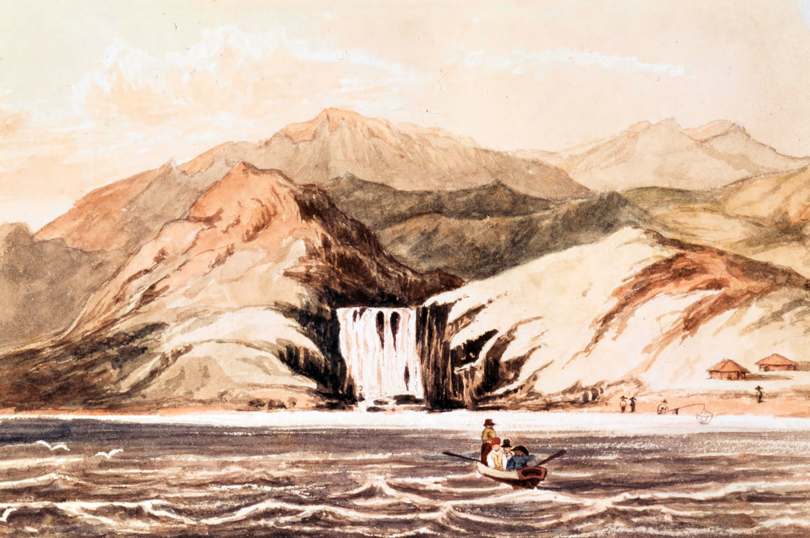
一張描繪公元19世紀初香港仔瀑布灣的畫作， 當時乘船途經香港的英國人會來這裏取水。
溪水香甜
以前到香港的船隻都在島上的山溪取水。由於溪水香甜可口，
人們便稱這個島嶼為香港。
地名、人物
- 相傳一個名叫「香姑」的海盜曾活躍於香港一帶，香港之名即源自香姑。
- 昔日香港島銅鑼灣天后廟前有一座紅香爐，人們便把廟前的海港稱為「紅香爐港」，其後演變成「香港」。
Stories about how Hong Kong got its name
Fragrances
In late Ming times, Shek Pai Wan was a trade centre for incense wood. Thus, the nearby region earned the name ‘Fragrant Harbour’.
Sweet stream water
When ships came to Hong Kong, sailors often collected drinking water from streams on the island. As the stream water had a sweet taste, people called this region ‘Fragrant Harbour’.
Place names and person
- According to legend, a female pirate called ‘fragrant lady’ was active in the region. Hong Kong was named after her.
- In the past, there was a red incense burner in front of the Tin Hau Temple in Causeway Bay on Hong Kong Island. Then, people named the harbour ahead ’Red Incense Burner Harbour’. Later, people simply called it ‘Incense Harbour’.

Painting depicting Waterfall Bay in Aberdeen in the early 19th century.
At the time, the British who sailed via Hong Kong would collect drinking water from there.

B 香港四大民系的生活習俗

今日香港大部分居民的來源，可以分為四大民系：廣府人、客家人、福佬人和水上人。

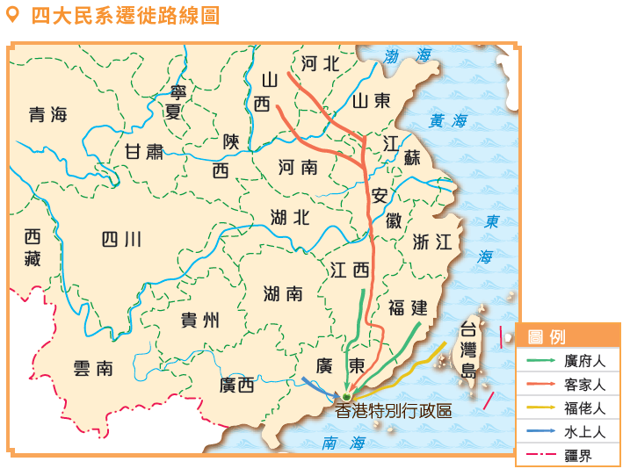

i. 廣府人

1 淵源

- 祖先原來是中原人士，其後陸續南遷至廣州，主要聚居於新界北部。
- 由於他們早在香港生活，所以又稱為「本地人」。
- 他們操粵語（廣東話），在古代以耕種為生。

B Four Major Groups in Hong Kong and their lifestyles

The majority of Hong Kong people have originated from the Four Major Groups: the Cantonese, the Hakkas, the Fuklos and the boat people.

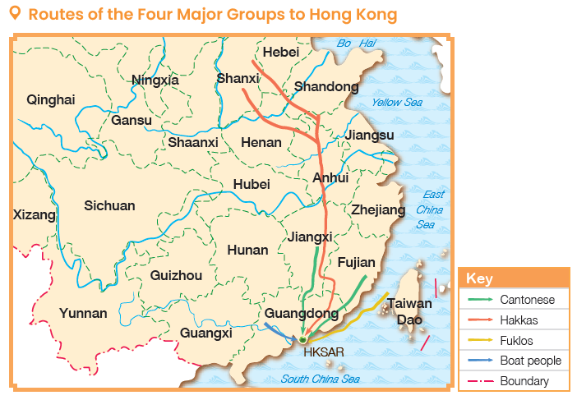

i. Cantonese

1 Origin

- The ancestors originated in Central China, then moved southwards to Guangzhou, and settled in the northern New Territories.
- Since they had lived in Hong Kong a long time ago, they were also called the Puntis.
- They mainly spoke Cantonese, and mostly were farmers.

2 新界五大姓族

自宋朝以來，五大姓族的祖先先後從內地遷居到香港地區，人口繁衍頗眾。他們在新界擁有大量土地，逐漸累積財富，又重視培育人才，在早期香港社會中佔有非常重要的地位。

姓族 | 始祖 | 遷入時間及地區
鄧氏 | 鄧漢黻 | 於北宋遷至岑田（今錦田）。其子孫遷居至龍躍頭、屏山、廈村和大埔頭。
侯氏 | 侯五郎 | 於北宋遷居至上水河上鄉。
彭氏 | 彭桂公 | 於南宋遷居至粉嶺龍山。
廖氏 | 廖仲傑 | 於元朝遷居屯門，後定居上水。
文氏 | 文孟常 | 於元朝遷居至大埔和新田。

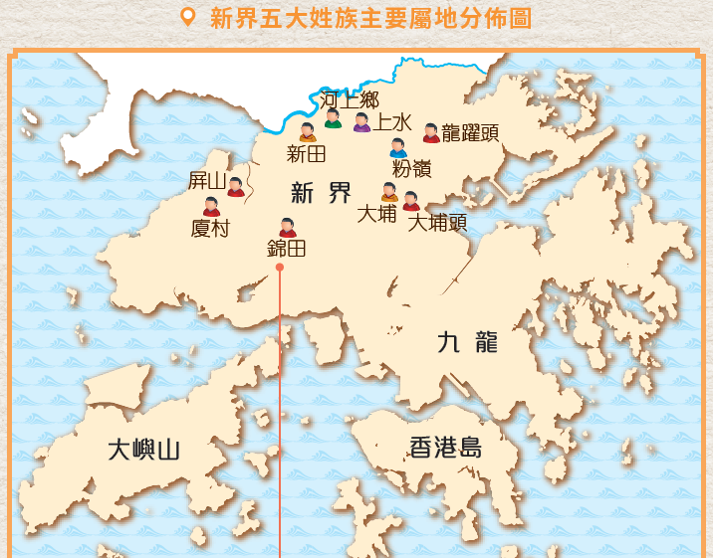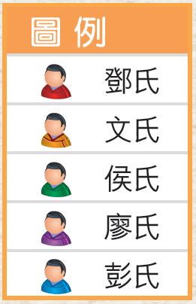

2 Five Great Clans in the New Territories

From the Song Dynasty onwards, the ancestors of the Five Great Clans moved to Hong Kong from the Mainland one after another. Their offsprings continued to grow in number. Owning lots of land in the New Territories, these clans gradually gathered wealth and put emphasis on nurturing talents. They thus played a key role in early Hong Kong society.

Clan | First ancestor | Arrival time and location of settlement
Tang | Tang Hon-Fat | They settled in Kam Tin during the Northern Song dynasty. Their later generations moved to Lung Yeuk Tau, Ping Shan, Ha Tsuen and Tai Po Tau.
Hau | Hau Ng-Long | They settled in Ho Sheung Heung of Sheung Shui during the Northern Song dynasty.
Pang | Pang Kwai-Kung | They settled in Lung Shan of Fanling during the Southern Song dynasty.
Liu | Liu Chong-Kit | They moved to Tuen Mun during the Yuan dynasty, later settled in Sheung Shui.
Man | Man Mang-Sheung | They settled in Tai Po and San Tin during the Yuan dynasty.

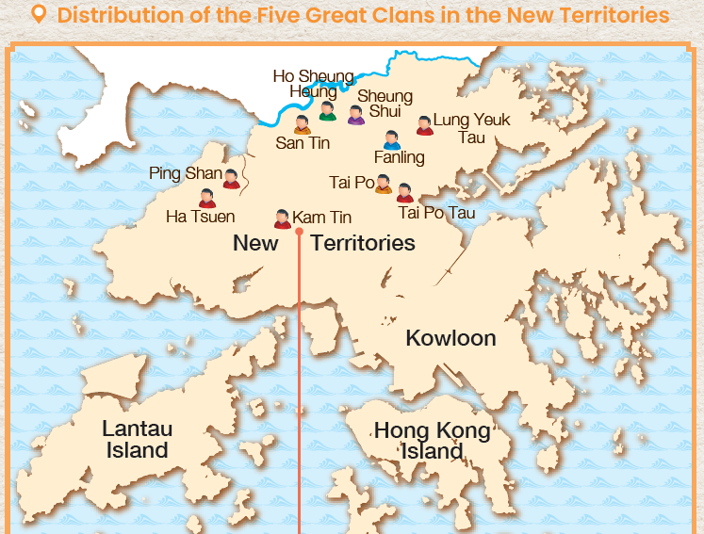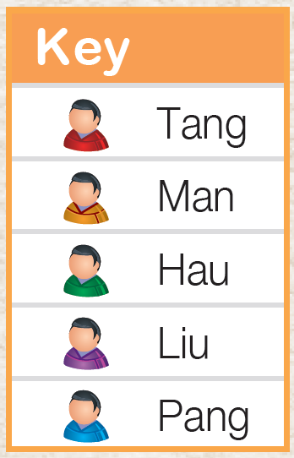

3 居住環境

3.1 興建圍村

- 興建圍村以保障本族民眾的安全。
- 在新界現存圍村之中， 較為著名的有錦田的吉慶圍和粉嶺的新圍等。

圍村的建築特色
圍村的結構工整，房屋緊密排列。
以磚建成的圍牆
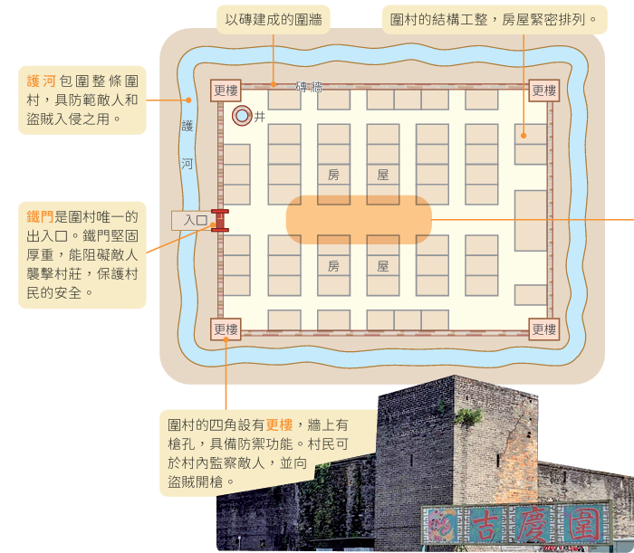
鐵門是圍村唯一的 出入口。鐵門堅固 厚重，能阻礙敵人 襲擊村莊，保護村 民的安全。
圍村的四角設有更樓，牆上有槍孔，具備防禦功能。村民可於村內監察敵人，並向盜賊開槍。
護河包圍整條圍村，具防範敵人和 盜賊入侵之用。

3.2 宗祠

- 宗族最重要的建築物。
- 主要用作安放祖先靈位，供族人定期祭祀，也是節日慶典、議事及舉行重要儀式的場地，有時亦兼作學堂。
- 新界各地現時仍遺留不少歷史悠久的宗祠，如屏山的鄧氏宗祠、新田的麟峰文公祠等。

3 Living environment

Construction of walled villages

- Built walled villages to protect themselves.
- Nowadays, some walled villages still remain in the New Territories, such as Kat Hing Wai in Kam Tin and San Wai in Fanling.

Architectural features in the walled village
There was a moat surrounding the entire walled village to defend against the enemy and thieves.
The structure of walled village was neat. Houses were lined up closely.
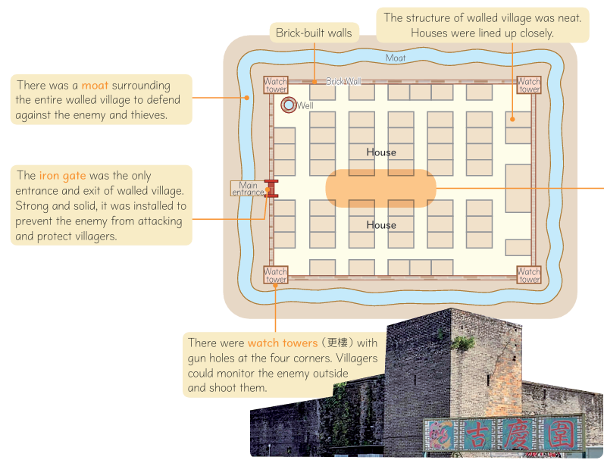
There were watch towers with gun holes at the four corners. Villagers could monitor the enemy outside and shoot them.
The iron gate was the only entrance and exit of walled village. Strong and solid, it was installed to prevent the enemy from attacking and protect villagers.
Brick-built walls

3.2 Ancestral hall

- The most important building for the whole clan.
- Mainly used for placing ancestral tablets so that clan members could perform worship regularly. The ancestral hall was also a venue for festive celebrations, meetings and important ceremonies. Sometimes, it served as a study hall as well.
- Many historic ancestral halls still remain in the New Territories, such as the Tang Ancestral Hall in Ping Shan and the Man Lun Fung Ancestral Hall in San Tin.

3.3 書室、書院及書屋

- 若有族人能在朝廷的科舉考試中考取功名、入仕做官，就能光宗耀祖。
- 新界各大姓族都會建立書室、書院、書屋等，為年輕族人提供教育。

傳統書室的學習生活
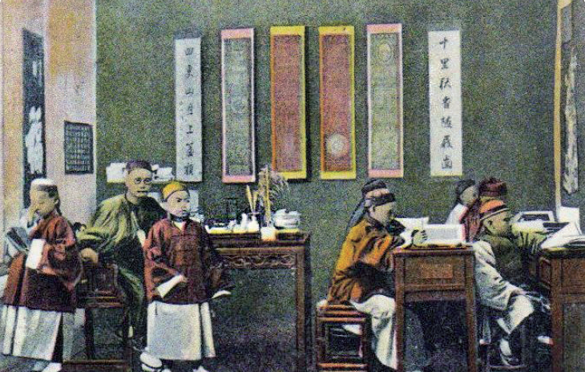
以學習古文為主，如《三字經》、《千字文》等。

只有男學生，由一位老師教授。

教學規模小，每班約十至三十人。

4 信仰習俗

4.1 拜祭祖先

- 重視拜祭祖先。新界各大姓族普遍都設立宗祠。
- 每年定期祭祖，發揚孝道。

4.2 拜祭神靈

- 十分重視拜祭天地、神佛。
- 為了酬謝神恩和祈求風調雨順，人們常請道士設壇唸經，稱為「打醮」。新界各地至今仍常定期舉行大型的醮會。

3.3 Study hall

- If a clan member passed the imperial examination and became an official, he brought great honour to the whole clan.
- The great clans in the New Territories set up study halls to provide education for young clan members.

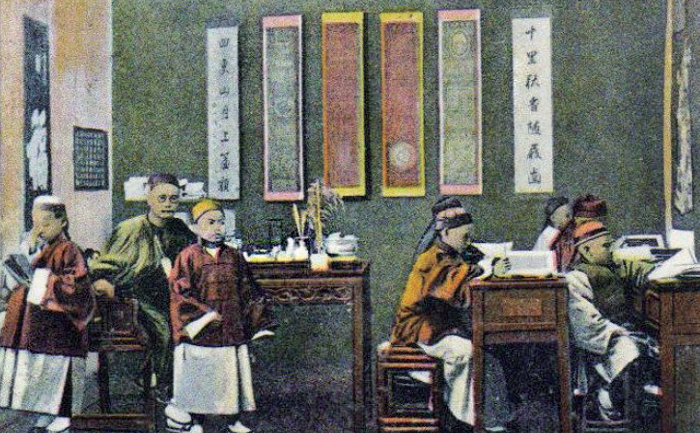
Studying in a traditional study hall
Male students only; they were all taught by the same teacher.

Focusing on Chinese classical writings, such as the Three Character Classic and the Thousand Character Classic.

Each class had a small size of 10-30 students.

4 Beliefs and customs

Ancestral worship

- Put emphasis on ancestral worship. The great clans usually have built their own ancestral halls.
- There they perform ancestral worship ceremonies on a regular basis to carry forward filial piety.

4.2 Worship of the deities

- Worship Heaven and Earth, as well as a variety of deities.
- In order to express gratitude towards the deities and pray for good weather, people pay Taoist priests to set up altar and chant scriptures. This is called da chiu. Nowadays, da chiu is still held regularly across the New Territories.

部分廣府人信奉的神明
黃大仙
被人們視為能救治疾病和帶來財富的神仙。
關帝
以忠義仁勇見稱，是不同行業的守護神。
玉皇大帝
管轄所有神仙，擁有至高無上的權力。
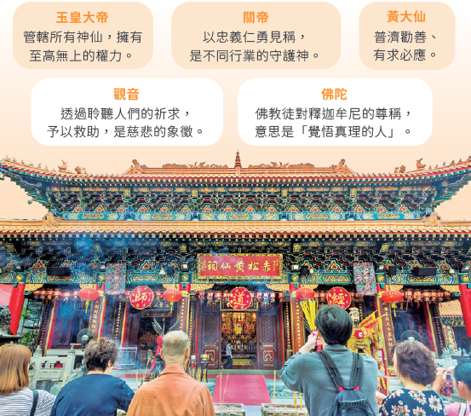
佛陀
佛教徒對釋迦牟尼的尊稱，
意思是「覺者」。
觀音
透過聆聽人們的祈求，予以救助，是慈悲的象徵。

4.3 傳統節日

十分重視中國的傳統節日，如農曆新年（春節）、中秋節等。

Some deities worshipped by the Cantonese
Kwan Tai
He is known for his loyalty and courage. He is the guardian deity of many industries.
Wong Tai Sin
He is regarded as the deity that cures illness and brings fortune and wealth.
Jade Emperor
He controls all the deities and holds the highest power.
Kwun Yum
She helps people by hearing their prayers. She is the symbol of compassion.
Buddha
It is the title used by Buddhists to refer to Siddhartha Gautama. It means‘the awakened one’ or ‘the enlightened one’.

4.3 Traditional festivals

Valued traditional Chinese festivals, such as the Chinese New Year (Spring Festival) and the Mid-Autumn Festival.

ii. 客家人

1 淵源

- 祖先是中原人士，後來由於逃避戰亂，遷居於江西、廣東、福建三省交界地區。
- 到了明末、清初，有許多客家人遷入香港，但繼續保留其客家方言和習俗。

2 居住環境

- 大多居於新界偏遠或貧瘠的山地。主要以農耕為生，並從事打石、燒灰等工作。
- 他們也興建並居於圍村，例如沙田曾大屋和荃灣三棟屋。

3 信仰習俗

- 主要信奉觀音和關帝。他們至今也保留着傳統的習俗，如點燈、祭祖、舉辦盆菜宴等。
- 他們亦會定期舉行太平清醮，藉以祈求平安。

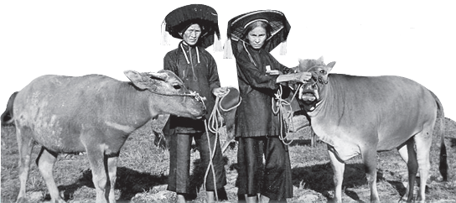
耕作中的客家婦女

ii. Hakkas

1 Origin

- The ancestors originated in Central China. They first moved to the areas between Jiangxi, Guangdong and Fujian. They spoke the Hakka dialect.
- In late Ming and early Qing times, many of them moved to Hong Kong while keeping their Hakka language and customs.

2 Living environment

- Mostly settled in the remote and barren uplands in the New Territories. They mainly farmed and also did stone quarrying and lime making.
- They also built and lived in walled villages, such as Tsang Tai Uk in Sha Tin and Sam Tung Uk in Tsuen Wan.

3 Beliefs and customs

- Mainly worshipped Kwun Yam and Kwan Tai. They now still observe traditional customs, such as lantern lighting ceremony, ancestral worship, basin feast, etc.
- They also hold the Jiao Festival on a regular basis to pray for peace.

Farming Hakka women

iii. 福佬人

1 淵源

- 祖先原居於福建南部及粵東，操閩南方言。
- 他們自宋朝時南遷到香港沿岸地區，起初以捕魚、航運為生。
- 至20 世紀中，不少來港的福佬人從事苦力工作。

2 居住環境

大多是水上居民，居住在大埔、屯門、香港仔、長洲及坪洲。此外，也有些福佬人在市區居住，如上環、筲箕灣、觀塘、柴灣等地。

3 信仰習俗

- 特別重視信奉與海有關的神靈，例如天后（又稱「媽祖」）及北帝。
- 居於長洲的福佬人，每年都會慶祝北帝誕，祈求家居平安。
- 居住在市區的福佬人，每年農曆七月則會在各區舉行盂蘭勝會，以超渡遊魂野鬼。

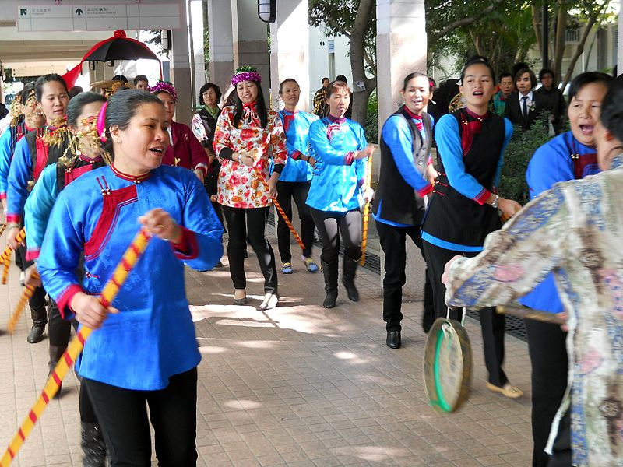
福佬婦女進行龍船舞

iii. Fuklos

1 Origin

- Their ancestors came from southern Fujian and eastern Guangdong, speaking the Hokkien dialect.
- Since the Song dynasty, they had moved southwards and settled along the coast in Hong Kong. Fuklos first made a living by fishing and shipping.
- By the mid-20th century, many Fuklos had arrived in Hong Kong to work as coolies.

2 Living environment

Living aboard vessels, most of Fuklos settled in Tai Po, Tuen Mun, Aberdeen, Cheung Chau and Peng Chau. Some lived on land and settled in urban areas, such as Sheung Wan, Shau Kei Wan, Kwun Tong, Chai Wan, etc.

3 Beliefs and customs

- They put emphasis on worshipping deities of the sea, such as Tin Hau (also named Mazu) and Pak Tai.
- Fuklos living in Cheung Chau still celebrate the Pak Tai Festival every year to pray for peace and safety at home.
- Fuklos living in urban areas hold the Yu Lan Festival in the seventh lunar month every year to comfort wondering ghosts.

Fuklo women performing the dragon boat dance

iv. 水上人

1 淵源

- 長期居住於香港的水上居民，舊稱「蜑家人」。
- 他們的祖先很可能是來自中國華南地區華南的原住民。
- 他們也講粵語，以捕魚、採珠或航運為業。

2 居住環境

- 以船為家，因此又被稱為「艇家人」。
- 他們散居於香港的漁港，如大澳、長洲、西貢及香港仔等。
- 隨着漁業日漸式微，很多水上人已遷居上岸，興建棚屋作居所，而棚屋現時成為大澳的特色建築。

3 信仰習俗

- 大多信奉與海、漁業和出航有關的神靈，如天后、洪聖和朱大仙等，祈求出海平安。
- 每年天后誕，各區均會舉行隆重慶典。
- 另外，他們也會在農曆七月十四晚， 在水邊燒紙錢拜祭水鬼。

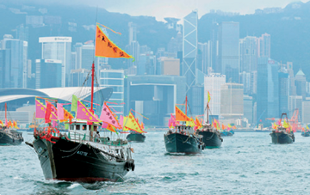
漁船在維港巡遊，慶祝天后誕。

iv. Boat people

1 Origin

- Lived aboard on boats. In the past, they were also known as 'Tankas'.
- Their ancestors were possibly originated in South China region.
- Speaking Cantonese, most of the boat people made a living by fishing, pearl hunting and shipping.

2 Living environment

- Used to live abroad vessels.
- They formed communities at fishing ports in Hong Kong, such as Tai O, Cheung Chau, Sai Kung and Aberdeen.
- As the fishing industry declined, many boat people went ashore. Some built stilt houses as their homes, which have become the unique architecture of Tai O.

3 Beliefs and customs

- Mainly worshipped deities of the sea, fisheries and sailing, such as Tin Hau, Hung Shing, and Chu Tai Sin, to pray for safety in sailing.
- During the Tin Hau Festival every year, different districts hold ceremonies to celebrate the birthday of Tin Hau.
- On the 14th day of the seventh lunar month every year, they also burn paper offerings near water to pacify the water ghosts.

Fishing vessels parading at Victoria Harbour to celebrate the Tin Hau Festival.

重點練習
1. 根據課文內容，完成下列各題文字。
(a) 香港之名最早見於公元16 世紀末的明朝晚期。「香港」一名由來的説法不一，其中有指 ___石排灣___ 附近是一個香料集散及貿易的中心，所以稱為「香港」。
(b) 今日香港大部分居民的來源，可以分為 ___四大民系___ ，即 ___廣府人___ 、 ___客家人___ 、 ___福佬人___ 和 ___水上人___ 。
(c) 明末清初， 本地人為了保障本族民眾的生命財產安全， ___同姓___ 村民多全族聚居，並興建 ___圍村___ ，以發揮 ___保衞___ 作用。
(d) 客家人的祖先也是 ___中原人士___ ，後來由於逃避戰亂，遷居於 ___江西___ 、___廣東___ 、 ___福建___ 三省交界地區，操 ___客家___ 方言。
(e) 福佬人自 ___宋朝___ 時南遷到香港沿岸地區，操 ___閩南___ 方言。
(f) 水上人以船為家，因此又被稱為「 ___艇家人___ 」。他們散居於香港的漁港，如 ___大澳___ 、 ___長洲___ 、 ___西貢___ 及 ___香港仔___ 等。隨着漁業日漸式微，很多水上人已遷居上岸，興建 ___棚屋___ 作居所。

2. 試選擇適當答案，並將其英文代號填入方格內。
(a) 新界五大姓族包括哪五族？
A. 鄧、文、廖、侯、彭
A
B. 鄧、林、孟、侯、彭
C. 鄧、文、廖、林、孟
D. 林、孟、廖、侯、彭

Key Exercises
1. Fill in the blanks according to the textbook content.
(a) The name 'Hong Kong' first appeared on history books during the late Ming dynasty at the end of the 16th century. There are different stories about how Hong Kong got its name. One of them says that ___Shek Pai Wan___ on Hong Kong Island, was a trading centre for incense products. Thus, this area was named 'Hong Kong'.
(b) Most of the early settlers in Hong Kong belonged to the ___four major groups___: the ___Cantonese___ , the ___Hakkas___ , the ___Fuklos___ and the ___boat people___ .
(c) In the late Ming and early Qing times, for ___protection___ , the Puntis belonging to the ___same clan___ usually lived together in ___walled villages___ .
(d) The ancestors of the Hakkas came from ___Central___ China. They first moved to the areas between ___Jiangxi___ , ___Guangdong___ and ___Fujian___ to escape wars. They spoke the ___Hakka___ dialect.
(e) The Fuklos moved southwards and settled along the coast in Hong Kong in the ___Song___ dynasty. They spoke the ___Hokkien___ dialect.
(f) The boat people were also called ___Tankas___. They lived in different harbours in Hong Kong, such as ___Tai O___ , ___Cheung Chau___ , ___Sai Kung___ and ___Aberdeen___. As the fishing industry declined, many boat people went ashore and built ___stilt houses___ as their homes.

2. Choose the appropriate answer and put it in the corresponding box.
(a) Which are the Five Great Clans in the New Territories?
A. Tang, Man, Liu, Hau, Pang
B. Tang, Lam, Mang, Hau Pang
C. Tang, Man, Liu, Lam, Mang
A
D. Lam, Mang, Liu, Hau, Pang

(b) 以下哪項不是新界姓族宗祠的用途？
A. 安放祖先靈位 B. 兼作學堂
C
C. 舉行科舉考試 D. 議事

(c) 在香港四大民系中，哪個有打醮的習俗？
A. 廣府人 B. 客家人
A
C. 福佬人 D. 水上人

(b) Which of the following is not the function of the ancestral hall of the clans in the New Territories?
A. for placing the soul tablets of ancestors B. as study halls
C
C. for holding the civil service examinations D. for meetings

(c) Which of the four major groups in Hong Kong have the custom of da chiu?
A. the Cantonese B. the Hakkas
A
C. the Fuklos D. the boat people

