課題4 早期香港地區的歷史、文化與承傳
II 透過非物質文化遺產認識本地居民的生活

關鍵詞
文化遺產 | cultural heritage
非物質文化遺產 | intangible cultural heritage
《保護非物質文化遺產公約》 | Convention for the Safeguarding of the Intangible Cultural Heritage
香港非物質文化遺產清單 | Intangible Culture Heritage Inventory of Hong Kong
長洲太平清醮 | Cheung Chau Jiao Festival
大坑舞火龍 | Tai Hang Fire Dragon Dance
香港潮人盂蘭勝會 | Yu Lan Festival of the Hong Kong Chiu Chow community
大澳端午龍舟遊涌 | Tai O Dragon Boat Water Parade

溫習要點

A 甚麼是非物質文化遺產？
非物質文化遺產社區和群體世代相傳的文化遺存，包括各種社會實踐、觀念表述、表現形式、知識、技能以及相關的工具、實物、手工藝品 和文化場所。

非物質文化遺產的五大範疇
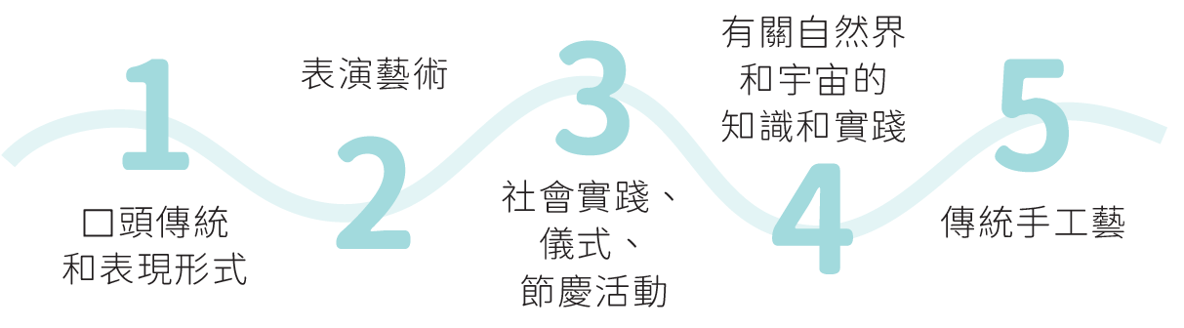
社會實踐、儀式、節慶活動
口頭傳統和
表現形式
表演藝術
傳統手工藝
有關自然界和宇宙的知識和實踐
Topic 4 History, culture and heritage

of the early Hong Kong region
II Understanding the life of local residents through Hong Kong's intangible cultural heritage

Key Terms
文化遺產 | cultural heritage
非物質文化遺產 | intangible cultural heritage
《保護非物質文化遺產公約》 | Convention for the Safeguarding of the Intangible Cultural Heritage
香港非物質文化遺產清單 | Intangible Culture Heritage Inventory of Hong Kong
長洲太平清醮 | Cheung Chau Jiao Festival
大坑舞火龍 | Tai Hang Fire Dragon Dance
香港潮人盂蘭勝會 | Yu Lan Festival of the Hong Kong Chiu Chow community
大澳端午龍舟遊涌 | Tai O Dragon Boat Water Parade

Revision Points

A What is intangible cultural heritage?
Intangible cultural heritage the cultural legacy that has been passed on through the generations by communities and groups, including practices, representations, expressions, knowledge, skills, as well as related instruments, objects, artifacts and cultural spaces.

Five main domains of intangible cultural heritage
Knowledge and practices concerning nature and the universe
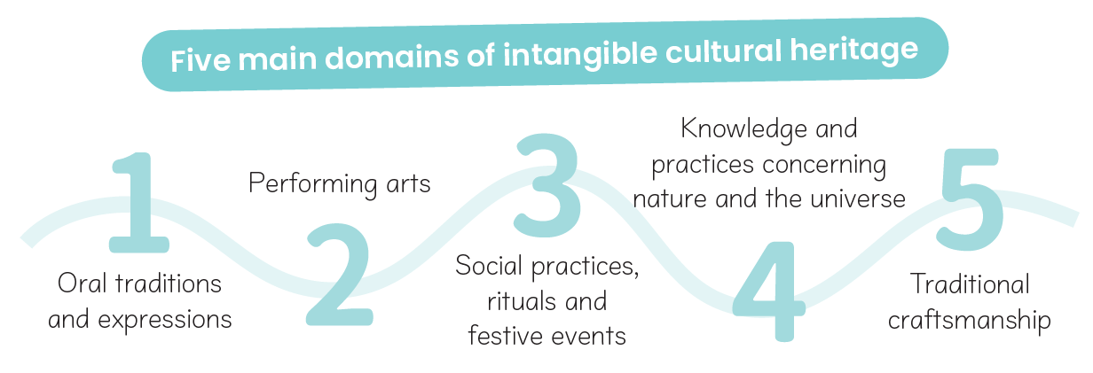
Performing arts
Oral traditions and expressions
Traditional craftsmanship
Social practices, rituals and festive events

B 香港的非物質文化遺產清單

2014年6月，香港政府正式公布香港非物質文化遺產清單，作為相關保護措施的基礎。

香港非遺項目示例（*為國家級非遺代表性項目）

粵劇*、舞獅、西貢坑口客家舞麒麟*、全真道堂科儀音樂*
表演藝術

潮州語、客家話、謎語、宗族口述傳説
口頭傳統和表現形式

- 長洲太平清醮*
- 大澳端午龍舟遊涌*
- 香港潮人盂蘭勝會*
- 中秋節—大坑舞火龍*
- 香港天后誕*
- 黃大仙信俗*
社會實踐、儀式、節慶活動

涼茶*、傳統中醫藥文化、傳統曆法
有關自然界和宇宙的知識和實踐

- 茶樓點心製作技藝
- 戲棚搭建技藝
- 香港中式長衫製作技藝*
- 古琴藝術（斲琴技藝）*
傳統手工藝

B Intangible Cultural Heritage Inventory of Hong Kong

In June 2014, the Hong Kong government released the Intangible Cultural Heritage Inventory of Hong Kong as the basis for protection measures.

Hong Kong ICH items Examples（* National ICH item）

Cantonese opera*,Lion dance, Hakka unicorn dance in Hang Hau in Sai Kung*, Quanzhen temples Taoist ritual music*
Performing arts

Chiu Chow dialect, Hakka dialect, Riddles, Oral legends of lineages
Oral traditions and expressions

- Cheung Chau Jiao Festival *
- Tai O Dragon Boat Water Parade*
- Yu Lan Festival of the Hong Kong Chiu Chow community*
- Mid-Autumn Festival – the Tai Hang Fire Dragon Dance*
- Tin Hau Festival in Hong Kong*
- Wong Tai Sin beliefs and customs*
Social practices, rituals and festive events

Herbal tea*, Culture of traditional Chinese medicine, Traditional Chinese almanac (傳統曆法)
Knowledge and practices concerning nature and the universe

- Chinese dim sum making technique
- Bamboo theatre building technique
- Hong Kong Cheongsam making technique*
- Arts of the guqin (the craft of qin making)*
Traditional craftsmanship

C 香港非物質文化遺產個案研習（四選一，延伸部分多選一項）

截至2024 年，香港有十二個非遺項目被列入國家級非遺代表性項目名錄，充分反映香港的風俗文化和傳統。

i. 長洲太平清醮

- 於每年農曆四月初五至初九舉行。
- 道教儀式「打醮」的一種，目的是潔淨地方社區、祈求平安健康。
19世紀末，為遏止疫症蔓延，居民在玉虛宮前設壇拜祭，超渡孤魂，並請北帝神像巡遊街道。
習俗源起

- 醮場設在北帝康樂廣場。
- 飄色會景巡遊則在主要街道進行。
舉行地點

長洲太平清醮醮場
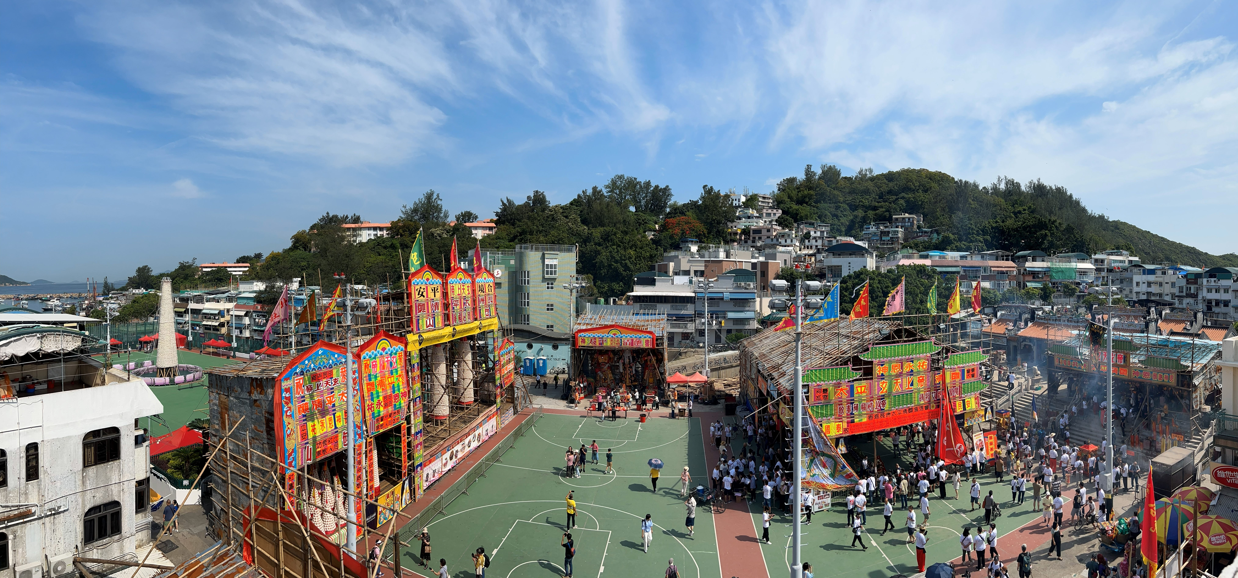
搶包山比賽場地
安放三座大型紙紮神像: 大士王、土地公、山神的神棚
玉虛宮
用作演出神功戲的戲棚
供奉神明的大包山

C Case study—Hong Kong intangible cultural heritage (choose 1 out of 4, study 1 more case for the extended part)

As at 2024, 12 Hong Kong ICH items have been inscribed onto the national list of ICH, reflecting the customs and cultural traditions of Hong Kong.

i. Cheung Chau Jiao Festival

- It is held annually from the 5th to 9th days of the fourth lunar month.
- An example of da chiu, which is a Taoist ritual. It is aimed at cleansing the community and praying for peace and health.
At the end of the 19th century, to suppress the plague, local residents set up an altar in front of the Yuk Hui Temple to comfort ghosts, as well as parading through the streets with the statue of Pak Tai.
Origin

- The Jiao venue is at Pak Tai Temple Playground.
- The carnival parade of floats is held along the main streets.
Location

Venue for the Cheung Chau Jiao Festival
Large bun towers dedicated to the deities
Yuk Hui Temple
Bamboo shed theatre for performing opera for appeasing deities
Deity shed placing the three large paper statues: Ghost King, Tudi Gong, Mountain God
Site of the bun scrambling competition
3 主要儀式程序

3.1 祭祀活動

- 農曆四月初五，長洲居民會到玉虛宮等廟宇迎請北帝及天后等神像到神棚，讓善信供奉。當晚亦有神功戲供神明和街坊欣賞。
- 農曆四月初六起，全島居民會齋戒三天。

3.2 飄色會景巡遊

- 農曆四月初八下午（即醮期正日），島上居民和團體派出十多支飄色、舞獅、舞麒麟等隊伍參加飄色會景巡遊。隊伍以長洲各廟宇的神像為首，沿着主要街道巡行。
- 飄色的角色取材包羅萬有，包括傳統神明、古今歷史人物，不同制服團隊等。

飄色解構
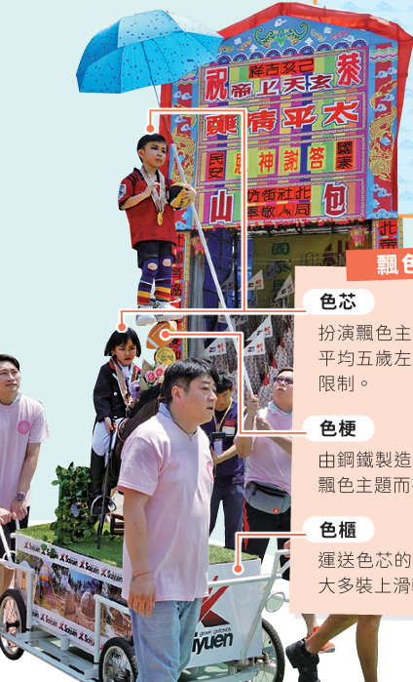
色櫃
運送色芯的流動舞台，大多裝上滑輪，節省人力。
色芯
扮演飄色主角的小童，他們平均五歲左右，體重亦有所限制。
色梗
由鋼鐵製造的支撐裝置，按主題而有不同的造型。

3 Sequence of major rituals

3.1 Worship activities

- On the 5th day of the fourth lunar month, Cheung Chau residents would head to the Yuk Hui Temple and other temples to invite the statues of Pak Tai, Tin Hau and other deities to the deity shed so that worshippers can make offerings. Performances of opera for appeasing the deities begin that night to entertain the deities and locals.
- Starting from the 6th day of the fourth lunar month, locals fast for 3 days.

3.2 Carnival parade of floats

- On the 8th day of the fourth lunar month (the actual day of the Jiao Festival), Cheung Chau residents and local groups send out more than a dozen floats, along with dancing lion and unicorn teams, to participate the Carnival parade of floats. Led by the deity statues from different temples in Cheung Chau, the parade proceeds along the main streets.
- Characters such as traditional deities, historical and modern figures in addition to uniformed groups are portrayed.
Structure of floats
Coloured cores (色芯)
Children who portray float characters are usually at the age of 5 and subject to weight limit.
Coloured cabinets (色櫃)
They are mobile stages to move coloured cores, most of them are installed with pulleys to save manpower.
Coloured stems (色梗)
They are supporting structures made of steel. They have different designs in accordance with themes.

3.3 祭幽

居民會預備齋菜讓幽魂享用。晚上，居民會把大士王火化，寓意幽魂離開陽間。

3.4 搶包山

- 農曆四月初九（即踏入午夜十二時），便會進行搶包山比賽。
- 2005 年，活動在政府支持下得以復辦，但形式改為包山嘉年華。

4 文化及社會價值

4.1 加強社區凝聚力

長洲太平清醮一直是當地居民最重視的節慶活動。居民組織不同隊伍參加各個活動，有助增強長洲人的凝聚力。

4.2 展現多姿多彩的民間工藝

長洲太平清醮中的紙紮神像、飄色、平安包等，都由人手製作而成，充分展現民間的傳統工藝。而不同宗教儀式和舞麒麟等活動，也體現了豐富的民間表演藝術。

4.3 成為本地及世界知名盛事

每年，飄色會景巡遊和搶包山比賽都會吸引大量本地及海外旅客參加，不但是香港政府積極推廣的傳統節慶活動，更成為世界知名的盛事。

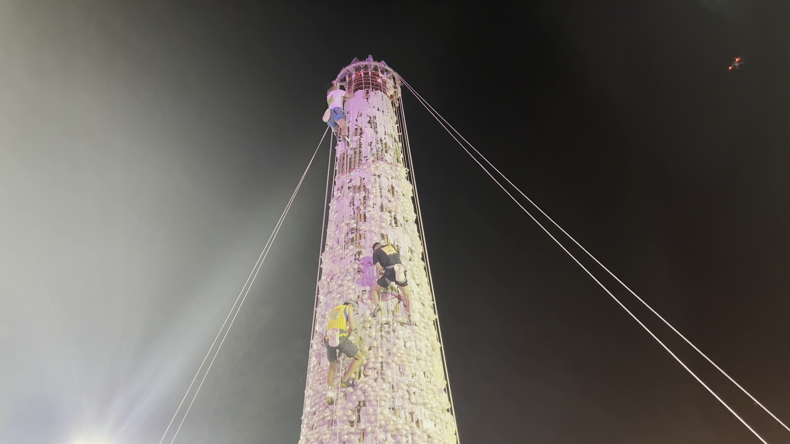
在搶包山決賽中，一眾健兒競相爬上包山爭奪平安包。

3.3 Giving offerings to wandering ghosts

Residents prepare a vegetarian feast to feed departed souls. On the evening of that day, local residents burn the Ghost King, symbolising that all wandering spirits have left the living world.

3.4 Bun scrambling

- On the 9th day of the fourth lunar month, the competition begins right at 12 midnight.
- From 2005 onwards, the event has resumed in the form of the Bun Carnival under the support of the government.

4 Cultural and social value

4.1 Enhancing community cohesion

The Cheung Chau Jiao Festival has always been the most important local festive event. residents form teams to participate in various activities, strengthening the cohesion among Cheung Chau locals.

4.2 Showcasing a variety of traditional craftsmanship

All paper statues, floats and lucky buns used in the Cheung Chau Jiao Festival are all made by hand, showcasing traditional craftsmanship. Various religious rituals, along with activities such as the unicorn dance, also displayed the diverse performance arts.

Becoming a local and world-famous mega event

The carnival parade of floats and the bun scrambling competition attract many local and overseas tourists every year. The Jiao Festival is not only a traditional festive celebration promoted by the Hong Kong government, but also a world-known mega event.
In the bun scrambling final, participants climb the bun tower to collect lucky buns.

ii. 大澳端午龍舟遊涌

1 習俗源起

居民請出四間廟宇的神像，包括侯王、天后、關帝和洪聖，安放在神艇上，他們以龍舟拖行神艇，巡遊主要水道，祈求驅除瘟疫。

2 舉行地點

儀式分開兩天在大澳舉行。居民於第一天（農曆五月初四）會到廟宇迎請神明，而第二天（農曆五月初五）則會在大澳水道進行遊涌活動。

3 主要儀式程序

3.1 採青

農曆五月初四，合心堂和鮮魚行的成員把龍舟划到楊侯古廟後的荒地，進行「採青」儀式，寓意為龍舟注入生氣。

3.2 喝龍

返回「龍躉」（即臨時神棚）後，便會舉行「喝龍」儀式。他們把雞血和酒混合，灑在整個龍舟上，以潔淨龍舟。

  - 接神

合心堂和鮮魚行的隊伍會到楊侯古廟、新村天后古廟、關帝廟和洪聖廟迎接神明。

ii. Tai O Dragon Boat Water Parade

1 Origin

Residents took the statues of Hau Wong, Tin Hau, Kwan Tai and Hung Shing out of the four local temples and placed them on the sacred sampans. They were towed by the dragon boats to parade along the main waterways, for the purposes of driving away and praying for peace and safety.

2 Location

The rituals are held in Tai O for 2 days. Residents head to the temples to receive the deities on the first day (the 4th day of the fifth lunar month). The water parade takes place on the second day (the 5th day of the fifth lunar month) along Tai O's waterways.

3 Sequence of major rituals

3.1 Picking the greens

On the 4th day of the fifth lunar month, members of Hap Sum Tong and Sin Yu Hong row the dragon boats to the land behind the Yeung Hau Temple to perform the ‘picking the greens’ ceremony, putting liveliness inside the dragon boats.

3.2 Drinking dragon

After returning to the ‘dragon bases’ (the temporary deity sheds), residents perform the ‘drinking dragon’ ceremony. They sprinkle wine mixed with rooster blood on the dragon boats for cleansing.

  - Receiving the deities

The teams of Hap Sum Tong and Sin Yu Hong will go to the Yeung Hau Temple, the Tin Hau Temple, the Kwan Tai Temple and the Hung Shing Temple, to receive the deities.

3.4 遊涌

- 遊涌隊伍由歷史最悠久的扒艇行先行，其次是鮮魚行和合心堂。首先，他們會從楊侯古廟出發，然後繞到新村天后古廟，最後經過關帝廟。
- 各隊在龍舟和神艇上插滿旗幟。神艇上的人沿途會化衣紙和撒水飯，藉以祭祀水中孤魂。與此同時，沿岸棚屋的居民也會焚燒元寶，祈求消災解難。
遊涌活動中各漁業行會的服裝顏色
扒艇行 | 鮮魚行 | 合心堂


大澳龍舟遊涌路線圖
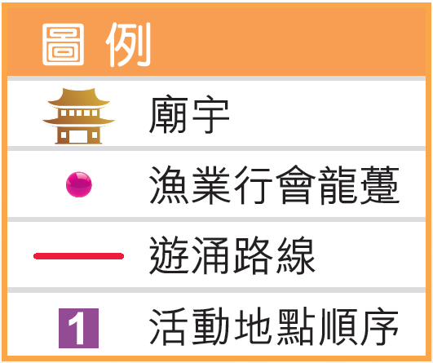
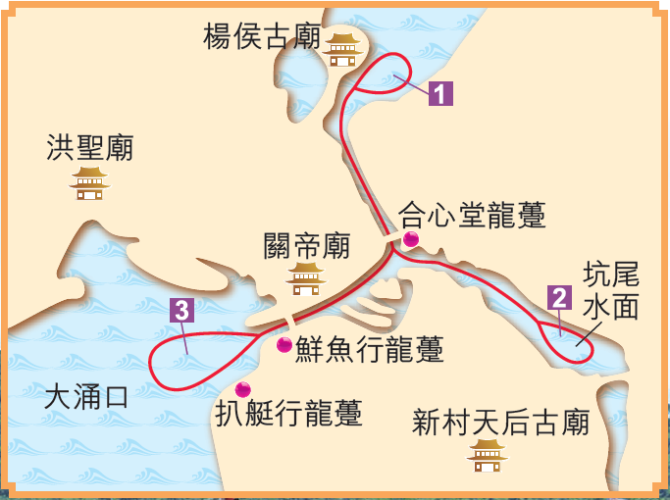

  - 龍舟競渡

遊涌活動結束後，三個漁業行會進行龍舟競渡，供神明觀賞。

  - Water parade

- Pa Teng Hong, which has the longest history, leads the parade, followed by Sin Yu Hong and Hap Sam Tong. They set out from the Yeung Hau Temple, then proceed to the Tin Hau Temple and lastly sail by the Kwan Tai Temple.
- The teams insert flags all over the dragon boats and the sacred sampans. People on the sacred sampans keep burning paper offerings and throwing watery rice to pacify water ghosts. At the same time, residents of the stilt houses along the coast also burn paper offerings in hope of removing misfortunes.
Uniform colour of each fishery organisation in the water parade
Pa Teng Hong | Sin Yu Hong | Hap Sam Tong

Route of the Tai O Dragon Boat Water Parade
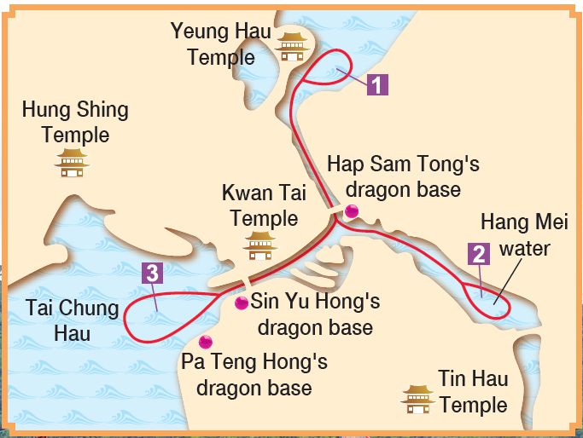
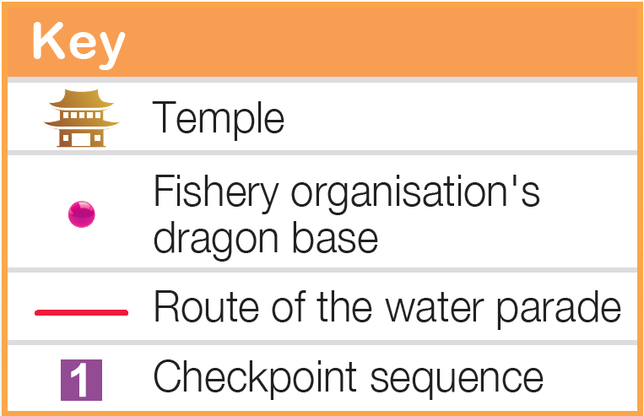

  - Dragon boat race

After the parade, the three fishery associations hold a dragon boat race to entertain the deities.

3.6 送神

最後，漁業行會將神像逐一送回廟宇。到達楊侯古廟時，負責人會以擲杯形式，詢問神明是否滿意活動。晚上，各行會成員舉行聚餐，慶祝端午節。

4 文化及社會價值

4.1 保留獨有的傳統習俗

大澳端午龍舟遊涌是一個歷史悠久，而且極具本土特色的節慶活動。通過保留這些習俗，有助市民和遊客認識大澳獨有的水鄉文化。

4.2 團結社區

- 大澳端午龍舟遊涌由區內多個團體共同舉辦，成功凝聚大澳的漁業和民間組織。
- 此外，不少已移居市區的原居民每年也會返回大澳參加遊涌活動，使活動成為維繫大澳居民關係的大型聚會。

遊涌傳統知多點
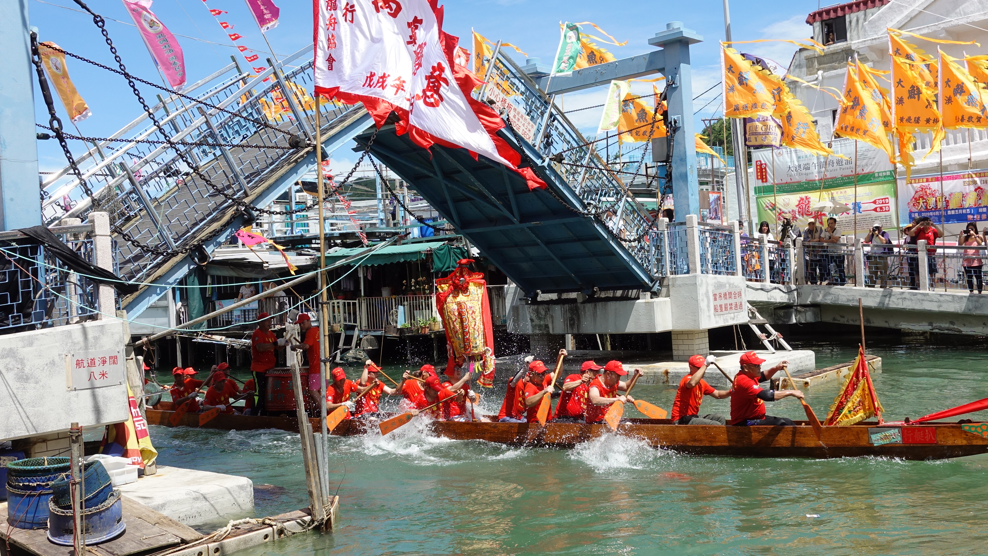
禁止女性坐船。
棚屋不能被龍舟及神艇觸碰。
假若漁業行會成員家中有白事，他在一個月內不得參加遊涌活動。
懷孕的婦女不能觀看龍舟和神艇。
當龍舟和神艇經過小橋時，所有人不可留在橋上，工作人員也會把橋樑升起，避免對神明不敬。

3.6 Sending off the deities

Finally, the fishery associations return the deity statues to the respective temples. When arriving at the Yeung Hau Temple, organisers ask the deities if they are satisfied with the event by throwing moon blocks. Everyone then gather for dinner that evening to celebrate the Tuen Ng Festival.

4 Cultural and social value

4.1 Preserving unique traditional customs

Having a long history, the Tai O Dragon Boat Water Parade is a festive event with distinctive local features. Preserving these traditional customs help citizens and tourists to know more about the unique culture of Tai O fishing village.

4.2 Uniting the community

- Jointly held by various local groups, the Tai O Dragon Boat Water Parade successfully brings together the fishery and community organisations in Tai O.
- Many former residents would return to Tai O to participate in the water parade every year. The event has thus become a large-scale gathering that maintains the relations among Tai O residents.

Know more about the water parade traditions
Pregnant women cannot make eye contact with the dragon boats and the sacred sampans.
No one can stay on bridges when the dragon boats and the sacred sampans pass through. Staff members also lift up all bridges to avoid being disrespectful towards the deities.
Females are not allowed to get on board.
Stilt houses cannot be hit by the dragon boats and the sacred sampans.
No one from the fishery associations can participate in the water parade if he has lost any family member in the last one month.

iii. 中秋節—大坑舞火龍

源自廣東的傳統習俗，每逢中秋節均會舉行，為期三晚（農曆八月十四至十六）。

1 習俗源起

村民按照神明的指示，在中秋節前後三晚，在大坑舞動火龍，並燃燒鞭炮。瘟疫後來果然消除了。

2 舉行地點

大坑舞火龍在港島大坑區內舉行，由大坑坊眾福利會主辦。

3 主要儀式程序

3.1 紮作火龍

中秋節前一個月，師傅們便要開始紮作火龍。火龍以珍珠草和鐵線紮作。火龍製作的技術以口傳形式相傳。

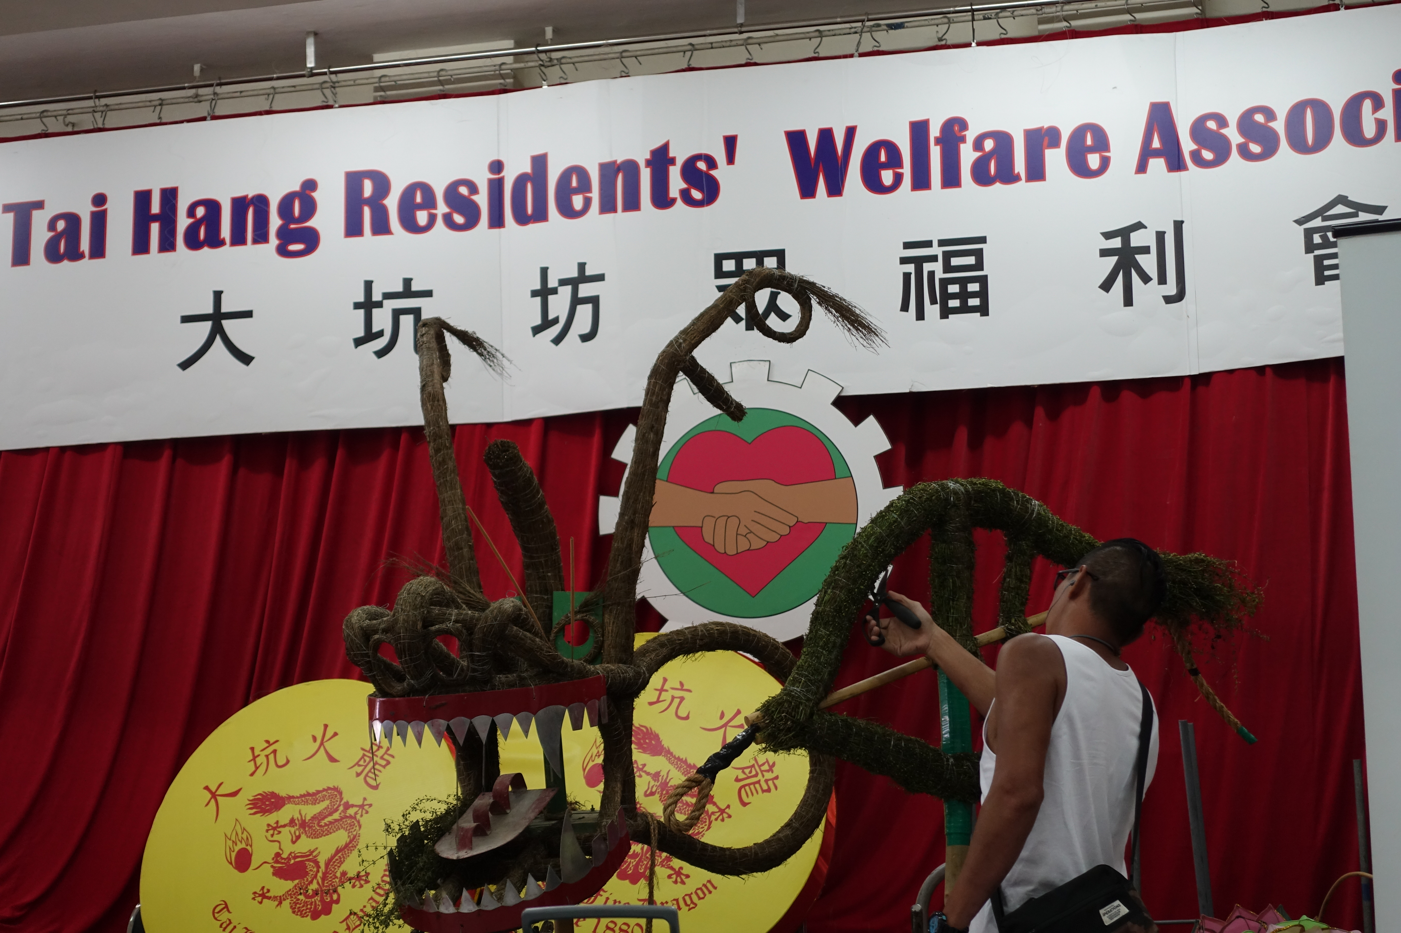正在紮作火龍的師傅

3.2 開光和起龍

- 農曆八月十四晚上，福利會成員到大坑的蓮花宮，為草龍點晴開光。
- 接着，他們便在草龍上插香。經過「起龍」儀式後，火龍便正式開始舞動了。

iii. Mid-Autumn Festival—Tai Hang Fire Dragon Dance

A traditional originating in Guangdong, and it is performed during the annual Mid-Autumn Festival for 3 nights (from the 14th to 16th nights of the eighth lunar month).

Origin

Doing as they were told, villagers performed fire dragon dance and set off firecrackers in Tai Hang during the three days of the Mid-Autumn Festival. As a result, the plague came to an end.

2 Location

Organised by the Tai Hang Residents' Welfare Association, the Tai Hang Fire Dragon Dance is held in Tai Hang on Hong Kong Island.

3 Sequence of major rituals
  - Crafting the fire dragon

Craftsmen begin to make the fire dragon a month before the Mid-Autumn Festival. The fire dragon is made of pearl grass and iron wires. The technique of fire dragon-making is passed down verbally.

The craftsmen crafting the fire dragon

  - Enshrinement and raising the dragon

- On the evening of the 14th day of the eighth lunar month, members of the Welfare Association head to the Lin Fa Temple in Tai Hang to enshrine the dragon by dotting its eyes.
- They then insert incense sticks all over the dragon. After the ceremony to raise the dragon, the dance of fire dragon starts.

3.3 舞動火龍

火龍須由三十六人同時合力舞動，全晚須動員超過三百人。
大坑舞火龍路線圖
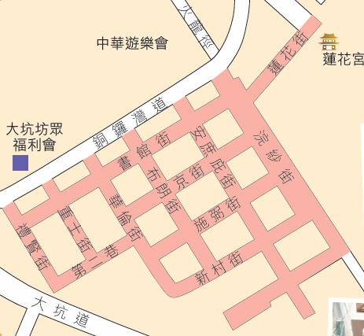
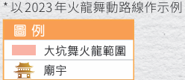

  - 遊大運和龍歸天

- 在最後一晚火龍完成巡遊後，便會循逆時針方向再次巡遊一周，稱為「遊大運」。
- 然後，火龍便會被送到銅鑼灣避風塘。經過拜祭後，各人會把火龍和花燈等一起拋下海，稱為「龍歸天」。這寓意把不吉利的東西帶走，使區內平安。

  - Fire dragon parade

The fire dragon needs to be held by 36 men at the same time. Over 300 men are required for each night.
Route of the Tai Hang Fire Dragon Dance
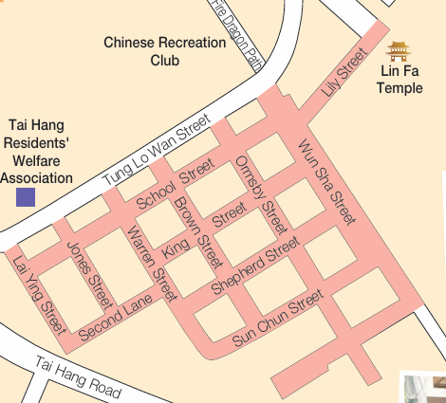
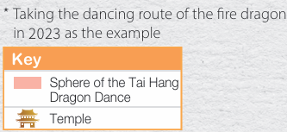

  - Lucky circle and dragon returning to Heaven

- After the parade on the last night, the fire dragon would proceed along the streets again in an anti-clockwise direction. This is called the ‘lucky circle’.
- Then, staff members take the fire dragon to the Causeway Bay Typhoon Shelter. After a worshipping ceremony, they throw the fire dragon into the sea along with lanterns. The ritual is called ‘dragon returning to Heaven’, symbolising the removal of misfortune and the blessings for peace in the community.

大坑舞火龍解構
龍身：全長220呎，分為32節，每節由一人以竹杆豎起舞動。
龍頭：重約45公斤，須由8-10名健兒輪流舞動。
龍珠：共有兩顆，在沙田柚上插滿香枝，用以引領火龍前進。
健兒：每年約有300人參與，主要由現在或曾經居於大坑的男性居民組成。
龍尾：以藤枝紮成葉的形狀，再包上珍珠草。

4 文化及社會價值

4.1 加強社區歸屬感

大坑區內的年度盛事，居民透過合力籌辦活動， 加強他們對社區的歸屬感。

4.2 傳承火龍文化

大坑舞火龍活動至今已有百多年歷史，居民一直保留着火龍紮作工藝及各種傳統儀式。

Breaking down the Tai Hang Fire Dragon Dance
Body: It has a total length of 220 feet and consists of 32 segments. Each segment is supported by a bamboo pole held by a staff member.
Head: It weighs about 45 kilograms, requiring 8 -10 staff members to move it.
Pearls: A pair of Chinese grapefruits with incense sticks is used for guiding the fire dragon.
Staff members：About 300 men participate each year. They are mostly current or former male residents of Tai Hang.
Tail：The leaf-shaped tail is made of rattan stems wrapped in pearl grass.

4 Cultural and social value

4.1 Strengthening the sense of community belonging

The Tai Hang Fire Dragon Dance is the annual mega event in the community of Tai Hang. Residents have joined forces to organise the event, strengthening their sense of belonging to the community.

4.2 Carrying on the culture of fire dragon

The Tai Hang Fire Dragon Dance had a history of over 100 years. Residents have preserved the technique of fire dragon-making and traditional rituals.

IV 香港潮人盂蘭勝會

- 人們多在每年農曆七月超渡孤魂，並拜祭祖先。
- 一般為期三天。

1 習俗源起

- 每逢農曆七月，潮州男性會按照故鄉的傳統，進行拜祭，既超渡逝世的同鄉，同時拜祭神靈祖先，希望得到庇佑。
- 根據記載，潮州公和堂在1897年舉辦了香港首個盂蘭勝會。

2 舉行地點

- 於公園或球場舉辦。場地搭建多個棚架，以供奉神明和超渡幽魂。
- 會場內擺滿神像和祭品，還會展出潮州民間藝術，供潮州同鄉聚會。
潮人盂蘭勝會場地佈置示意圖
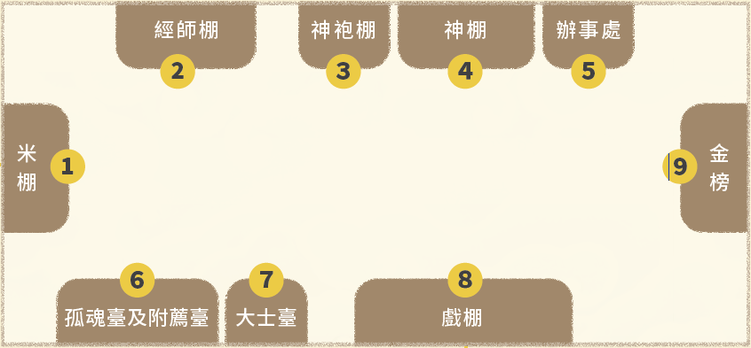
1 | 擺放白米和其他用作祭品的食物
2 | 供經師誦經和進行法事
3 | 放置神明穿着的衣服，以及紙紮祭品
4 | 用來安放神像和拜祭神靈
5 | 接待善信和接受捐助香油的地方
6 | 孤魂臺放置孤魂神主牌，附薦臺用作超渡過世的祖先或朋友
7 | 擺放管理孤魂野鬼的大士王
8 | 上演神功戲的地方
9 | 公布善信捐贈善款和福品的告示

IV Yu Lan Festival of the Hong Kong Chiu Chow community

- People would comfort wandering ghosts and worship their ancestors in the seventh lunar month.
- It generally lasts for 3 days.

1 Origin

- Observing their tradition at home, Chiu Chow men would perform rituals in the seventh lunar month every year to comfort the souls of their fellow natives from Chiu Chow who had passed away, as well as worshipping the deities and their ancestors to seek blessings.
- According to records, the first Yu Lan Festival in Hong Kong was held by the Chiu Chow Kung Wo Tong in 1897.

2 Location

- It is held in parks or playgrounds. A number of sheds are set up at the venue for worshipping the deities and comforting wandering ghosts.
- In addition to the deity statues and offerings, various Chiu Chow folk arts are also on display. The Chiu Chow people would come out to meet each other at the venue.
Venue setup of the Yu Lan Festival of the Chiu Chow community
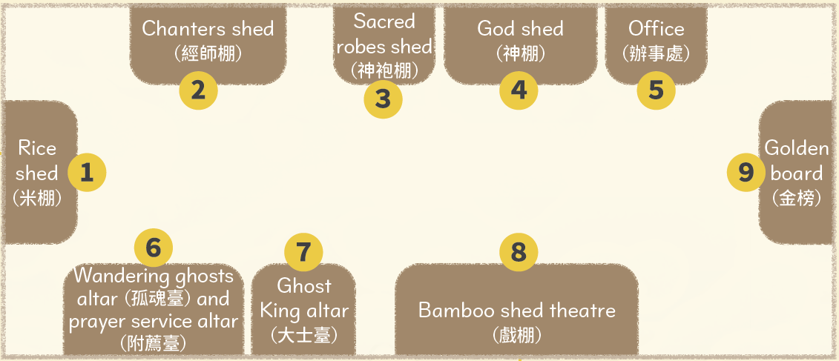
1 | Stores rice and food offerings.
2 | Chanters perform the chanting and other rituals.
3 | Displays the costumes of the deities and paper offerings.
4 | Placing the deity statues and worshipping the deities.
5 | Receiving believers and accepting donations.
6 | The wandering ghost altar places the soul tablets of wandering ghosts. The prayer service altar is for the purpose of comforting the deceased ancestors and friends.
7 | Placing the Ghost King, the deity responsible for managing wandering ghosts.
8 | Performing opera for appeasing the deities.
9 | Records the funds and auspicious items donated by believers

3 主要儀式程序
  - 請神、遊神

第一天的上午，盂蘭勝會組織先進行請神儀式，前往區內廟宇接請代表神明的香爐。隊伍返回會場前，會經過區內的主要地點，稱為「遊神」，象徵淨化社區。

  - 召大士、召孤魂

第一天的下午，由經師誦讀經文，先邀請大士王到達會場，繼而召喚孤魂野鬼，目的是由大士王鎮壓孤魂，不讓它們作亂。

  - 公演神功戲

盂蘭勝會期間的晚上，會由戲班在戲棚出演潮劇神功戲，既供神明欣賞以酬謝神恩，又可娛樂大眾，成為潮籍人士的聯誼活動。

3.4 放焰口

- 第三天下午，經師誦經後會向壇外撒出孤蕾粿和大米，象徵讓孤魂得以飽食。
- 善信會爭奪孤蕾粿，認為吃下可保平安。

3.5 化大士王

工作人員會火化大士王和其他紙紮祭品，藉以恭送大士王及孤魂離開陽間。

3.6 派平安米

所有儀式完成後，工作人員會把祭祀的白米和食品，分發給輪候的市民，寓意救助貧苦大眾，以及為先人積福。

3 Sequence of major rituals

3.1 Inviting and parading the deities

On the morning of the first day, the Yu Lan organisation invites the deities. They head to the temples in the community to take out the incenses burners symbolising the deities. Before returning to the venue, staff members parade the incenses burners through the main sites in the community. This ritual, called ‘parading the deities’, is meant to cleanse the community.

3.2 Summoning the Ghost King and wandering ghosts

On the afternoon of the first day, chanters perform the chanting to invite the Ghost King first and then summon wandering ghosts. The presence of the Ghost King can suppress wandering souls, preventing them from causing chaos.

  - Performances of opera for appeasing the deities

On every evening during the Yu Lan Festival, Chiu Chow opera is performed in the bamboo shed theatre to express gratitude to the deities and entertain the public. This also serves as a gathering for the Chiu Chow people.

3.4 Liberating the flaming mouths

- On the afternoon of the third day, chanters perform the chanting and then throw gulei dumplings along with rice out of the shed, feeding wandering souls.
- Believers also scramble for gulei dumplings as they believe that eating them would bring peace and safety.

3.5 Burning the Ghost King

After liberating the flaming mouths, staff members burn the Ghost King and other paper offerings. This is meant to send off the Ghost King and wandering ghosts out of the living world.

3.6 Distribution of blessed rice

After finishing all the rituals, staff members hand out rice and food offerings to the queuing public. This serves as a form of poor relief and a way to gain blessings for ancestors.

4 文化及社會價值

4.1 傳承中華傳統美德

盂蘭勝會保留了傳統的祭祀文化，在祭祀祖先時宣揚孝道，超渡孤魂時教人行善和發揮同情心。而派發平安米也能幫助有需要的人們，具慈善功能。

4.2 維繫潮籍人士與社區街坊的關係

盂蘭勝會由各區潮籍人士團體舉辦，至今已有過百年歷史，成為潮籍人士與社區街坊聯誼的活動。

4 Social and cultural value

4.1 Carrying on Chinese traditional virtues

The Yu Lan Festival has preserved the traditional culture of worship. Not only does it promote filial piety during ancestral worship, but it also teaches people to do good deeds and show sympathy when comforting wandering ghosts. In addition, the distribution of blessed rice helps people in need, serving as a charitable activity.

4.2 Maintaining the relations between the Chiu Chow people and community residents

Having a history of over 100 years, the Yu Lan Festival has been held by the Chiu Chow organisations in different districts. It has become a social event for the Chiu Chow people and community residents.

重點練習
1. 根據課文內容，完成下列各題文字。
(a) 無形的文化遺產稱為「___非物質文化遺產___」，包括傳統習俗和節日、歌曲、工藝技術等。
(b) 2014 年6 月，香港政府正式對外公布 ___香港非物質文化遺產___ 清單，作為相關保護措施的基礎。
(c) 截至2024 年，香港有十二個非遺項目被列入國家級非遺代表性項目名錄，充分反映香港的風俗文化和傳統。當中的 ___長洲太平清醮___、 ___大澳端午龍舟遊涌___、 ___中秋節—大坑舞火龍___ 和 ___香港潮人盂蘭勝會___ ，均與 ___驅除瘟疫___ 和 ___超渡亡靈___ 有關。
(d) 每年農曆四月 ___初五___ 至 ___初九___，___長洲___ 居民都會舉行為期 ___五___ 天的太平清醮。
(e) 遊涌活動由大澳三個漁業行會聯合舉辦，分別是 ___扒艇行___、 ___鮮魚行___和 ___合心堂___ 。
(f) 大坑舞火龍活動由 ___大坑坊眾福利會___ 主辦。由 ___紮作___ 火龍到徵集壯丁 ___舞動___ 火龍，都需要大量人力和物力。
(g) 根據記載， ___潮州公和堂___ 在1897年舉辦了香港首個盂蘭勝會。

2. 試選擇適當答案，並將其英文代號填入方格內。
(a) 以下哪項不是長洲太平清醮的習俗特色？
A. 神功戲演出 B. 搶火龍
C. 飄色會景巡遊 D. 祭幽儀式
B
Key Exercises
1. Fill in the blanks according to the textbook content.
(a) Non-physical cultural heritage is called ___Intangible cultural heritage___, including traditional customs, festivals, songs, techniques, etc.
(b) In June 2014, it released the ___Intangible Cultural Heritage Inventory of Hong Kong ___ as the basis for the safeguarding measures to be taken.
(c) As at 2024, 12 Hong Kong ICH items have been inscribed onto the national list of ICH, reflecting the customs and cultural traditions of Hong Kong. Among them the ___Cheung Chau Jiao Festival___, ___Tai Hang Fire Dragon Dance___, ___Chiu Chow Yu Lan Ghost Festival___ and ___Tai O Dragon Boat Water Parade___ in the third batch of ___national intangible cultural heritage___ are related to driving away plagues and comforting ghosts.
(d) From the 5th to 9th days of the fourth lunar month every year, ___Cheung Chau___ residents celebrate the Cheung Chau Jiao Festival for ___five___ days.
(e) The Dragon Boat Water Parade is now co-organised by 3 fishery associations, namely ___Pa Teng Hong___, ___Sin Yu Hong___ and ___Hap Sam Tong___,
(f) The Tai Hang Fire Dragon Dance is held by the ___Tai Hang Residents' Welfare Association___. Works including ___crafting___ the fire dragon and ___waving___ it, require lots of manpower and resources.
(g) According to records, the first Yu Lan Festival in Hong Kong was held by ___Chiu Chow Kung Wo Tong___ in 1897.

2. Choose the appropriate answer and put it in the corresponding box.
(a) Which of the following is not a characteristic of the Cheung Chau Jiao Festival?
A. Opera for appeasing the deities B. Fire dragon scrambling
C. Carnival parade D. Spirit assuaging ceremony
B
(b) 以下哪項是潮人盂蘭勝會分發平安米的寓意？
A. 答謝神明 B. 消災解難
D
C. 超渡孤魂 D. 為先人積福

(c) 大澳端午龍舟遊涌的最後環節是甚麼？
A. 採青 B. 請神
C
C. 送神 D. 喝龍

(b) Which of the following is the purpose of distributing ‘blessed rice in the Yu Lan Festival?
A. thanksgiving to deity B. relieving disasters
D
C. releasing the souls of the dead D. gaining merit for the ancestors

(c) What is the last part of the Tai O Dragon Boat Water Parade?
A. picking the greens B. inviting the deities
C
C. sending off the deities D. drinking dragon

