課題5 近代歐洲的興起
I 從神本走向人本：文藝復興與宗教改革

關鍵詞
文藝復興 | Renaissance
美第奇家族 | Medici family
人文主義 | Humanism
但丁 | Dante
莎士比亞 | William Shakespeare
達文西 | Leonardo da Vinci
馬丁路德 | Martin Luther
宗教改革 | Reformation
贖罪券 | Indulgence
《九十五點論證》 | Ninety-Five Theses
基督新教 | Protestantism
路德教派 | Lutheranism
卡爾文教派 | Calvinism
聖公會 | Anglican Church

溫習要點

A 文藝復興

- 一場發生於14-17世紀的文化革新運動。
- 文藝復興的原意為「恢復」或「重生」，即復興古希臘、古羅馬文明。
- 同時，人們亦在古典文明上加以創新。

Topic 5 The rise of modern Europe
I From God-centred to human-centred: the Renaissance and the Reformation

Key Terms
文藝復興 | Renaissance
美第奇家族 | Medici family
人文主義 | Humanism
但丁 | Dante
莎士比亞 | William Shakespeare
達文西 | Leonardo da Vinci
馬丁路德 | Martin Luther
宗教改革 | Reformation
贖罪券 | Indulgence
《九十五點論證》 | Ninety-Five Theses
基督新教 | Protestantism
路德教派 | Lutheranism
卡爾文教派 | Calvinism
聖公會 | Anglican Church

Revision Points

A Renaissance

- A cultural movement took place between the 14th and 17th centuries.
- The Renaissance originally means ‘recovery’ or ‘rebirth’, referring to the revival of ancient Greek and ancient Roman civilisations.
- Meanwhile, people also reinvented classical civilisation on their own.

i. 文藝復興出現的背景

- 歐洲封建社會開始衰落，教會影響力日弱。
- 農民離開莊園，到自治城市定居。許多大學興起，人們開始研習新興的實用科學。
- 伊斯蘭文明逐漸傳入歐洲，帶來新知識。

ii. 文藝復興發源於意大利的原因
1 海外貿易發達

- 11-13世紀，多次十字軍東征，大大促進了東、西方之間的貿易發展。
- 意大利位處歐洲大陸的中心，其沿海城市如威尼斯、熱那亞和佛羅倫斯等的商業貿易十分繁盛。
- 富裕的經濟生活為學術研究和文藝創作，提供了理想的物質條件。

14世紀意大利貿易路線圖
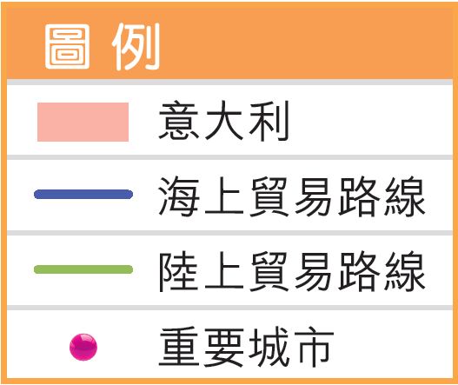
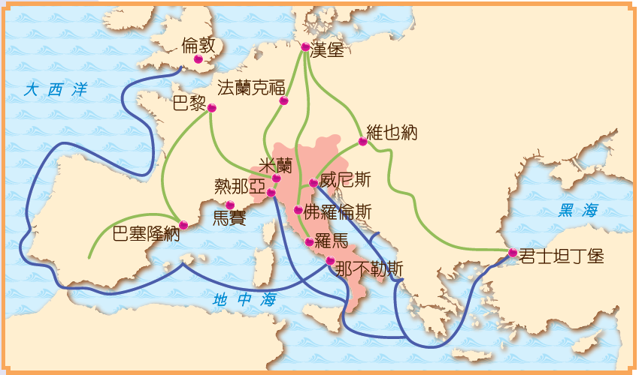

2 富商資助

在佛羅倫斯的美第奇家族的支持下，佛羅倫斯一度成為意大利文藝復興的中心。

i. Background of the Renaissance

- The feudal society in Europe started to decline. The influence of the Church became weaker.
- Many serfs fled from manors to autonomous cities. People began to study practical science.
- Islamic civilisation gradually spread in Europe, bringing new knowledge

ii. Reasons for Italy being the birthplace of the Renaissance
1 Prosperous overseas trade

- Between the 11th and 13th centuries, a series of Crusades greatly enhanced the development of trade between the East and the West.
- As Italy was located in the centre of Europe, its coastal cities such as Venice, Genoa and Florence flourished in commerce.
- Wealthy economic lives provided an ideal condition for intellectual studies and art creations.

Italian trade routes in the 14th century 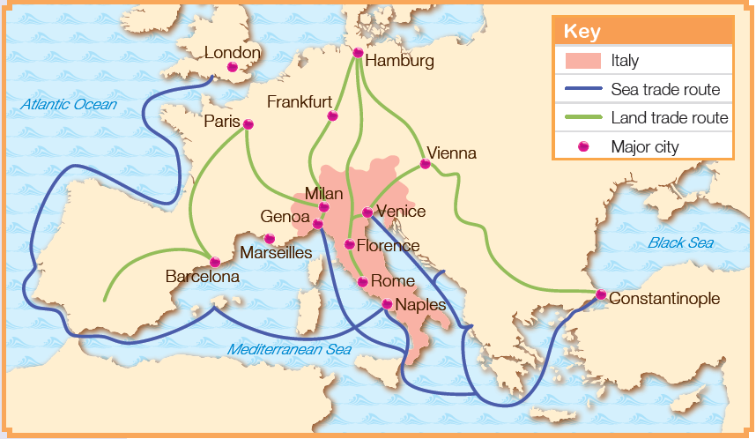

2 Funds from rich merchants

With the support of the Medici family in Florence., Florence had once become the centre of the Renaissance in Italy.
文藝復興的推動者——美第奇家族
坐擁15世紀歐洲最大銀行
- 遍及全歐洲
- 財產而被稱為「上帝的銀行」
15-18世紀意大利的名門望族
- 地位顯赫，曾出過3位教皇、2位法國王后
- 統治佛羅倫斯長達近3個世紀
美第奇家族紋章

最活躍的藝術贊助者
- 曾資助達文西、米開蘭基羅、拉斐爾、伽利略等
- 資助興建聖母百花大教堂、烏菲茲美術館等著名建築

3 城市享有自治

中古時代後期，意大利城市的富商透過繳納金錢，從貴族領主手中取得城市自治權。因此，意大利人在思想上較少受限制，傾向自由，敢於創新。

Promoter of the Renaissance——Medici family
Upholding the largest bank in 15th-century Europe
- Bank branches spreading over Europe
- Taking care of the Pope's fortune and being called the God's Bank
One of the greatest and most influential families in Italy between the 15th and 18th centuries
- Family members including 3 Popes and 2 French queens
- Ruling Florence for nearly 3 centuries
Coat of arms of the Medici family

Most active sponsor of art
- Sponsoring Leonardo da Vinci, Michelangelo, Raphael, Galileo Galilei, etc
- Sponsoring the construction projects of famous buildings such as the Cathedral of Saint Mary of the Flower and the Uffizi Gallery

3 Autonomy of cities

In the late Medieval Times, Italian rich merchants paid the feudal lords to get charters of autonomy for their cities. Therefore, the Italian people were less restricted in their thinking. They had more freedom and were more open to new ideas.

4 古典文明的文化遺產

- 意大利是繼承古希臘、古羅馬文明之故鄉，有着豐富的歷史遺蹟和遺物。
- 1453年東羅馬帝國滅亡後，大批學者逃亡到意大利，掀起研究古典文明的新熱潮。

iii. 文藝復興的特徵
1 重視人文主義

- 以人為中心的世界觀。它尊重人的價值，主張人是完美和多才多藝的。
- 當時的藝術作品題材注重表現人的思想和感情。
- 文藝復興時期的畫作生動寫實，與中古時代的藝術風格形成鮮明對比。

文藝復興三傑
達文西  留下《蒙娜麗莎》等多幅不朽畫作，並在科學方面有傑出成就。 | 米開蘭基羅  傑出的畫家、雕刻家、詩人和建築師。他耗時四年多，繪畫宏大的西斯汀大教堂屋頂壁畫。 | 拉斐爾  以繪畫聖母像而馳名的畫家，曾獲教皇邀請繪畫梵蒂岡的壁畫。
4 Cultural heritage of classical civilisation

- Italy was the successor to ancient Greek and ancient Roman civilisations. It had many historical sites and artifacts.
- After the fall of the Eastern Roman Empire in 1453, a lot of scholars fled to Italy and gave rise to the trend of studying classical civilisation.

iii. Feature of the Renaissance
1 Emphasising humanism

- A worldview with humans as the centre. It respected the value of human beings as perfect and all-rounded individuals.
- The themes of the artworks at that time emphasised the thoughts and feelings of individuals.
- The style of Renaissance painting was lively and realistic, standing in sharp contrast to that of medieval artworks.

Three great masters of the Renaissance
Leonardo da Vinci  He left many timeless artworks like Mona Lisa and made significant scientific contributions. | Michelangelo  A great painter, sculptor, poet and architect. He spent more than 4 years to complete the grand celling paintings of the Sistine Chapel. | Raphael  A painter famous for his artworks depicting the mother of Jesus. He was invited by the Pope to create wall paintings in Vatican City.

2 復興古典

文藝復興時期的思想家、藝術家從事文藝創作時，都以發揚古典文明為號召，在學習古希臘、古羅馬文明之外，也加入具有新時代特色的內涵。
除了仿傚古希臘、古羅馬的藝術外，也創造了很多新式建築。
中古時代與文藝復興的建築
 | 中古時代 | 文藝復興
拱門 | 尖形拱門 | 古羅馬或拱門
屋頂 | 高高的尖塔 | 圓屋頂
花窗 | 彩色玻璃鑲成花窗 | 沒有
圓柱 | 沒有 | 有

建築

古希臘、古羅馬時代所盛行的獨立性雕像再次成為主流。
雕刻

3 提倡個人奮鬥

鼓勵個人奮鬥，提倡言論和創作自由，反對各種不合理制度對人們思想的束縛。

2 Reviving classical civilisation

Renaissance thinkers and artists sought to carry forward classical civilisation through reinventing culture and the arts. While studying ancient Greek and ancient Roman civilisations, they also added new knowledge of their times.

Other than following ancient Greek and ancient Roman styles, Renaissance buildings also created many new features.
Medieval and Renaissance architectural styles
 | Medieval Times | Renaissance
Arch | Pointed arches | Ancient Roman-style arches
Roof | Tall pointed towers | Vaulting dome
Stained glass window | Colourful stained glass window | No
Column | No | Yes

Architecture

Sculpture

Free-standing statues, which had been popular in ancient Greek and ancient Roman times, became the mainstream again.

3 Promoting personal striving

Encouraged personal striving, emphasising individual freedom of speech and creativity. It also opposed control of unreasonable systems over human thoughts.

文藝復興的文學作品

塞萬提斯
代表作：
小説《唐吉訶德》
作品反映16-17世紀西班牙社會的黑暗，諷刺封建社會和騎士階級，同情民眾的困苦。

莎士比亞
代表作：
劇本《哈姆雷特》、《羅密歐與朱麗葉》、
《威尼斯商人》
作品反映了16世紀的社會黑暗面，並歌頌善良與正義，至今仍經常在世界各地的舞台上演出。

4 大膽懷疑

- 人們都勇於對舊制度、舊文化和舊觀念提出疑問。
- 不少科學家開始敢於挑戰教會對事物的定論，大膽提出一些全新的科學結論。

Renaissance literature

Miguel de Cervantes
Representative work:
Novel Don Quixote
This novel work reflected the dark side of Spanish society between the 16th and 17th centuries. It also criticised the feudal society and the knighthood and expressed sympathy to poor people.

William Shakespeare
Representative works:
Plays such as Hamlet, Romeo and Juliet and
The Merchant of Venice
His plays are still played on stages all around the world today, describing the dark side of 16th- century society and giving praises to kindness and righteousness

4 Daring to question

- People were brave enough to doubt the old systems, cultures and thoughts.
- Many scientists began to challenge the Church's explanation of how the world worked. They also raised new scientific theories.

iv. 文藝復興的影響
1 奠定歐洲近代文明基石

許多學者取得超越前人的成就，奠定西方近代文明的基石。
在巴黎羅浮宮展出的達爾文畫作《蒙娜麗莎》，現時仍吸引不少人前往觀賞。

2 促進宗教改革運動

- 人們對教會的權威產生懷疑，甚至大膽加以挑戰。
- 1517 年，德意志教士馬丁路德公然張貼抨擊教會的意見書，掀起了歐洲宗教改革運動的序幕。

3 推動新航路的開闢

- 個人奮鬥的精神，使人們積極投身航海冒險。
- 西歐的航海家開闢了東、西方之間的新航路，還發現美洲這片「新大陸」。

iv. Impact of the Renaissance
1 Laying the foundation for early modern European civilisation

Many scholars had greater achievements than their predecessors in various fields. This laid the foundation for the early modern civilisation of the West.
Mona Lisa by Leonardo remains on display in the Louvre of Paris nowadays.
It still attracts a great number of visitors.

2 Leading to the Reformation

- People started to doubt the authority of the Church and eagerly challenge it.
- In 1517, Martin Luther, a German monk, openly posted his ideas criticising the Church. This led to the rise of the Reformation in Europe.

3 Prompting the voyages of discovery

- The spirit of personal striving made people eager to sail across the sea.
- Navigators from Western Europe discovered new routes connecting the East and the West, and even the New World of the Americas.

4 展開科學革命

削弱了教會對文化、學術的控制，令人們漸漸培養出質疑、批判的精神，促使科學革命在16 世紀歐洲出現。

5 影響近代啟蒙運動

反傳統精神在歐洲各地傳播開來。至18 世紀，一場要求變革社會的啟蒙運動興起，主導了歐洲思想界的發展方向。

中古時代與文藝復興時期的思想比較
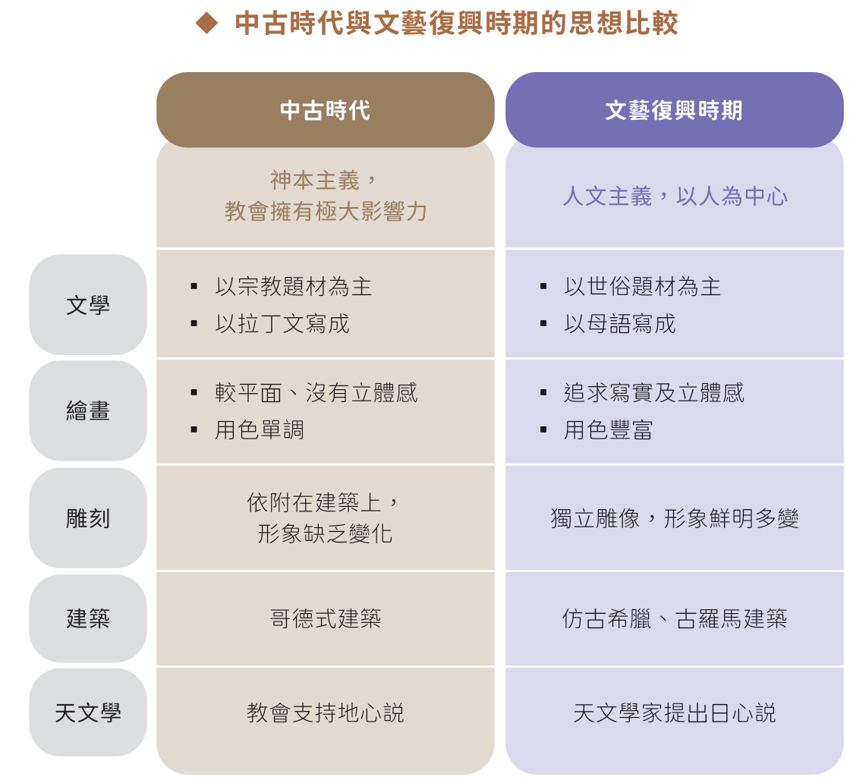

4 Leading to the Scientific Revolution

The Renaissance weakened the control of the Church over culture and knowledge. People gradually developed the spirit of questioning and criticising, leading to the emergence of the Scientific Revolution in 16th-century Europe.

5 Influencing the Enlightenment

The Renaissance promoted the spirit of anti-tradition, which spread throughout Europe. By the 18th century, there had been the Enlightenment calling for social transformations. This movement made clear the direction of intellectual development in Europe.

Comparison between Medieval thoughts and Renaissance thoughts
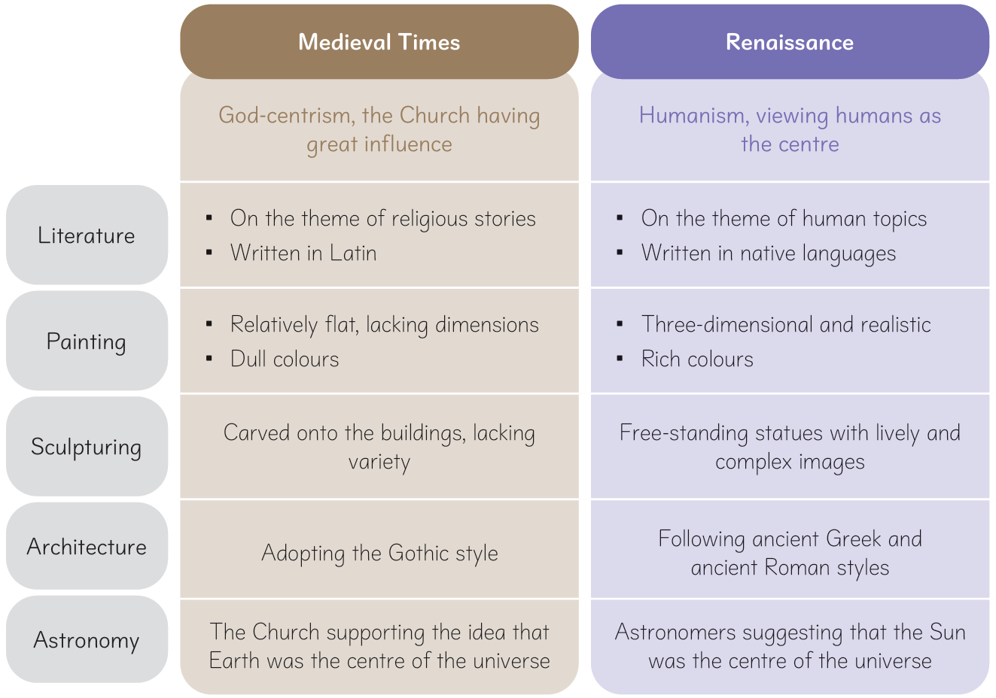

B 宗教改革

i. 起因
1 教會的內部弊端

- 中古時代後期，羅馬天主教會出售神職圖利。
- 教會為了籌集興建聖彼得大教堂的經費販賣「贖罪券」。教會聲稱人們只要買了它， 就可贖免罪過，死後進入天堂。這種歛財行為引起人們極大的憤慨。

中古時代教會販賣的贖罪券

2 君主對教會的不滿

在中古時代後期，羅馬天主教會出售神職圖利。在中古時代的歐洲，教會佔有大量土地，又經常干涉各國內政。
後來，一些歐洲君主對此深感不滿，希望能削弱教會的勢力，加強自身的統治。

B Reformation

i. Causes
1 Misbehaviour within the Church

- In the late Medieval Times, the Roman Catholic Church sold priesthood for profit.
- To raise funds for building the St Peter's Basilica, the Church started to sell indulgences, claiming that the people who bought them would be forgiven and could go to heaven after death. These greedy acts of the Church angered people.

Indulgence sold by the Church in the Medieval Times

2 Discontent of monarchs towards the Church

In the Medieval Europe, the Church had a large amount of land and often intervened in the internal affairs of countries.
Later, some European monarchs became discontented with that. They hoped to weaken the Church's forces and strengthen their own rules.

ii. 經過

- 《九十五點論證》的提出

1517 年10月，德意志教士馬丁路德在一所教堂門上張貼了名為《九十五點論證》的意見書，抨擊教會的錯誤行徑，揭開了宗教改革的序幕。

2 馬丁路德與教會的決裂

- 馬丁路德多次公開否定教皇的絕對權威，並主張人的救贖只能透過對基督的信念所得。
- 1521 年，教皇下令將馬丁路德逐出教會。馬丁路德在德意志貴族的保護下，把《聖經》翻譯為德文，並印刷出版，使更多人能夠閱讀《聖經》。

3 基督新教的誕生

- 支持馬丁路德的人越來越多，逐漸形成一個新教派，稱為「基督新教」。
- 新教徒主張以《聖經》為信仰的最高原則，強調教徒可直接與上帝溝通。

iii. 結果
1 導致基督宗教的分裂

- 1517 年，基督新教脫離天主教自立。
- 基督新教在歐洲陸續出現不同的宗派，例如德意志的路德宗、法國的卡爾文宗、英國的聖公會等。

ii. Course

1 Posting of the Ninety-five Theses

In October 1517, Martin Luther, a monk from Germany, nailed the Ninety-five Theses to the gate of a church to criticise the Church's misbehaviour, sparked the Reformation.

2 Breakup between Martin Luther and the Church

- Then, Martin Luther publicly denied the absolute authority of the Pope for several times. He also claimed that people could only get salvation through their faith in Jesus Christ.
- In 1521, the Pope banished Martin Luther from the Church. Under the protection of the German nobility, Martin Luther continued to translate the Bible into German and published it. Hence, more people could read the Bible.

3 Birth of Protestantism

- As more and more people supported Martin Luther, a new branch of Christianity called Protestantism emerged.
- Protestants believed that the Bible was the highest authority for Christian faith. They emphasised that every Christian could communicate with God directly.

iii. Results
1 Leading to the split of Christianity

- In 1517, Protestantism left Catholicism to become independent.
- Various Protestant branches formed one by one in Europe, such as Lutheranism in Germany, Calvinism in France and the Anglican Church in Britain.

2 促成羅馬天主教會的改革

- 教皇對信奉天主教的君主實行讓步，承認他們在本國宗教事務上有更大自主權。
- 教會禁止出售贖罪券，亦不准神職人員染指非宗教事業。
- 教會內部產生了一些反對宗教改革的新團體，其中最著名的是由西班牙人羅耀拉創立的耶穌會。

1560年歐洲基督新教教派分佈圖
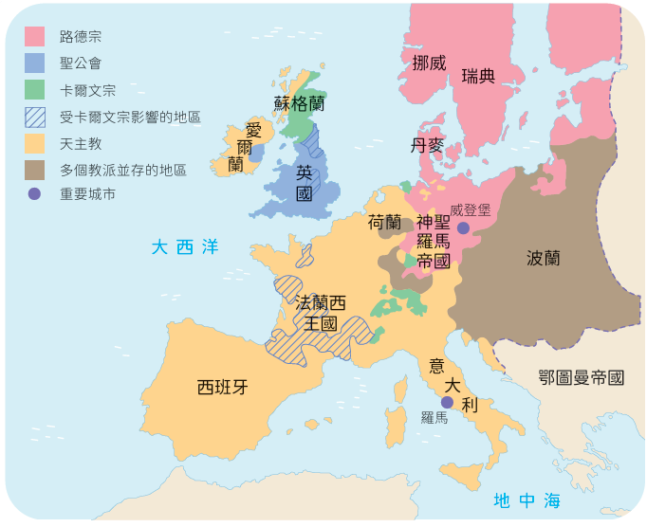

3 削弱羅馬天主教會的影響力

宗教改革嚴重打擊了羅馬天主教會的權威。一些歐洲君主和貴族趁機沒收教會的土地和財產，大大減低教會對各國政治、經濟的控制。

2 Prompting the Roman Catholic Church's reforms

- First, the Church reached agreements with some Catholic monarchs, recognising that they had greater autonomy on their own national religious matters.
- Furthermore, the Church banned the selling of indulgences and no longer allowed the clergy to do nonreligious businesses.
- Some new communities that opposed the Reformation emerged within the Church. The most famous one was the Society of Jesus founded by Ignatius of Loyola from Spain.

Distribution of Protestant branches in Europe in 1560
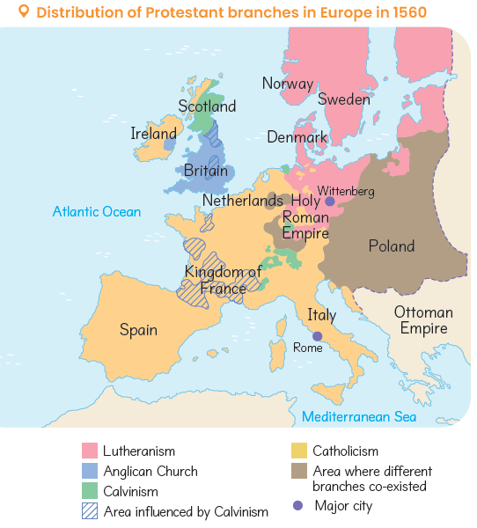
3 Weakening the Roman Catholic Church's influence

The Reformation was a blow to the authority of the Roman Catholic Church. Some European monarchs took the opportunity to seize the Church's land and properties. This greatly weakened the Church's political and economic control over countries.

重點練習

1. 根據課文內容，完成下列各題文字。
(a) 意大利富商競相出錢贊助文藝、科學的發展，以重金羅致各種人才。其中最有名的是 ___佛羅倫斯___ 首富 ___美第奇___家族。

(b) 文藝復興的主要精神是「 ___人文主義___ 」，即以人為中心的世界觀。

(c) 基於人文主義，文藝復興使人的個性得到解放，鼓勵個人奮鬥，提倡個人的言論、創作自由，反對各種不合理制度對人們思想的束縛。英國劇作家兼詩人 ___莎士比亞___ ，便留下許多膾炙人口的作品，包括《哈姆雷特》、《羅密歐與朱麗葉》、《威尼斯商人》等。

(d) 1517 年10 月，德意志教士 ___馬丁路德___ 提出《 ___九十五點論證___ 》的意見書，抨擊教會的錯誤行徑。這事件標誌了歐洲宗教改革的開始。支持___馬丁路德___ 的人越來越多，逐漸形成一個基督宗教的新教派，稱為「 ___基督新教___」。

(e) 基督新教很快便傳播到歐洲許多國家，並出現不同的宗派，如擁護馬丁路德的路德教派、法國的 ___卡爾文___ 教派、英國國教 ___聖公會___ 等。

Key Exercises

1. Fill in the blanks according to the textbook content.
(a) Rich merchants spent large sums of money to sponsor cultural and science activities, as well as recruit all kinds of talents. Among them, the most famous was the ___Medici___ family in ___Florence___ .

(b) The main spirit of the Renaissance was ___humanism___ , a worldview with human as the centre.

(c) Founded on ___humanism___ , the Renaissance freed humanity and encouraged personal striving. ___William Shakespeare___, a British playwright and poet, wrote many popular plays, such as Hamlet, Romeo and Juliet, The Merchant of Venice.

(d) In October 1517, German monk __Martin Luther___ posted the ___Ninety-Five Theses___ to criticise the Church’s misbehaviour. As more and more people supported ___Martin Luther___ , a new branch of Christianity called ___Protestantism___ was formed.

(e) ___Protestantism___ soon spread to many European countries and developed different branches, such as ___Lutheranism___ in Germany, ___Calvinism___ in France, and the ___Anglican Church___ in Britain

2. 試選擇適當答案，並將其英文代號填入方格內。
(a) 文藝復興的發源自哪個國家？
A. 意大利 B. 法國
A
C. 葡萄牙 C. 英國

(b) 以下哪項是宗教改革的起因？
A. 啟蒙運動的出現 B. 教會出售「贖罪券」
B
C. 奧克斯堡宗教會議 D. 耶穌會的創立

2. Choose the appropriate answer and put it in the corresponding box.
(a) Where did the Renaissance originate from?
A. Italy B. France
A
C. Portugal C. Britain

(b) Which of the following was a cause of the Reformation?
A. Enlightenment B. The Church selling indulgences
B
C. Diet of Augsburg D. The founding of the Society of Jesus

