課題5 近代歐洲的興起
III 技術的革新：工業革命

關鍵詞
工業革命 | Industrial Revolution
機器時代 | Age of Machines
圈地運動 | Enclosure Movement
家庭手工業 | Domestic industry
電力時代 | Age of Electricity
珍妮紡紗機 | Spinning jenny
Χ 射線 | X-ray
萬國博覽會 | Great Exhibition
工業資產階級 | Industrial-capitalist class
童工 | Child labour
憲章運動 | Chartist Movement
社會主義 | Socialism
馬克思主義 | Marxism
溫習要點
工業革命的特徵
工業興起，從事工業生產的人數上升
工業化

Topic 5 The rise of modern Europe
各類新發明出現，改善人們生活水平
現代化

以機器生產為主，使生產動力由人力轉為機械推動
機械化

人們從農村搬往城市居住，城市興起
都市化

III Technological advancements: the Industrial Revolution

Key Terms
工業革命 | Industrial Revolution
機器時代 | Age of Machines
圈地運動 | Enclosure Movement
家庭手工業 | Domestic industry
電力時代 | Age of Electricity
珍妮紡紗機 | Spinning jenny
Χ 射線 | X-ray
萬國博覽會 | Great Exhibition
工業資產階級 | Industrial-capitalist class
童工 | Child labour
憲章運動 | Chartist Movement
社會主義 | Socialism
馬克思主義 | Marxism
Revision Points
Characteristics of the Industrial Revolution
The rise of industry led to a growing number of industrial workers
Industrialisation
Machinery came into wide use. Production went from hand methods to the use of machines.
Mechanisation
New inventions were made. People’s living standards were improved.
Modernisation
Cities rose as people moved from rural areas to urban areas.
Urbanisation
工業革命開展的條件
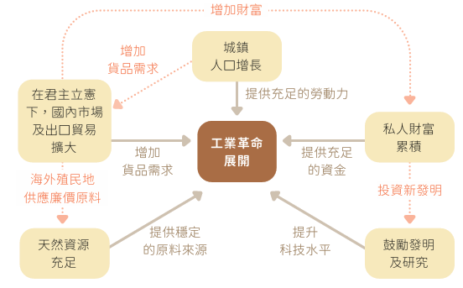

A 工業革命從英國開始的原因

i. 原料：天然資源充足

- 英國有相當豐富的煤、鐵資源。
- 17 世紀，圈地運動出現，大牧場湧現，為紡織業提供大量羊毛原料。

在18 世紀，英國是世界上煤礦開採技術最發達的國家。煤炭為英國的工業發展提供充足能源。
Conditions for the start of the Industrial Revolution
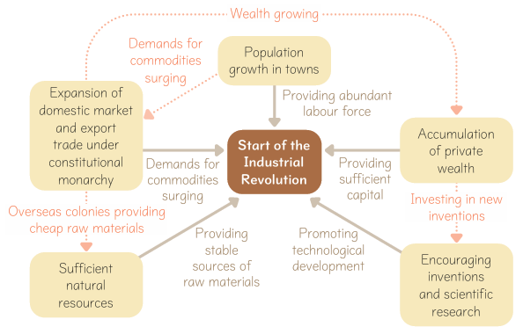

A Reasons for the Industrial Revolution starting in Britain

i. Raw materials: sufficient natural resources

- Britain was rich in coal and iron.
- In the 17th century, the Enclosure Movement emerged. The rise of large pastures provided a great amount of wool for the textile industry.

18th-century Britain had the most advanced coal-mining technology. Coal provided sufficient energy for the British industrial development.

ii. 勞動力：城鎮人口的增長

圈地運動使大批農民喪失了原有的耕地，他們紛紛湧入城鎮尋找生計。這為工業的發展提供了充足的勞動力。

iii. 市場：國內市場及出口貿易擴大

- 英國人口快速增長，為工業製品創造龐大的國內市場。
- 英國為數眾多的殖民地，亦提供了工業原料和出口市場。

iv. 資金：私人財富的累積

在中古時代末期，不少英國商人成為資本家。他們累積大量財富，紛紛購買機器、開設工廠，助長了英國的工業發展。

v. 科學技術：鼓勵發明和科學研究

- 1624 年，英國立法保障發明者的專利權。
- 1660 年，皇家學會成立，成為英國培養科學人才的重要機構。

1809 年，英國人在商店內購買布料的情形，可見人們對商品的需求上升。

ii. Labour force: population growth in towns

Due to the Enclosure Movement, many farmers lost their land. They rushed to towns for work and provided abundant labour force for industrial development.

iii. Markets: expansion of domestic market and export trade

- The rapid population growth in Britain had brought about a huge domestic market for industrial products.
- Numerous colonies provided Britain with industrial raw materials and export markets.

iv. Capital: accumulation of private wealth

In the late Medieval Times, many British merchants became capitalists. They accumulated large amounts of wealth, and soon started to purchase machines and establish factories. This promoted the industrial development of Britain.

v. Technology: encouragement of inventions and scientific research

- In 1624, Britain passed a law to protect the patent rights of inventors.
- In 1660, the Royal Society was established, which became a significant organisation in nurturing scientists for Britain.

British people visiting a store to purchase cloth for dresses in 1809 under
increasing demands for commodities

B 工業革命的主要發展

能源的轉變

18 世紀初，歐洲人仍依靠人力、畜力、風力和水力作為生產動力。後來，新能源興起直接促成工業革命的開展。

蒸汽

- 1769 年，英國的瓦特改良了蒸汽機，利用蒸汽產生力量來帶動各種機器，為工業發展提供了更穩定的生產動力，刺激了工業生產。
- 工廠的位置也不再受水力限制，可建於交通便利的地方，減低運輸成本。

紀念瓦特改良蒸汽機的郵票

煤

- 以蒸汽推動的新式機械陸續發明，使煤產量大增。
- 煤逐漸取代木材，成為工業生產和交通運輸的主要燃料。
- 18 世紀末，英國更開始使用煤氣。

B Main developments of the Industrial Revolution

Changes of energy sources

In the early 18th century, Europeans still relied on human power, animal power, wind power and water power for production. Later, the rise of new energy sources led to the start of the Industrial Revolution.

Steam

- In 1769, James Watt from Britain improved the steam engine and used it to drive machines, which provided a more stable source of industrial power and raised production.
- The location of factories was no longer dependent on water power. They could be built on well-connected sites in order to save transport costs.

Stamp marking Watt's improvement to the steam engine

Coal

- The invention of steam-powered machines made the production of coal grow greatly.
- Coal gradually replaced wood to become the main fuel for production and transport.
- In the late 18th century, Britain started to use coal gas.

3 電力

- 1879 年，美國人愛迪生發明了較耐用的電燈泡。
- 電力開始成為日常生活中最重要的能源，工業生產的規模持續擴大。
- 人們開始進入「電力時代」。

愛迪生手持他所改良的燈泡
工業革命期間能源的轉變
1769年：瓦特成功改良蒸汽機
18世紀 19世紀 20世紀
動力  人力  畜力  水力  風力 | 動力  蒸汽  燃料  煤炭 | 動力  電力  燃料  煤炭及石油

3 Electricity

- In 1879, Thomas Edison from the US invented more durable light bulbs.
- Electricity has become the most important energy source in daily life. The scale of industrial production continued to expand.
- People entered the Age of Electricity.

Edison holding his improved light bulb
Changes of energy sources during the Industrial Revolution

1769: Watt successfully improving the steam engine
18th century 19th century 20th century
Energy source  Humans  Animals  Water  Wind | Energy source  Steam  Fuel  Coal | Energy source  Electricity  Fuel  Coal and oil

ii. 工業的機械化

1 紡織業

- 1760 年代起，各種紡織機器相繼面世，使生產率不斷提高。
- 工人集中在紡織廠，使用機器進行生產，逐漸形成工廠制度。

18 世紀英國棉紡織業的機械化進程
1733年 |  | 飛梭 （由凱約翰發明）  織布效率提高一倍
1764年 |  | 珍妮紡紗機  可同時紡六、七根紗
1769年 |  | 水力紡紗機  紡出較結實的粗紗
1779年 |  | 走錠精紡機  - 紡出精細而結實的幼紗  - 改良後，成為以蒸氣推動的自動精紡機
1785年 |  | 動力織布機（由凱約翰發明）  產量相當於四十個工人

Mechanisation of industry

Textile industry

- From the 1760s onwards, the invention of textile machinery helped to raise productivity.
- Workers gathered in textile factories to make goods by using machines. The factory system gradually formed.

Road to mechanisation of Britain’s
cotton textile industry in the 18th century
1733 |  | Flying Shuttle (Invented by John Kay)  It doubled the efficiency of waving
1764 |  | Spinning jenny  It could spin 6-7 pieces of yarn at once
1769 |  | Water frame  It could spin strong and rough yarn.
1779 |  | Spinning mule  - It could spin fine and strong yarn.  - After improvement, it became the steam-driven automatic spinning mule.
1785 |  | Power loom (Invented by Edmund Cartwright)  Its production capacity equalled to the output of 40 workers

鋼鐵業

以燒煤來煉鋼的技術逐漸成熟。鋼鐵產量大幅提升，為各種機器的生產提供了必要的原材料。

機器製造業

1840 年代，英國已用機器來製造機器。機器製造業興起。英國的工業化已基本完成。

1851 年，英國倫敦舉行萬國工業博覽會，會場上展出了超過十萬種工業新產品。

iii. 交通運輸的機械化

- 工業革命前，人們主要以馬車和帆船作為交通工具，而各地道路大都崎嶇不平。
- 工業革命開始後，人們希望改善交通運輸效率，以便迅速運送原料和燃料，並及時把產品送往市場。
- 蒸汽機的改良帶動了交通運輸工具的機械化，新的水陸交通工具相繼出現。

Steel industry

The method of steelmaking technology with the use of coal gradually matured. The significant rise in steel output greatly helped to provide necessary raw materials for producing different types of machine.

Machinery industry

In the 1840s, Britain had started to use machines to make machines. The rise of the machinery industry marked the completion of industrialisation in Britain.

The Great Exhibition of 1851 was held in London, Britain.
It showcased over 100, 000 new industrial products.

iii. Transport mechanisation

- Before the Industrial Revolution, horse-drawn vehicles and sailing ship were the main means of transport. Most of the roads were rough and uneven.
- During the Industrial Revolution, people wanted to improve transport efficiency. By doing so, they could move raw materials and fuel quickly, as well as sending their products to markets on time.
- The improvement to the steam engine promoted transport mechanisation. New water and land vehicles appeared one by one.

工業革命期間的水路交通發展

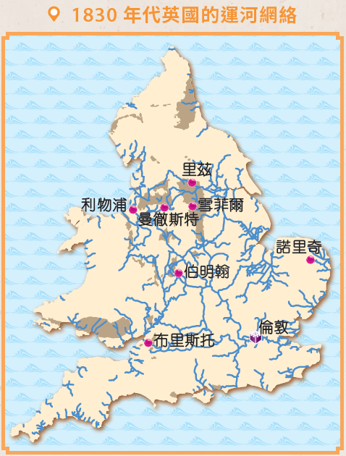
1830年代英國的運河網絡

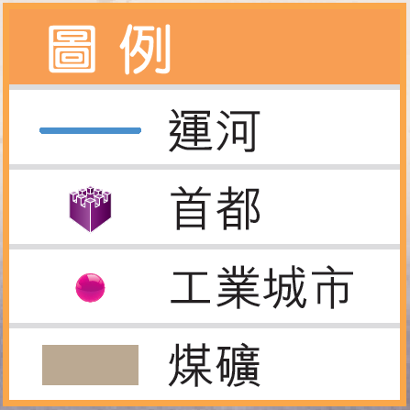
- 開鑿運河，加強運輸網絡
1761年起，英國開鑿了多條運河，以便把煤及其他原料運到主要的工業城市。

- 改以蒸汽推動汽船，節省運輸時間
1807年，美國人富爾敦發明了用蒸汽機帶動的汽船。這大大縮短了航行和貨物運輸的時間。
Development of water transport during the Industrial Revolution

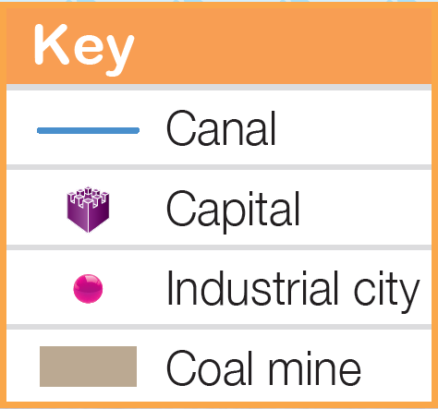
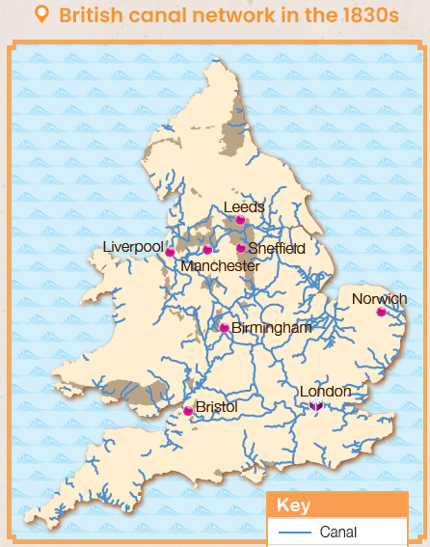
British canal network in 1830s

- Building canals to strengthen transport network

Since 1761, Britain built many canals to transport coal and other raw materials to major industrial cities.

- Switching to steam-powered steamboats to save transport time

In 1807, Robert Fulton from the US invented the steam engine-powered steamboat. This greatly reduced time spent on travelling and carrying goods.
工業革命期間的陸路交通發展
- 發明蒸汽機車，建立鐵路網絡
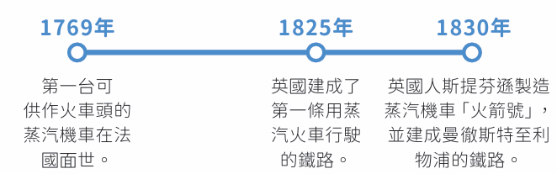
英國建成了第一條用蒸汽火車行駛的鐵路。

第一台可供作火車頭的蒸汽機車在法國面世。
英國人斯提芬遜製造蒸汽機車「火箭號」，並建成曼徹斯特至利的鐵路。

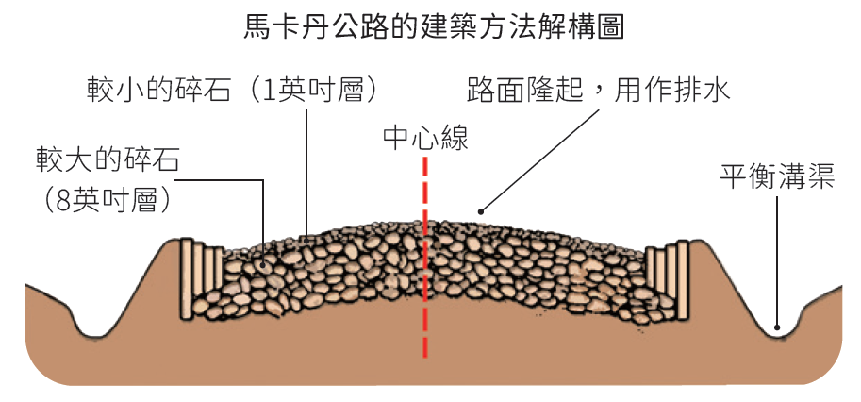
- 研發新的築路方法，使路面平坦安全
19世紀，蘇格蘭人馬卡丹發明築路新方法，使路面結實平順。

- 首部汽車誕生，成為主要的交通工具
1888年 賓治的妻子貝爾塔成功以三輪汽車進行世界第一次汽車長途旅行，路程長達106公里。
1885年
德國人賓治發明首部裝上單汽缸內燃機的汽車。

1886年
首部三輪汽車正式面世。

Development of land transport during the Industrial Revolution
- Inventing the steam locomotive and building the railway network
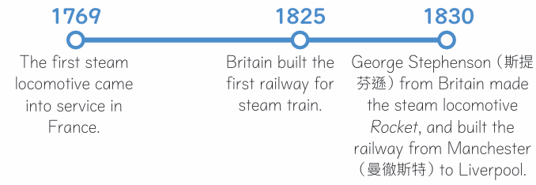
George Stephenson from Britain made the steam locomotive Rocket, and built the railway from Manchester to Liverpool.
Britain built the first railway for steam train.
The first steam locomotive came into service in France.

- Inventing the new road-building method to make roads flat and safe
In the 19th century, John McAdam from Scotland invented the new road-building method. Road surfaces became firm and smooth.
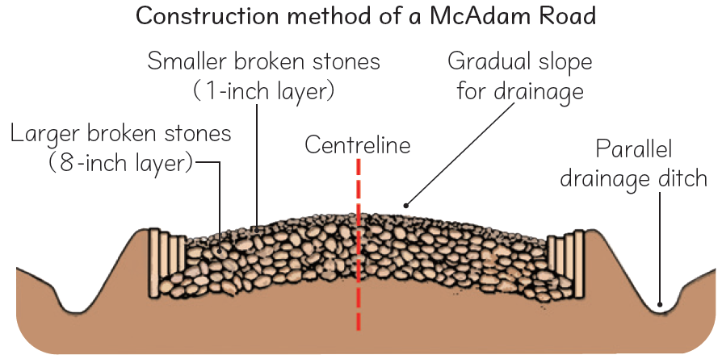

- The car becoming the main means of transport after its invention
1885
Carl Benz from Germany invented the first car equipped with the single-cylinder internal engine

1886
The first three-wheeled car was invented.

1888 Benz's wife Bertha became the first person to drive a three-wheeled car over a long distance of 106 kilometres.
during her journey年 賓治的妻子貝爾塔成功以三輪汽車進行世界第一次汽車長途旅行，路程長達106公里。

iv. 通訊的革新

自19 世紀中期起，伴隨電力的發展，電報和電話等新的通訊發明陸續面世，大大提高了資訊傳播的速度。
19 世紀通訊設備的發展
 | 人們主要以書信溝通 | 1840 年代的電報機  穆齊發明的電話裝置  貝爾首次公開示範使用電話。
1835年 | 第一部電報機面世，成為人類最早使用電力通訊的方式。
1837年 | 美國人摩爾斯發明摩爾斯電碼，利用代碼表示英文字母和數字，方便收發訊息。
1839年 | 首條電報線路在英國出現
1860年 | 意大利人穆齊首次在報章發布電話裝置。
1866年 | 英、美建立越洋電報裝置。
1876年 | 加拿大人貝爾改良電話裝置，並取得電話的專利。

自19 世紀中期起，伴隨電力的發展，電報和電話等新的通訊發明陸續面世，大大提高了資訊傳播的速度。
19世紀通訊設備的發展
 | 人們主要以書信溝通 | 1840 年代的電報機  穆齊發明的電話裝置  貝爾首次公開示範使用電話。
1835年 | 第一部電報機面世，成為人類最早使用電力通訊的方式。
1837年 | 美國人摩爾斯發明摩爾斯電碼，利用代碼表示英文字母和數字，方便收發訊息。
1839年 | 首條電報線路在英國出現
1860年 | 意大利人穆齊首次在報章發布電話裝置。
1866年 | 英、美建立越洋電報裝置。
1876年 | 加拿大人貝爾改良電話裝置，並取得電話的專利。

iv. Innovations in communication

From the mid-19th century onwards, following the development of electricity, new communication inventions such as telegraphs and telephones appeared one by one. They greatly sped up the flow of information.
Development of communication devices in the 19th century
 | People mainly communicated by letters | Telegraph in the 1840s  Telephone invented by Meucci  Bell showing how to use the telephone in public for the first time
1835 | The first telegraph was made. It became the earliest electrical means of communication.
1837 | Samuel Morse from the US invented Morse Code, which use codes to represent the English letters and numbers. Text messaging became more convenient.
1839 | The first telegraph circuit was made in Britain.
1860 | Antonio Meucci from Italy announced the invention of the telephone in a newspaper.
1866 | Britain and the US built a telegraph system across the sea.
1876 | Alexander Bell from Canada improved the telephone. The patent for the telephone was granted to him.

v. 醫學的新發明

- 工業革命期間，預防天花、霍亂等傳染病的疫苗相繼面世。
- 麻醉藥的發明，可用於外科手術。
- 德國人倫琴發現Χ 射線，可透視人體以助檢查身體。法國人居禮夫婦亦發現用於治療癌症的鐳元素。

vi. 農業技術的進步

- 工業革命促進了農業機械化，播種機和收割機相繼被發明。
- 人造肥料和穀物輪耕法的普及，也提高了農作物產量。

穀物輪耕法示意圖
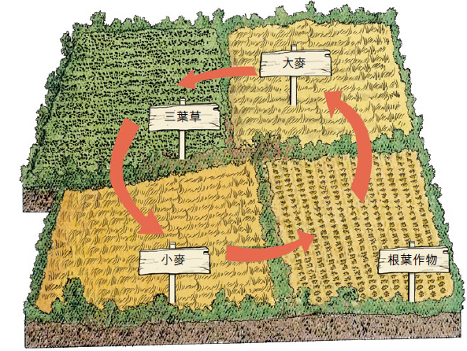
農民輪流在地上種植不同的農作物，既可恢復地力，同時可大大提高農作物的產量。

v. New medical inventions

- During the Industrial Revolution, vaccines against infectious disease such as smallpox and cholera were developed.
- Drugs that kept patients unconscious appeared and were used in surgery.
- Wilhelm Roentgen from Germany discovered X-rays, which were used to view the inside of the human body. The Curie couple from France discovered radium, which was used to treat cancer.

vi. Technological advancements in agriculture

- The Industrial Revolution led to agricultural mechanisation. Machines for seed drilling and harvesting were invented.
- The introduction of artificial fertilisers and crop rotation also raised agricultural output.

A diagram showing how crop rotation worked
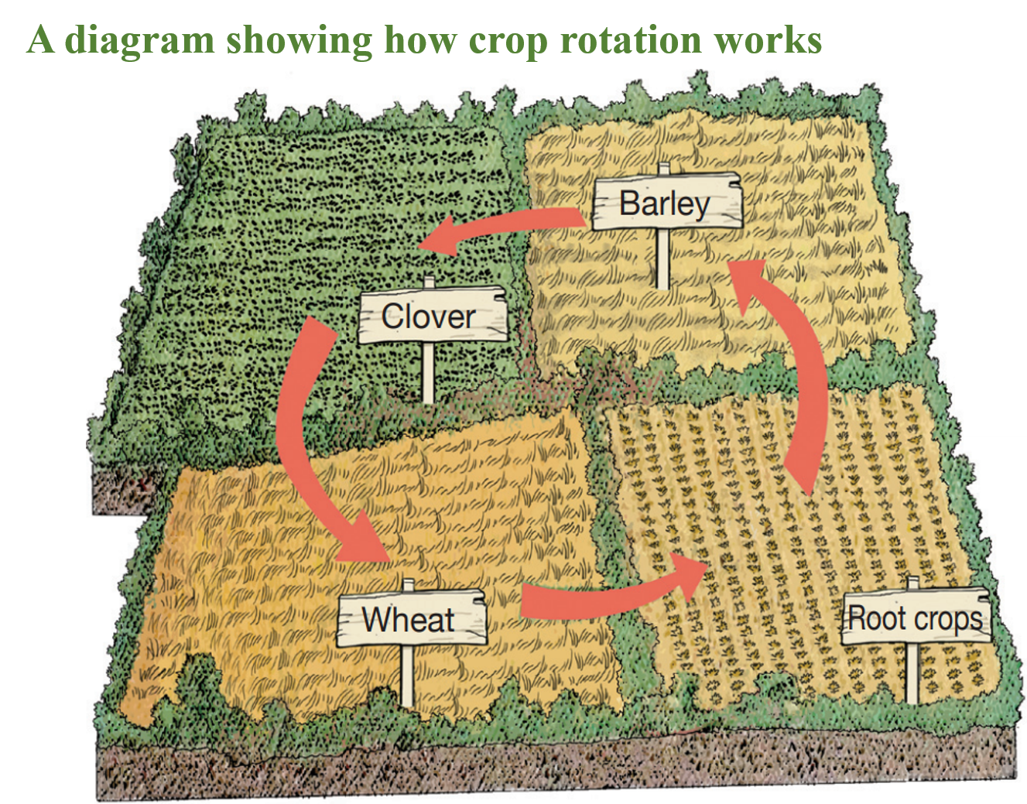
Farmers grew different set of crops on farmland on a rotating cycle. This method could restore soil fertility as well as increase crop production.

C 工業革命的影響

經濟方面

1 工廠制度的形成

- 使用大型機器進行生產，需要鉅額資金和寬敝的地方，工廠因此應運而生，成為工業生產的主要形式。
- 在新式工廠裏，生產過程分成多個專門工序，由不同的工人分別完成。這樣的分工模式大大提高了生產效率，並且可以節約原料、減低成本。

工廠制度下的生產模式
廠主聘用大量工人，並定下產品的數量和生產時間
工人在過程中彼此分工
使用大型機器生產
C Impact of the Industrial Revolution

Economic aspect

1 Formation of the factory system

- Production with the use of large machines required a great amount of capital and a spacious environment. The factory system thus took place, and became the main form of industrial production.
- In a new factory, the process of production was divided into various specialised tasks that to be done by different workers separately. This division of labour greatly increased productivity. It could also save raw materials and lower production costs.

Production mode under the factory system
The division of labour was practised. Workers performed specialised tasks separately.
Large machines were used in the production of goods.
Factory owners hired a large number of workers. They set the production target and schedule.

2 歐美工業國的殖民擴張

- 很多歐洲國家和美國迅速工業化。它們通過蓬勃的貿易累積財富，成為世界強國。
- 歐、美先進的工業國為了取得更多的商品市場和原料供應地，不斷向海外擴張，在亞洲和非洲爭相建立殖民地。世界局勢因而變得越來越複雜。

工業革命後西方國家的經濟擴張
西方國家
亞洲
非洲
為工業發展提供原料
為工業產品尋找海外市場
為工業產品尋找海外市場
西方透過建立由他們主導的貿易體系，賺取鉅額財富。

2 Colonial expansion of European and American industrialised countries

- Many European countries and the US underwent rapid industrialisation. Through the flourishing trade, they accumulated great wealth and became the world's great powers.
- In search of more markets and raw material suppliers, industrialised European countries and the US continuously carried out overseas expansion. They rushed to seize colonies in Asia and Africa. As a result, the world situation became increasing complicated.

Economic expansion of Western countries after
the Industrial Revolution
Western countries

Asia

Africa

Providing raw materials for industrial development
Looking for overseas markets for industrial products

Looking for overseas markets for industrial products
By setting up a West-led trading system, Western countries have gained great amounts of wealth.

社會方面

1 促進都市化發展

- 隨着大批工廠建立，新的工業城市漸漸出現。城市提供較多就業機會，而農村的勞動力需求也大大降低。
- 農民紛紛湧到工廠附近的城市地區，尋找工作機會。這導致歐洲各國的城市人口不斷上升，促進都市化的發展。


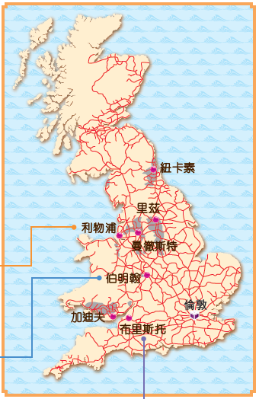
1860 年代英國的工業城市分佈圖

布里斯托人口
1750年︰22,000
1801年︰61,000
1851年︰137,000
利物浦人口
1750年︰22,000
1801年︰82,000
1851年︰376,000
伯明翰人口
1750年︰24,000
1801年︰71,000
1851年︰233,000

Social aspect

1 Promotion of urbanisation

- New industrial cities gradually appeared as a large number of factories were built. Cities provided more job opportunities, while villages needed less and less labour force.
- A lot of farmers flooded into the urban areas near factories in search of jobs. As a result, the urban population in various European countries grew quickly. The development of urbanisation was enhanced.

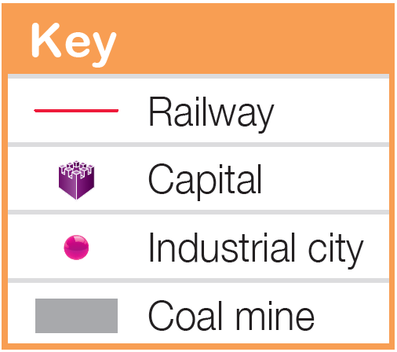
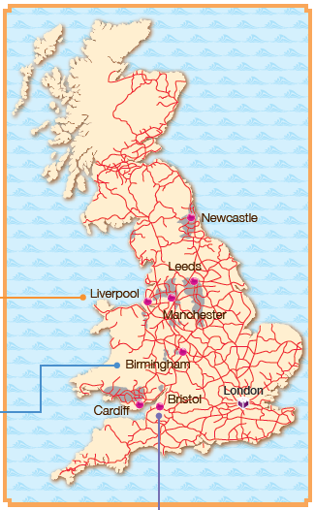
Distribution of British industrial cities in the 1860s
Population of Liverpool
1750: 22,000
1801: 82,000
1851: 376,000
Population of Birmingham
1750: 24,000
1801: 71,000
1851: 233,000
Population of Bristol
1750: 22,000
1801: 61,000
1851: 137,000
2 工業資產階級和工人階級的形成

- 工業資產階級指擁有工廠、礦山、鐵路、銀行的資本家。他們生活富裕，社會地位較高。
- 工人階級又稱「無產階級」，他們受僱於資本家，以換取維持生活的工資。工人生活困苦，社會地位低下。

3 工人生活困苦

3.1 工作時間長，收入低下

- 城市工人的工資微薄，而且工作時間長，每天往往要勞動十二至十六小時。
- 工廠內的工作環境惡劣，缺乏安全設備，不少工人因而受傷甚至死亡。

3.2 生活環境惡劣

- 多數工人居住在貧民窟中。那裏的房屋簡陋，街道狹窄擁擠。
- 許多家庭有多名成員居住在小屋內，衞生情況惡劣，傳染病流行。火災亦經常發生。

- 童工問題的形成

- 工業革命時期，不少兒童需外出工作幫補家計而工廠亦會聘請工資較成人低的童工。這些童工不能到學校上課，而且須長時間工作。
- 此外，他們經常受到虐待，健康亦出現嚴重問題。

在煤礦工作的童工

2 Formation of the industrial-capitalist class and the working class

- The industrial-capitalist class refers to owners of factories, mines, railways and banks. They were very rich, and enjoyed high social status.
- The working class is also known as the proletariat. They worked for capitalists to make living wages. Workers lived in hardship, and their social status was low.

3 Poor life of workers

3.1 Long working hours and low wages

- City workers had to work long hours for very little pay. They usually worked 12-16 hours a day.
- Working conditions in factories were harsh. The lack of safety equipment caused many workers to become injured or even get killed.

3.2 Poor living conditions

- Most workers lived in slums, where houses were simple and streets were narrow.
- Usually the whole family lived in the same small house with poor hygiene conditions. Infectious diseases were widespread. Fires often broke out as well.

4 Problem of child labour

- During the Industrial Revolution, many children worked in order to help their families make ends meet. Factories hired a lot of low wage child labourers, who were not allowed to attend school and were made to work long hours.
- Furthermore, child labourers were often abused and they had poor health.

Child labourers working inside a coal mine

- 工會和工人運動的出現

- 19 世紀初起，英國工人為了爭取合理待遇，逐漸組織工會，並參與罷工。
- 1838-1858 年， 英國工人發起憲章運動， 爭取減少工時、提高工資和普選權。
- 憲章運動雖以失敗告終，但英國由1830 年代起通過多條改善工人生活的法例，如限制工時、禁止童工等。
- 1871 年，英國最終允許工會合法化。

19世紀英國工廠法下工人工作時間的轉變
 | 9-13歲童工 | 14-18歲工人 | 女工
《1833年工廠法》 | ≤ 9小時 | ≤ 12小時 | -
《1844年工廠法》 | ≤ 6.5小時 | ≤ 12小時 | ≤ 12小時
《1847年工廠法》 | - | ≤ 10小時 | ≤ 10小時

iii. 思想方面：社會主義出現
- 19 世紀時，一些同情工人階級的思想家，提出了「社會主義」的理論。
- 他們認為生產資源應屬社會公有，並主張重新分配財富，以創造公平的社會。
- 社會主義當中較激進的派別，以德國人馬克思為代表。根據馬克思提倡的共產主義， 工人階級應過過革命推翻工業資產階級，奪取政權。共產主義其後逐漸傳播到世界各地，影響極為深遠。

5 Rise of trade unions and labour movements

- From the early 19th century onwards, British workers gradually formed trade unions to push for reasonable treatment. They also participated in strikes.
- In 1838-1858, British workers organised the Chartist Movement in which they demanded fewer working hours, higher wages and the right to vote.
- Although the Chartist Movement ended in failure, the British government passed several laws to improve the life of workers from the 1830s, such as limiting working hours and banning child labour, etc.
- In 1871, Britain finally allowed trade unions to become legalised.
Changing working hours under the
British factory acts in the 19th century
 | Child labourers aged 9-13 | Workers aged 14-18 | Female worker
1833 Factory Act | ≤ 9 hours | ≤ 12 hours | -
1844 Factory Act | ≤ 6.5 hours | ≤ 12 hours | ≤ 12 hours
1847 Factory Act | - | ≤ 10 hours | ≤ 10 hours

iii. Intellectual aspect: emergence of socialism
- In the 19th century, some thinkers, who had sympathy for the working class, put forward the theory of socialism.
- They believed that production resources should be owned by the public, and wealth should be redistributed. By doing so, a fair society would be achieved.
- Karl Marx from Germany was the central figure in the radical wing of socialism. According to communism proposed by Marx, the working class should overthrow the industrial-capitalist class through revolutions to seize power. Communism then spread around the world and had far-reaching influence.

重點練習
1. 根據課文內容，完成下列各題文字。
(a) 從1760年代到19世紀末的一百多年間，西方在工業、科學、技術等方面出現一場巨大的變革，稱為「 ___工業革命___ 」。
(b) 在英國，___圈地運動___ 使大批農民喪失了原有的耕地。
(c) 1898年， ___法國___ 人 ___居禮___ 及其夫人發現放射性元素「 ___鐳___ 」。
(d) 早期的 ___紡織廠___ 多建於近流水的地方，以便利用水力作動力來源。

2. 試選擇適當答案，並將其英文代號填入方格內。
(a) 以下哪項發明成為工業革命正式開始的標誌？
A. 飛梭 B. 生鐵煉鋼
D
C. 電報機 D. 珍妮紡紗機

(b) 19世紀發明築路新方法的馬卡丹是哪裡人？
A. 英國人 B. 蘇格蘭人
C. 威爾斯人 D. 康和人
B

(c) 誰發明Χ 射線？
A. 瓦特 B. 摩爾斯
C. 倫琴 D. 馬克思
C

Key Exercises
1. Fill in the blanks according to the textbook content.
(a) Between the 1760s and late 19th century, there were great transformations in Western industry, science and technology. This was called the ___Industrial Revolution___ .
(b) In Britain, because of the ___Enclosure Movement___, many farmers lost their land and homes.
(c) In 1898, a ___French___ , ___Pierre Curie___ and his wife discovered ___radium___ , a radioactive element.
(d) The early ___textile factories___ were usually built in places near streams in order to have water as the source of power.

2. Choose the appropriate answer and put it in the corresponding box.
(a) Which of the following invention marked the beginning of the Industrial Revolution?
A. flying shuttle B. using pig iron to make steel
D
C. telegraph D. spinning jenny

(b) What ethnic group was the inventor of a new method of building roads, John McAdam?
A. Briton B. Scotsman
C. Welsh people D. Cornish people
B

(c) Who discovered X-rays?
A. James Watt B. Samuel Morse
C. Wihelm Roentgen D. Karl Marx
C

