課題5 近代歐洲的興起
IV 對自由和民主的追求：法國大革命及其歷史意義

關鍵詞
法國大革命 | French Revolution
波旁王朝 | Bourbon House
民族國家 | Nation state
君主專制 | Absolute monarchy
君權神授 | Divine right of kings
三級會議 | Estates General
凡爾賽宮 | Palace of Versailles
網球場宣言 | Tennis Court Oath
巴士底監獄 | Bastille
雅各賓派 | Jacobins
恐佈時代 | Reign of Terror
拿破崙戰爭 | Napoleonic Wars
滑鐡盧戰役 | Battle of Waterloo
維也納會議 | Congress of Vienna

溫習要點
法國大革命（1789-1799年）的背景
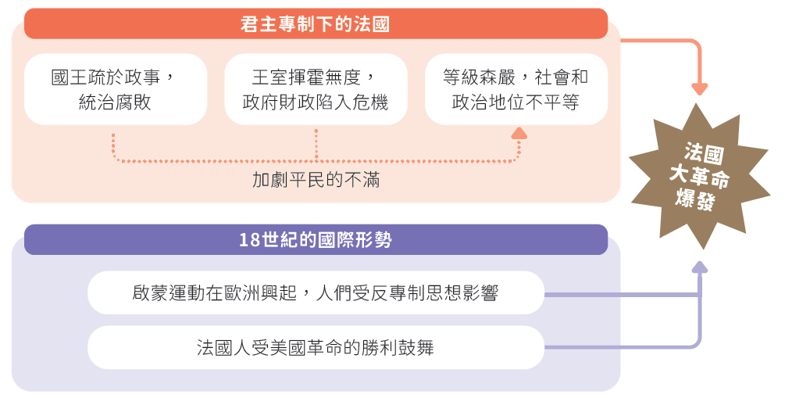

Topic 5 The rise of modern Europe
IV Pursuit of liberty and democracy: the French Revolution and its historical significance

Key Terms
法國大革命 | French Revolution
波旁王朝 | Bourbon House
民族國家 | Nation state
君主專制 | Absolute monarchy
君權神授 | Divine right of kings
三級會議 | Estates General
凡爾賽宮 | Palace of Versailles
網球場宣言 | Tennis Court Oath
巴士底監獄 | Bastille
雅各賓派 | Jacobins
恐怖時代 | Reign of Terror
拿破崙戰爭 | Napoleonic Wars
滑鐡盧戰役 | Battle of Waterloo
維也納會議 | Congress of Vienna

Revision Points
Background of the French Revolution (1789-1799) 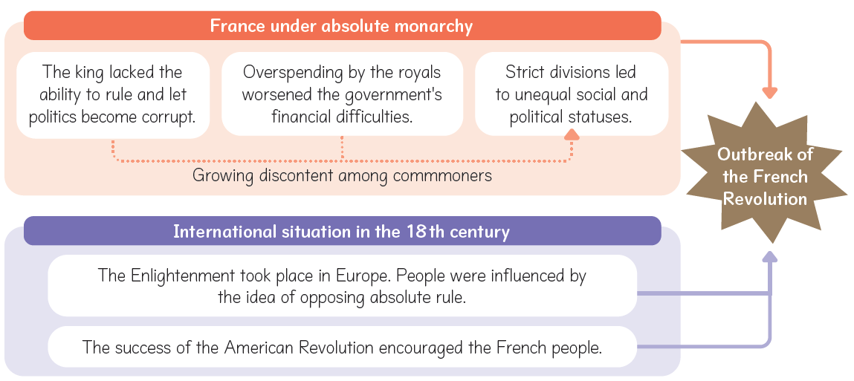

A 法國大革命爆發的原因
i. 國王統治腐敗

1774 年， 波旁王朝的路易十六成為法國國王。他疏於政事，與王后瑪利•安東妮特耽於奢靡逸樂，任由政治腐敗。法國人民越趨不滿。

ii. 政府面臨財政危機

- 17世紀中葉以來，法國接連參與多場歐洲戰爭，軍費負擔極重。
- 路易十六繼位後，宮廷生活奢侈浪費，更使國庫空虛。到了1780 年代，法國政府債台高築，財政已瀕臨破產。
1788年法國政府支出分佈
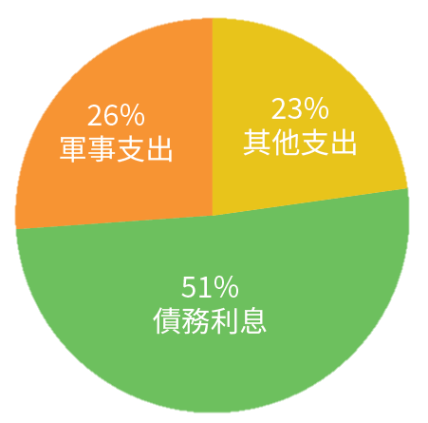

iii. 社會階級不平等

- 法國社會分為三個等級：第一等級是教士，第二等級是貴族，第三等級是平民。
- 第二等級的教士、貴族，只佔法國人口的絕少數，卻擁有全國接近四成的土地，亦不需要承擔納稅義務。
- 第三等級的平民，包括農民、工人，以及商人、律師等中產階級，佔法國人口百分之九十七。他們沒有任何政治權利，並須繳納重稅，不滿情緒日益加劇。

A Causes of the French Revolution
i. Corrupt rule of the king

In 1774, Louis XVI of the Bourbon dynasty became the king of France. He had no interest in governance and led a luxurious life with his queen Marie Antoinette. Political corruption was widespread. Dissatisfaction with the Bourbon rule grew among the French people.

ii. Financial crisis of the government

- France had participated in many European wars since the mid-17th century, leading to heavy military spending.
- After Louis XVI became the king, his wasteful way of life at court further exhausted the treasury. By the 1780s, the French government was already deep in debt. France almost went broke.
Expenditure of the French government by function in 1788
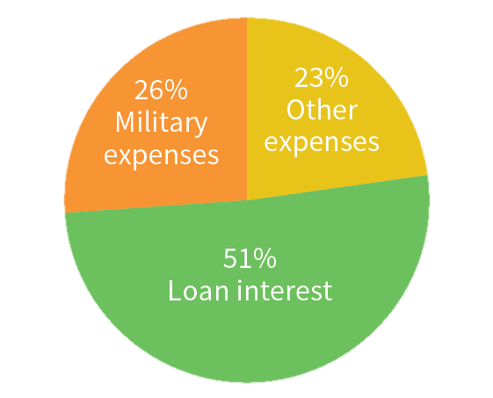

iii. Social inequality

- The French society was divided into 3 estates: the first estate was the clergy, the second was the nobility and the third was commoners.
- The first estate of the clergy and the second estate of the nobility only made up a small percentage of France's population. However, they owned almost 40% of the land in France. Besides, they paid no taxes.
- The third estate of commoners, including peasants, craftsmen and the middle class like merchants and lawyers, made up 97% of France's population. They had no political rights and paid high taxes. Their discontent became increasingly strong.

18世紀的法國社會等級制度
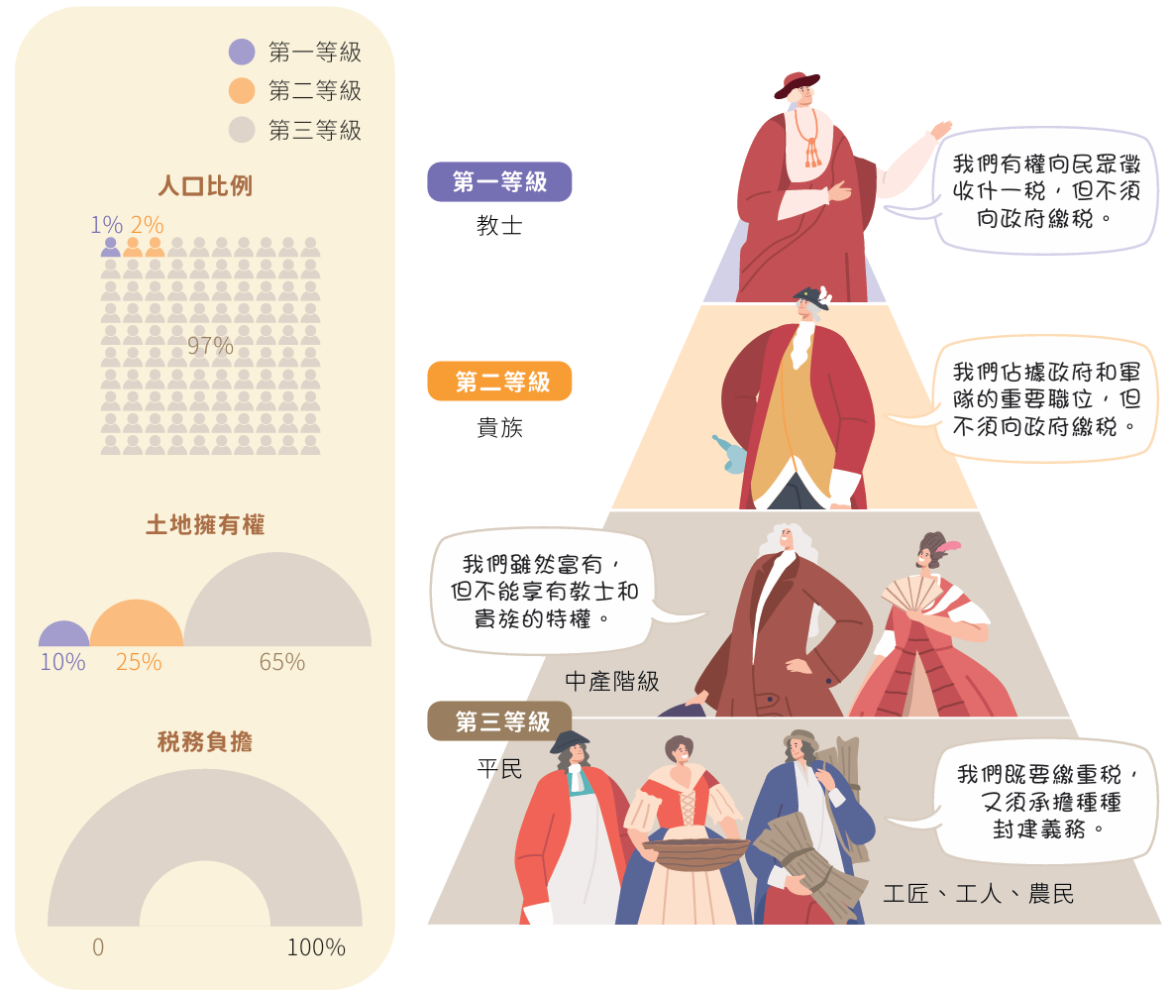

iv. 啟蒙思想的影響

- 啟蒙運動時期，伏爾泰、孟德斯鳩、盧騷等啟蒙思想家都是法國人。他們提倡自由、平等、民主，大力反對君主專制。
- 法國人民深受這些思想影響，加上對政府的統治越益不滿，逐漸萌生反抗暴政的意識。

Estate system of the French society in the 18th century
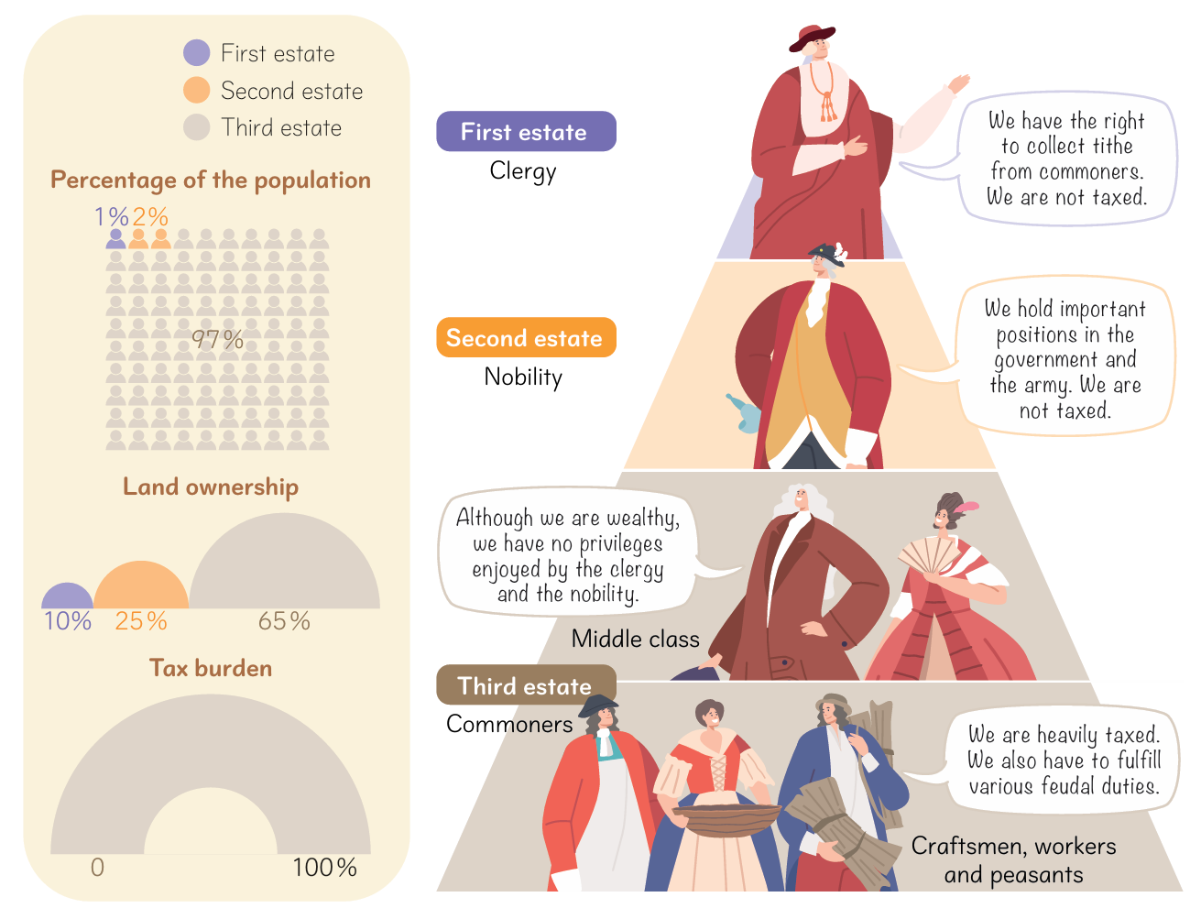

iv. Influence of Enlightenment ideas

- During the Enlightenment, thinkers such as Voltaire, Montesquieu and Rousseau were Frenchmen. They suggested ideas of liberty, equality and democracy, as well as opposing absolute monarchy.
- All these greatly influenced the French people. Their growing discontent with the government gave birth to the consciousness of resisting tyranny.

v. 美國革命樹立的榜樣

美國革命的勝利，令法國人民深受鼓舞，認為自己也能像美國人民一樣推翻暴政，促使他們日後發動革命。

B 法國大革命的經過

i. 法國大革命的導火線
1 三級會議召開（1789年5月）

- 1789 年5 月，路易十六在巴黎的凡爾賽宮召開三級會議，商討如何改革稅制，以解決國家財政危機。
- 按照傳統，每一等級不論代表人數多少，各有一票。第三等級的代表認為這種投票方式極不公平。最終，他們退出三級會議，另行召開國民議會。

三級會議的表決方式
等級 | 人口佔全國百分比 | 代表人數 | 表決票數
第一等級 | 1% | 303人 | 1票
第二等級 | 2% | 282人 | 1票
第三等級 | 97% | 610人 | 1票
三級會議是法國不定期舉行的會議。會議通常是在國家遇到困難時，由國王召開，參加者包括每個等級的代表。

2 發表《網球場宣言》（1789年6月）

- 1789 年6 月，路易十六關閉國民議會的場地。
- 第三等級的代表改往附近一個網球場集會， 發誓在憲法制定之前， 國民議會決不解散， 歷史上稱為《網球場宣言》。

v. Example set by the American Revolution

The success of the American Revolution made the French people believe that they were also able to overthrow tyranny, like the Americans. They were inspired to stage their own revolution.

B Course of the French Revolution

i. Events leading to the French Revolution
1 Calling of the Estates-General (May 1789)

- In May 1789, Louis XVI called the Estates-General at the Palace of Versailles to discuss how to reform taxation, in order to solve France's financial crisis.
- Traditionally, each estate had a single vote regardless of the number of representatives. Representatives of the third estate thought that this way of voting was unfair. In the end, they withdrew from the Estate-General and called the National Assembly on their own.

Voting method of the Estates-General
Estate | Population percentage | Number of representatives | Number of Vote
First estate | 1% | 303 | 1
Second estate | 2% | 282 | 1
Third estate | 97% | 610 | 1
The Estates-General was an assembly held irregularly in France. It was usually called by the king amid a national crisis. Participants were representatives of the different estates.

2 Taking of the Tennis Court Oath (June 1789)

- On 14 July 1789, when the people of Paris heard that the king planned to secretly sent troops to break up the National Assembly, they immediately attacked the Bastille.
- The fall of the Bastille marked the beginning of the French Revolution. Later, 14 July was made the national day of France. The tricolour flag of blue, white and red became a revolutionary symbol.

ii. 法國大革命的爆發
- 巴士底監獄陷落（1789年7月14日）

- 巴黎民眾得知路易十六暗中調動軍隊，準備鎮壓國民議會，於是立即攻佔巴士底監獄。
- 巴士底監獄陷落，是法國大革命開始的標誌，後來法國的國慶日也定於7月14日。此外，藍、白、紅三色旗在法國四處飄揚，成為了革命的象徵。

2 《人權及公民權利宣言》發表（1789年8月26日）

這份宣言宣告全部主權在於國民，所有公民在法律面前都是平等的，同樣享有言論、出版等自由。這成為法國大革命的政治綱領。

《人權及公民權利宣言》節錄
第一條
在權利方面，人類是與生俱來而且始終是自由與平等的。

第三條
整個主權的本源根本上乃存在於國民。

第六條
法律對於所有的人，無論是施行保護或是懲罰都是一樣的。

第十一條
自由傳達思想與意見乃是人類最為寶貴的權利之一。每一個公民都可以自由地從事言論、著作與出版。
ii. Outbreak of the French Revolution
1 Fall of the Bastille (14 July 1789)

- When the people of Paris heard that the king planned to secretly sent troops to break up the National Assembly, they immediately attacked the Bastille.
- The fall of the Bastille marked the beginning of the French Revolution. Later, 14 July was made the national day of France. The tricolour flag of blue, white and red became a revolutionary symbol.

- Publication of the Declaration of the Rights of Man and of the Citizen (August 26 1789)

This document stated that all political authority belonged to the people. All citizens were equal before the law and enjoyed freedom of speech, of publication, etc. It served as the political principles of the French Revolution.

Extracts from the Declaration of the Rights of Man and of the Citizen
Article 1
Men are born and remain free and equal in rights.

Article 3
The nation is basically the source of all sovereignty.

Article 6
The law should be the same to all, whether it protects or punishes.

Article 11
The free communication of ideas and opinions is one of the most precious of the rights of man. Every citizen may speak, write and publish freely.

iii. 君主立憲制的建立與廢除
- 宣布君主立憲（1791年9月）
- 行政、立法、司法三權的分立引起部分歐洲國家的恐慌，害怕法國的革命會動搖它們的統治。
- 1792 年，奧地利、普魯士等國組成聯軍進攻法國，企圖平息法國大革命，展開「法國大革命戰爭」（1792-1802 年）。

- 共和國建立（1792年9月）

- 1792 年9 月，新成立的國民大會宣布廢除君主制，建立法蘭西第一共和國。
- 路易十六因叛國罪成立，於1793 年1 月被送上斷頭台處死。

描繪路易十六被送到斷頭台前一刻的畫作

iv. 共和國動盪時期
1 恐怖時代（1793-1794年）

- 以羅伯斯比爾為首的激進派「雅各賓派」掌權。他們設立「公安委員會」，在全國大肆整肅反對者，並把他們送上斷頭台。他們的統治時期被稱為「恐怖時代」。
- 對外方面， 普魯士、奧地利及英國組成數次「反法同盟」，不斷進攻法國。

iii. Establishment and abolition of the constitutional monarchy
1 Establishment of the constitutional monarchy (September 1791)

- The introduction of the separation of the executive, legislative and judicial powers worried some European countries, as they feared that the French Revolution would shake their rule.
- In 1792, countries such as Austria and Prussia jointly sent troops to invade France in an attempt to put down the French Revolution. The French Revolutionary Wars (1792-1802) broke out.

2 Establishment of the Republic (September 1792)

- In September 1792, the newly established National Convention abolished the monarchy and founded the First French Republic.
- Louis XVI was found guilty of being disloyal to France, and was executed at the guillotine in January 1793.

Painting depicting the moment shortly before Louis
XVI's execution at the guillotine

iv. Instability of the Republic
1 Reign of Terror (1793-1794)

- A radical faction called the Jacobins, which was headed by Maximillian Robespierre, rose to power. They set up the Committee of Public Safety, arrested their opponents and sent them to the guillotine. Their rule is known as the Reign of Terror.
- Diplomatically, Prussia, Austria and Britain formed several anti-French coalitions to continuously attack France.

2 督政委員會時期（1795-1799年）

- 1794 年7 月，羅伯斯比爾被處死，恐怖時代結束。
- 其後，政府落入督政委員會的控制，國內持續發生動亂，對外亦面對反法同盟的進攻。

v. 法國大革命結束

- 1799 年11月，軍官拿破崙發動政變，推翻督政委員會。他成立新的執政府，自任第一執政。
- 法國大革命宣告終結，法國進入拿破崙時代。

C 拿破崙時代

i. 拿破崙的改革

1802年，拿破崙成為終身獨裁者。他推行廣泛的改革，包括取消貴族特權、重新分配土地、保障私有財產等。他還頒布了《拿破崙法典》，把革命的一些成果用法律形式肯定下來。

ii. 法蘭西第一帝國的建立

1804 年12 月， 拿破崙稱帝，成立法蘭西第一帝國。法國第一次共和時期結束。
1804 年拿破崙的加冕儀式

2 Directory period (1795-1799)

- In July 1794, the Reign of Terror came to an end after the execution of Robespierre.
- Shortly afterwards, the government was controlled by the Directory. Civil disorder and foreign invasions continued.

v. End of the French Revolution

- In November 1799, Napoleon Bonaparte, a military officer, staged a coup to overthrow the Directory. He set up the Consulate and made himself First Consul.
- The French Revolution ended, and France entered the Napoleonic era.

C Napoleonic era

i. Reforms of Napoleon

In 1802, Napoleon became dictator for life. He introduced a wide range of reforms, including removing the nobility's privileges, redistributing the land, and protecting private property. He also issued the Napoleonic Code to recognise some revolutionary fruits in the form of law.

ii. Establishment of the First French Empire

In December 1804, Napoleon crowned himself emperor and founded the First French Empire. Thus the first republican period of France ended.
Crowning of Napoleon in 1804

iii. 拿破崙戰爭

拿破崙具有擴張野心，不斷對外征戰，史稱「拿破崙戰爭」（1803-1815 年）。拿破崙勢力最盛時，法國幾乎控制了除俄國和英國外整個歐洲。

iv. 拿破崙的覆亡
1 首次退位

- 1813 年10 月，法國與歐洲各國聯軍展開大規模決戰，史稱「民族會戰」， 結果法軍全面潰敗。
- 1814 年4 月，拿破崙退位，並遭流放到地中海的愛爾巴島。

描繪拿破崙被流放到愛爾巴島前向士兵道別的畫作。
畫中的士兵流露悲傷的神情，可見拿破崙在他們心中的地位崇高。

2 再次退位

- 1815 年2 月，拿破崙潛返法國，重新登上帝位。歐洲各國立即再組成聯軍，在同年6 月的滑鐵盧戰役中徹底擊敗法軍。
- 結果，拿破崙被流放到大西洋的聖海倫娜島，至1821 年病逝。由於拿破崙再次即位的時期僅大約一百天，歷史上稱為「百日王朝」。

iii. Napoleonic Wars

Napoleon had huge ambitions. He launched a series of wars, known as the Napoleonic Wars (1803-1815), to carry out foreign expansion. At the height of Napoleon's power, France occupied almost the whole of Europe, except Russia and Britain.

iv. Fall of Napoleon
1 First abdication

- In October 1813, France opposed the coalition armies of European countries at the Battle of the Nations. The French army was totally defeated.
- In April 1814, Napoleon gave up his throne, and was exiled to the island of Elba in the Mediterranean Sea.

This painting depicts Napoleon bidding farewell to his troops before his exile to Elba.
The troops in the painting are shown having sad faces,reflecting the high standing of Napoleon in their hearts.

2 Second abdication

- In February 1815, Napoleon escaped back to France and took the throne again. European countries immediately joined forces to completely defeat the French army at the Battle of Waterloo in June the same year.
- As a result, Napoleon was exiled again, this time to the island of Saint Helena in the Atlantic Ocean. In 1821, Napoleon died. As there were only about 100 days between Napoleon's return and his second abdication, this period is called the Hundred Days.

D 法國大革命和拿破崙時代的影響

i. 自由主義的傳播

法國大革命標榜「自由、平等、博愛」的口號。它所主張的天賦人權、民主、共和等思想，被明確寫入《人權及公民權利宣言》。

ii. 奠定法治的基礎

《拿破崙法典》廣泛地傳播到歐洲各地， 豎立了法治的基礎。時至今日，《拿破崙法典》仍是重要的法律參考藍本。

《拿破崙法典》

D Impact of the French Revolution and the Napoleonic era

i. Spread of liberalism

The French Revolution emphasised the slogan of ‘liberty, equality, fraternity’, as well as natural rights, democracy and republicanism. These ideas were written into the Declaration of the Rights of Man and of the Citizen.

ii. Foundation for the rule of law

The Napoleonic Code was spread across Europe, laying the foundation for the rule of law. Today, it still serves as an important source of legal reference.

Napoleonic Code

iii. 掀起歐洲革命浪潮

- 1814 - 1815 年，歐洲列強舉行維也納會議，旨在恢復法國大革命以前的舊秩序。
- 與會代表同意復辟被推翻的專制王朝，又按照自己的利益重新分配歐洲領土。

維也納會議於1814 - 1815 年間在奧地利首都維也納舉行，由奧、普、俄、英四國主持。
它是首次由列強共同商討和處理國際問題的會議。

1816年的歐洲版圖（維也納會議後）

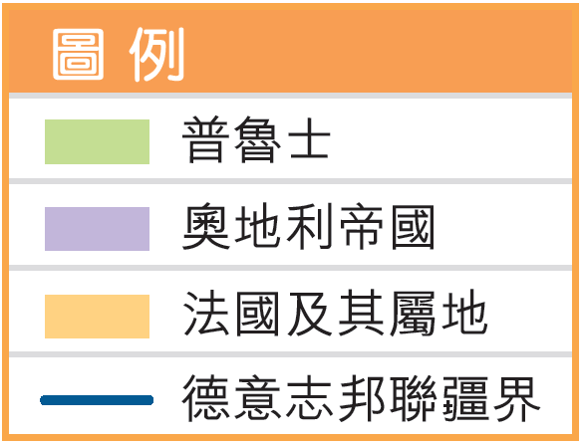
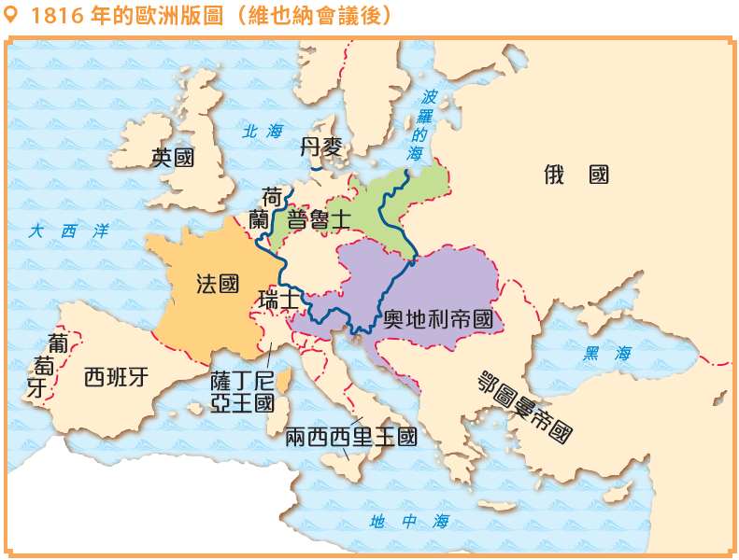

iii. Beginning of revolutionary waves in Europe

- Between 1814 and 1815, European great powers held the Congress of Vienna in an attempt to restore the old order before the French Revolution.
- Participants agreed to support the restoration of absolute dynasty, and rearranged the European territories based on their own interests.

The Congress of Vienna was held between 1814 and 1815 in Vienna, the capital of Austria.
Led by Austria, Prussia, Russia and Britain, it was the first of a series of meetings in which
great powers gathered to discuss and settle international issues together.

Europe in 1816 (after the Congress of Vienna)
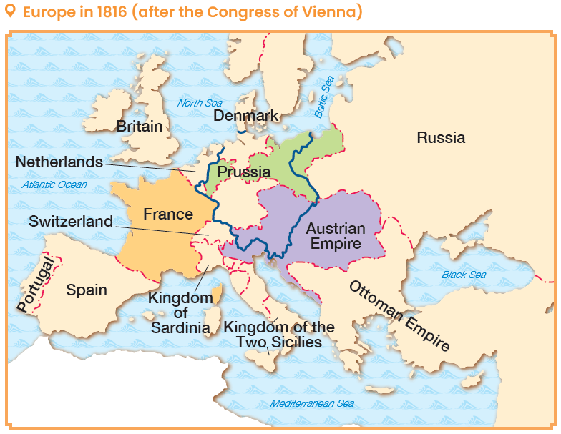
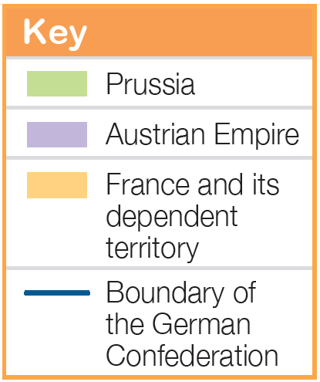

- 維也納會議引起歐洲各地人民的不滿。在1820-1840 年代，法國、普魯士、奧地利等國出現數次革命浪潮。

1848-1849年間的歐洲革命
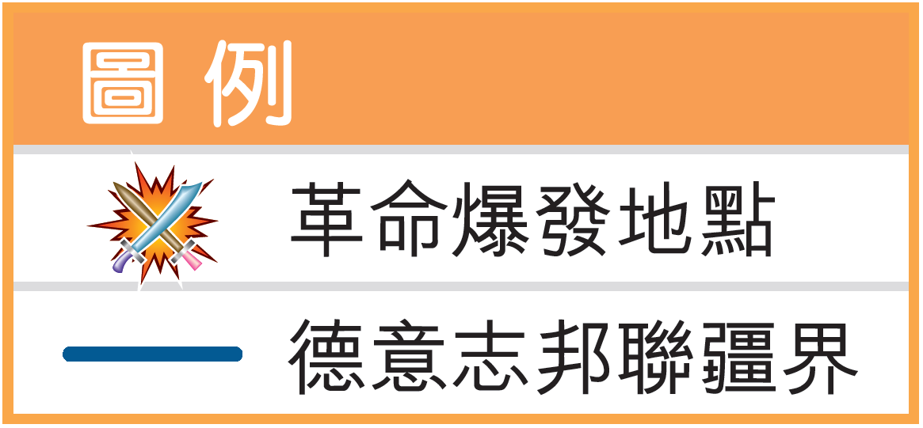
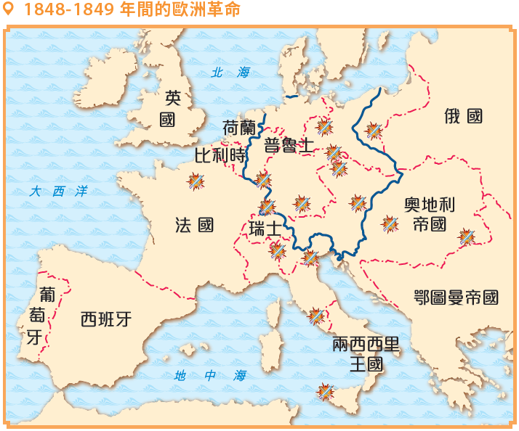

iv. 推動歐洲民族統一運動

法國大革命喚醒歐洲各國爭取民族獨立的思潮。其後，拿破崙的軍事擴張亦帶來新的壓迫，使民族主義在歐洲進一步流行。

- The Congress of Vienna aroused discontent throughout Europe. As a result, several revolutionary waves took place in countries such as France, Prussia, Austria, etc. during the 1820s-1840s.

European revolutions during 1848-1849
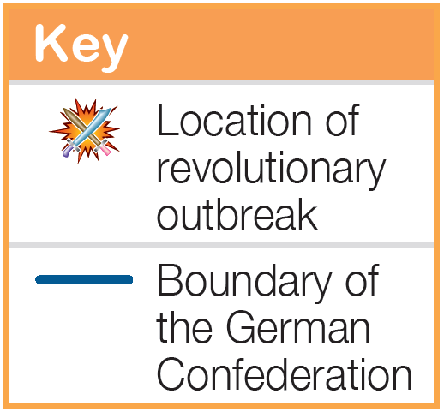
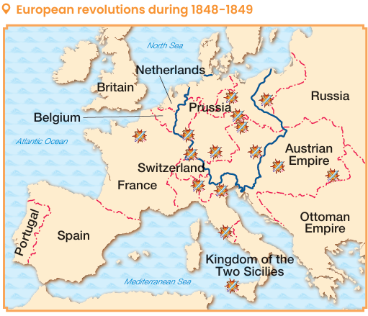

iv. Promoting national unification movements in Europe

The French Revolution gave rise to the idea of fighting for national independence in European countries. Later, Napoleon's military expansion, which brought about new oppressions, further pushed the spread of nationalism in Europe.

1 意大利統一運動

維也納會議把意大利的許多領土置於外國統治下，促使意大利人投身於統一運動。在薩丁尼亞王國的領導下，意大利於1870 年完成統一。

意大利統一運動的主要發展
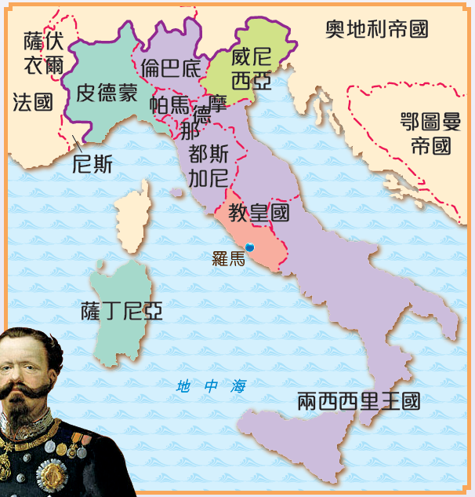

1859年 | 薩丁尼亞在對奧地利的戰爭中，奪回北部的一些土地。
1860年 | 薩丁尼亞與中、南部諸邦合併。
1861年 | 收復南部西西里等地區，成立意大利王國。
1866年 | 意大利收復威尼西亞。
1870年 | 意大利乘法國在普法戰爭（1870 -1871年）中失敗之機，派軍佔領羅馬。
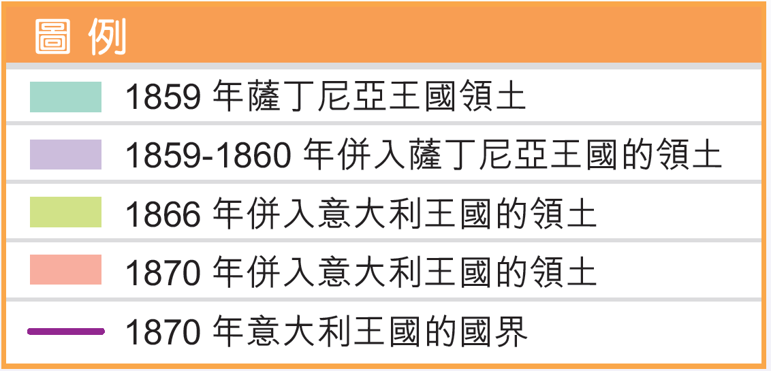
1 Unification of Italy

When the Congress of Vienna put many parts of the Italian territory under foreign rule, the Italians took part in the unification movement. Led by the Kingdom of Sardinia, the unification of Italy was completed in 1870.

Major developments of the unification of Italy

1859 | Sardinia fought Austria and won back some northern territories.
1860 | Sardinia united with some states in central and southern Italy.
1861 | Sardinia recovered the southern regions, including Sicily. The Kingdom of Italy was founded.
1866 | Italy recovered Venetia.
1870 | Taking advantage of the French defeat in theFranco-Prussian War (1870-1871), Italy sent troops to occupy Rome.
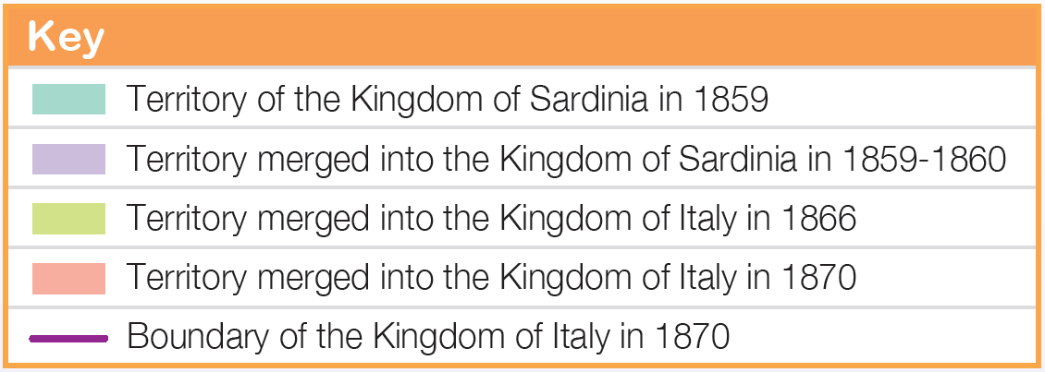
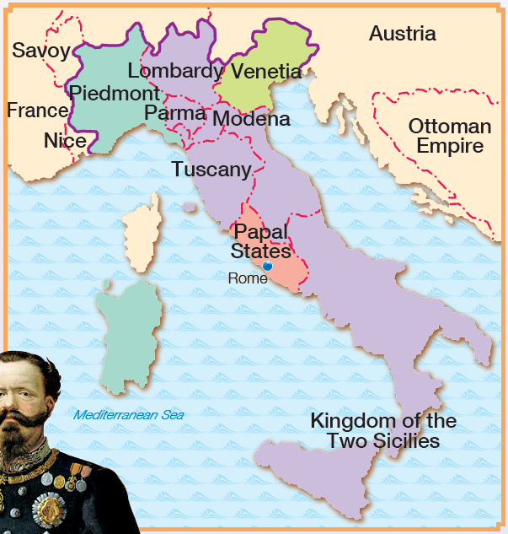
Sardinia
2 德意志統一運動

- 由1830 年代起，德意志邦聯內的普魯士和奧地利爭奪統一運動的領導權。
- 後來，普魯士漸漸取得上風，最後於1871 年完成統一，建立德意志帝國。

德意志統一運動的主要發展
1834年 | 普魯士與德意志十多個邦國訂立關税聯盟，其後成員不斷增多（但奧地利未有參加）。
1866年 | 普魯士在戰爭中打敗奧地利。
1867年 | 以普魯士為首的北德意志邦聯成立。
1870年 | 普法戰爭爆發，結果法國慘敗，德意志南部各邦國擺脱其控制。
1871年 | 德意志帝國成立。

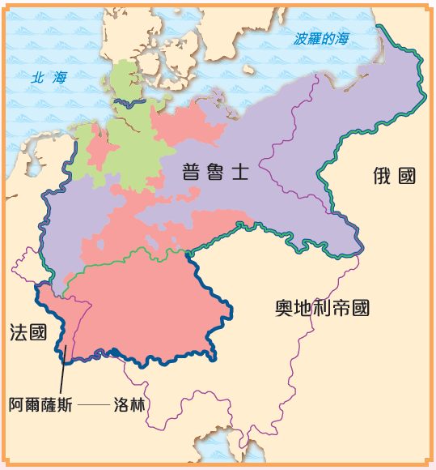

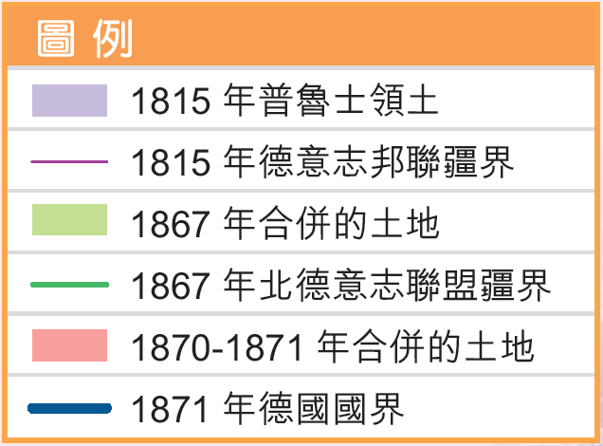

v. 激發美洲的獨立運動

- 法國的美洲殖民地海地於1804年取得獨立。
- 其後，墨西哥、阿根廷、巴西等地亦相繼在19 世紀上半葉掀起獨立戰爭，成功擺脫歐洲殖民統治而獲得獨立。
2 Unification of Germany

- Since the 1830s, Prussia and Austria in the German Confederation had competed for the leadership role in the national unification. Prussia gradually gained the upper hand.
- In 1871, the unification of Germany was completed. The German Empire was founded.

Major developments of the unification of Germany
1834 | Prussia and a dozen German states formed a customs union, whose members continued to grow in number (but Austria never joined).
1866 | Prussia defeated Austria in a war.
1867 | The Northern German Confederation, headed by Prussia, was formed.
1870 | France was defeated in the Franco-Prussian War. The southern German states thus got rid of the French control.
1871 | The German Empire was founded.

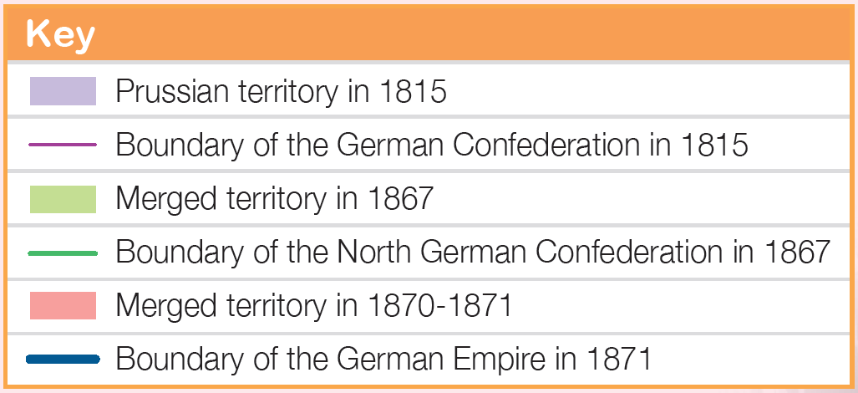
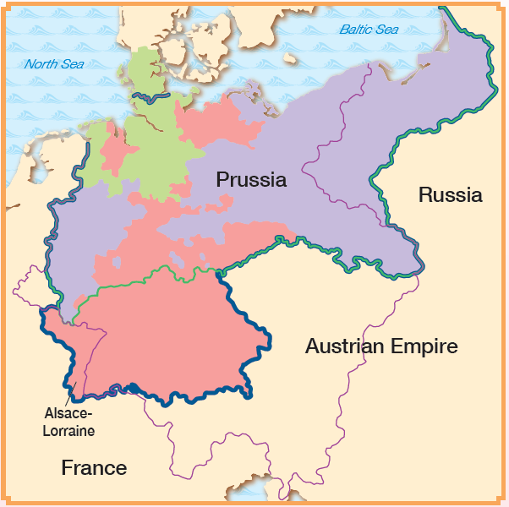
v. Encouraging independence movements in the Americas

- Haiti, a French colony in the Americas, gained independence in 1804.
- Since then, Mexico, Argentina, Brazil, etc. had also launched wars of independence in the first half of the 19th century. They succeeded in overthrowing European colonial rule and gained independence.
重點練習

1. 根據課文內容，完成下列各題文字。

(a) ___1789___ 年爆發的法國大革命，是近代最重要的政治革命之一。它的規模龐大，歷時長達十年（1789-1799年），以「______自由___ 、 ___平等___ 、 ___博愛___ 」口號而著稱於世。
(b) 在 ___波旁___ 王朝的統治下，法國社會存在嚴格的等級區分。整個社會主要分為三個等級：第一等級是 ___教士___ ，第二等級是 ___貴族___ ，第三等級是 ___平民___ ，包括 ___農民___ 、 ___工人___ ，以及 ___商人___ 、 ___律師___ 等中產階級。
(c) ___巴士底監獄___ 陷落，被視為法國大革命開始的標誌，後來法國的國慶日也定於7月14日。
(d) ___1804___ 年12月，拿破崙正式加冕為皇帝，成立「 ___法蘭西第一帝國___ 」。1814年初，拿破崙被迫退位，並遭流放到地中海的 ___愛爾巴島___ 。1814年2月，拿破崙潛返法國，重新登上帝位。1815年6月，法軍在 ___滑鐡盧戰役___ 戰敗，被流放到大西洋的 ___聖海倫娜島___，至1821 年病逝。
(e) 「 ___維也納會議___ 」旨在恢復 ___法國大革命___ 以前的舊秩序。與會代表同意復辟被推翻的 ___專制王朝___ ，又按照自己的利益重新分配歐洲領土。

2. 試選擇適當答案，並將其英文代號填入方格內。
(a) 法國大革命在哪位君主在位期間爆發？
A. 路易十四 B. 路易十五
C. 路易十六 D. 路易十七
C

Key Exercises

1. Fill in the blanks according to the textbook content.

(a) The French Revolution that broke out in ___1789___ lasted for ten years was one of the most important political revolutions in the modern world. Its scale was broad. It was famous for its ' ___liberty___, ___equality___ and ___fraternity___' slogan.
(b) Under the rule of the Bourbon House, there were strict divisions of estates in the French society. There were three estates: the first estate was the ___clergy___ , the second was the ___nobility___ , and the third was the ___common people___ , including ___peasants___ , ___craftsmen___ and the middle class like ___merchants___ and ___lawyers___ .
(c) The fall of the ___Bastille___ marked the beginning of the French Revolution. ___14 July___ has become the national day of France.
(d) In December ___1804___, Napoleon crowned himself emperor and founded the ___First French Empire___ . In early 1814, Napoleon gave up his throne, and was exiled to the ___island of Elba___ in the Mediterranean Sea. In June 1815, the French army was defeated at the ___Battle of Waterloo___ . As a result, Napoleon was exiled again, this time to ___the island of Saint Helena___ in the Atlantic Ocean. In 1821, Napoleon died.
(e) ___Congress of Vienna___ aimed at restoring the old order before the ___French Revolution___ . The Participants agreed to support the restoration of ___absolute dynasty___ , and rearranged the European territories based on their own interests.

2. Choose the appropriate answer and put it in the corresponding box.
(a) During the reign of which king did the French Revolution break out?
A. Louis XIV B. Louis XV
C. Louis XVI D. Louis XVII
C

(b) 以下哪一項為有關法國大革命時間的正確時序？
A. 巴士底監獄陷落→ 拿破崙時代→恐怖時代→ 維也納會議
B. 巴士底監獄陷落→ 恐怖時代→ 拿破崙時代→ 維也納會議
C. 恐怖時代→ 巴士底監獄陷落→拿破崙時代→ 維也納會議
B
D. 巴士底監獄陷落→恐怖時代→ 維也納會議→ 拿破崙時代

(c) 意大利於哪一年完成民族統一運動？
A. 1872年 B. 1871年
C
C. 1870年 D. 1869年

(d) 以下哪項歷史事件受法國大革命的影響？
A. 美國革命 B. 七年戰爭
C
C. 維也納會議 D. 明治維新

(b) Which of the following is a correct chronological order for the events during the French Revolution?
A. Fall of the Bastille→ Napoleonic era→ Reign of Terror→ Congress of Vienna
B. Fall of the Bastille→ Reign of Terror→ Napoleonic era→ Congress of Vienna
C. Reign of Terror→ Fall of the Bastille→ Napoleonic era→ Congress of Vienna
D. Fall of the Bastille→ Reign of Terror→Congress of Vienna→ Napoleonic era
B

(c) In which years did Italy complete its national unification?
A. 1872 B. 1871
C
C. 1870 D. 1869

(d) Which of the following historical events was caused by the French Revolution?
A. American Revolution B. Seven Years' War
C
C. Congress of Vienna D. Meiji Restoration

