課題5 近代歐洲的興起
V 15至18世紀亞洲文明的狀況（延伸部份）

關鍵詞
蒙兀兒帝國 | Mughal Empire
鄂圖曼帝國 | Ottoman Empire
細密畫 | Miniature painting
泰姬陵 | Taj Mahal
印地語 | Hindi
烏爾都語 | Urdu
梵文 | Sanskrit
伊斯坦堡 | Istanbul
蘇丹 | Sultan
米利特 | Millet
花押體 | Tughra
英屬東印度公司 | British East Indian Company

溫習要點
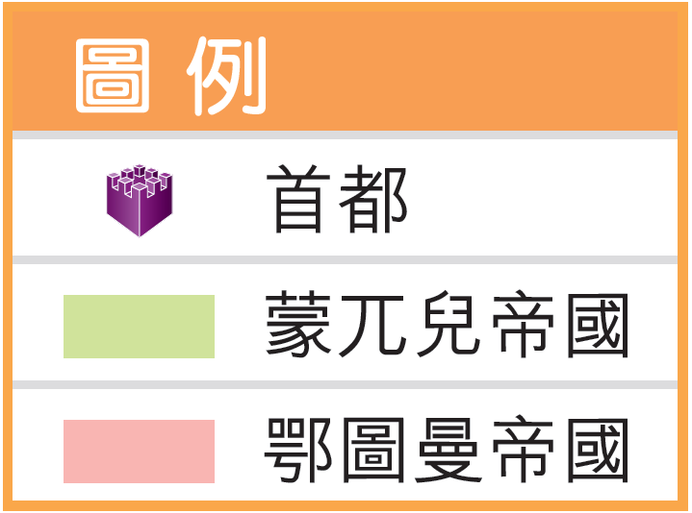
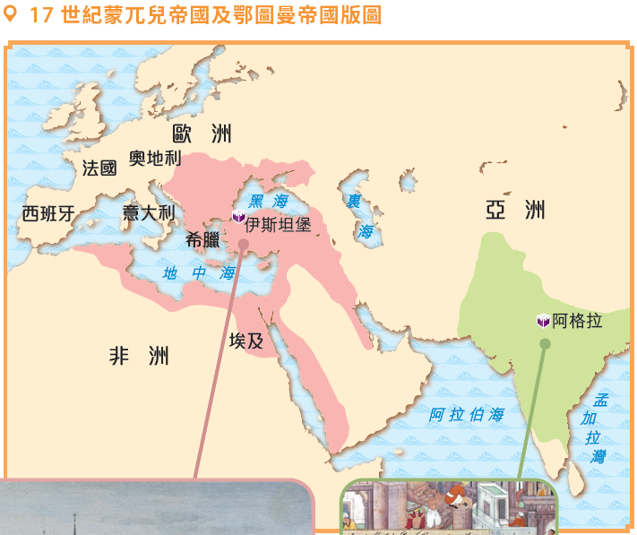
在歐洲經歷文藝復興的同時，兩個強大的伊斯蘭帝國在亞洲及西亞地區崛起，分別是印度的蒙兀兒帝國和土耳其的鄂圖曼帝國。

Topic 5 The rise of modern Europe
V Condition of Asian civilisations from the 15th to 18th centuries (Extended part)

Key Terms
蒙兀兒帝國 | Mughal Empire
鄂圖曼帝國 | Ottoman Empire
細密畫 | Miniature painting
泰姬陵 | Taj Mahal
印地語 | Hindi
烏爾都語 | Urdu
梵文 | Sanskrit
伊斯坦堡 | Istanbul
蘇丹 | Sultan
米利特 | Millet
花押體 | Tughra
英屬東印度公司 | British East Indian Company
Revision Points
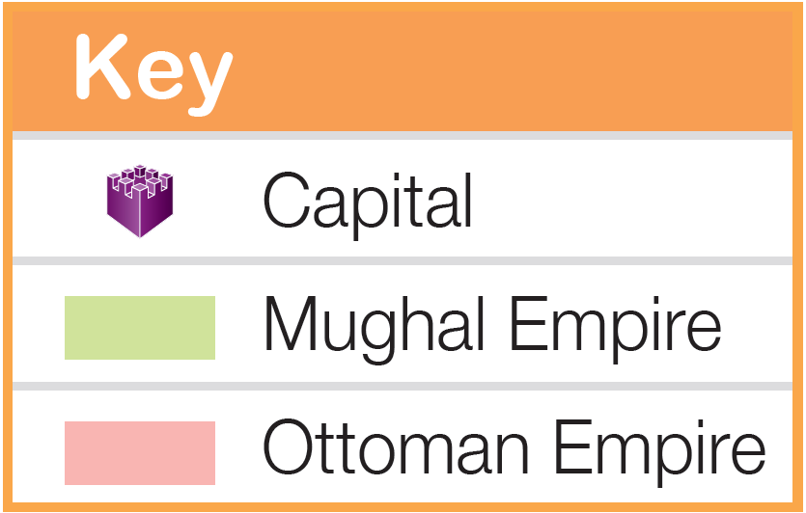
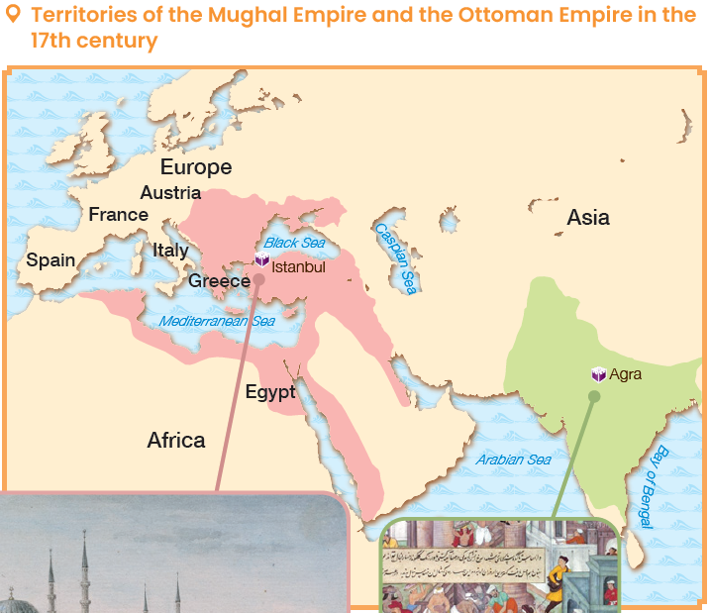
While Europe underwent the Renaissance, two great empires rose in Asia and West Asia respectively, namely the Mughal Empire in India and the Ottoman Empire in Turkey.

A 印度的蒙兀兒帝國

蒙兀兒帝國的興起

- 1526 年，巴布爾開創了蒙兀兒帝國。他自命是蒙古帝國的繼承者，而「蒙兀兒」是波斯語的「蒙古」。
- 蒙兀兒皇帝對原來信奉印度教的民眾採取寬容的政策，使印度文化得到保留，並與伊斯蘭文化相互融合。

ii. 蒙兀兒帝國的文化成就
1 繪畫

- 蒙兀兒皇帝大多愛好藝術，宮廷裏聚集了大批來自波斯的畫家。
- 這些畫家融合伊斯蘭、印度和西方的繪畫風格，形成別具一格的蒙兀兒畫派。

蒙兀兒畫作特色
- 多出現在書籍插畫或畫集內
- 以宮廷生活、戰爭、狩獵等為題材
- 色彩艷麗
- 人物描繪較平面

A Mughal Empire in India

Rise of the Mughal Empire

- In 1526, Babur founded the Mughal Empire. He claimed himself to be the successor to the Mongol Empire. ‘Mughal’ means ‘Mongol’ in Persian.
- The Mughal emperors adopted tolerant policies towards the people who believed in Hinduism, which helped to preserve Indian culture, which also absorbed Islamic culture.

ii. Cultural achievements of the Mughal Empire
1 Painting

- As most of the Mughal emperors loved art, there were a lot of Persian painters at court.
- These painters merged Islamic, Indian and Western painting styles together, forming the unique Mughal style.

Features of the Mughal paintings
- Usually as book illustrations or works in albums
- On the subjects of court life, battles, hunting scenes, etc.
- Bright colours
- Flat depiction of characters

2 建築

- 蒙兀兒建築一方面保留印度建築的特色，如多以紅砂岩和白色大理石建成；同時吸收了圓頂、拱門等伊斯蘭特色。
- 蒙兀兒建築以泰姬陵為典範。泰姬陵典雅優美，於1983 年被列為世界文化遺產。

泰姬陵的建築特色
結構對稱
拱門
圓頂
主要以白色大理石建成

3 宗教

在蒙兀兒帝國時期，一些融合印度教和伊斯蘭教的新宗教出現，其中以錫克教最廣為流傳。

4 文學

波斯語是蒙兀兒帝國的官方語言。不少穆斯林詩人移居印度，以波斯語寫下出色的詩作。

2 Architecture

- The Mughal buildings maintained Indian architectural features, such as using red sandstone and white marble as building materials. They also adopted Islamic features, including domes and arches.
- The beautiful Taj Mahal, which was declared a World Cultural Heritage site in 1983, is a prime example of Mughal architecture.

Architecture features of the Taj Mahal
Dome
Arch
Symmetrical structure
Mainly built of white marble

3 Religion

During the Mughal period, new religions that adopted elements from both Hinduism and Islam emerged. Among them, Sikhism was the most popular and widely spread one.

4 Literature

Persian was the official language of the Mughal Empire. Many Muslim poets moved to India and wrote outstanding poems in Persian.

B 土耳其鄂圖曼帝國

鄂圖曼帝國的興起

- 13 世紀末，信奉伊斯蘭教的奧斯曼一世在西亞建立鄂圖曼帝國，其最高統治者稱為蘇丹。
- 1453 年，鄂圖曼帝國攻陷君士坦丁堡，東羅馬帝國滅亡。君士坦丁堡改名為伊斯坦堡，成為了鄂圖曼帝國的首都。
- 鄂圖曼帝國位處東、西方的交匯處，而且版圖橫跨歐、亞、非三大洲。
- 鄂圖曼帝國因而長期吸收各地的文化，造就了多元的文化特質。

ii. 蒙兀兒帝國的文化成就
1 宗教

鄂圖曼帝國以伊斯蘭教為國教，同時實施寬容的宗教政策。非穆斯林人民被允許保持原有信仰，甚至享有部分自治權。

描繪鄂圖曼蘇丹（左）與東正教教會領袖會面的畫作

B Ottoman Empire in Turkey

Rise of the Ottoman Empire

- At the end of the 13th century, Osman I, who believed in Islam, founded the Ottoman Empire in West Asia. The Ottoman supreme ruler is known as sultan.
- In 1453, the Ottoman Empire conquered Constantinople, leading to the fall of the East Roman Empire. Constantinople was then renamed Istanbul and became the capital of the Ottoman Empire.
- The Ottoman Empire was at the centre of interactions between the East and the West, covering parts of Europe, Asia and Africa.
- The Ottoman Empire continuously absorbed cultures from different regions, fostering its multi-cultural nature.

ii. Cultural achievements of the Ottoman Empire
1 Religion

While having Islam as the state religion, the Ottoman Empire adopted tolerant religious policies. Non-Muslims were allowed to practise their original religions, and could even enjoy a certain degree of autonomy.

Painting showing a meeting between the Ottoman sultan
(left) and the leader of the Eastern Orthodox Church

2 文學

鄂圖曼帝國時期的詩歌創作豐富。詩人以阿拉伯語、波斯語和土耳其語進行創作，呈現出鄂圖曼文學的多元特色。

3 建築

- 鄂圖曼建築吸收了波斯、東羅馬帝國和伊斯蘭阿拉伯式的建築風格，以方形建築上的圓穹為特色。
- 鄂圖曼帝國又把東羅馬帝國時期所建造的聖索菲亞大教堂轉化為清真寺。

鄂圖曼時期的建築及藝術特色
- 位於伊斯坦堡的聖索菲亞大教堂原是君士坦丁大帝在4世紀建成的東正教教堂。
- 鄂圖曼帝國時期，教堂被改裝成清真寺，加上伊斯蘭教的紋飾和建築等。

為召喚穆斯林進行禮拜而加建的尖塔
圓頂
今日的聖索菲亞大教堂，於2020年再度被改為清真寺。

2 Literature

The Ottoman Empire was rich in poetic works. Poets used Arabic, Persian and Turkish to write poems, showing the diversity of Ottoman literature.

3 Architecture

- The Ottoman Empire absorbed the architectural styles of Persia, the Eastern Roman Empire and Islamic Arabia. The main feature of Ottoman architecture was the use of domes at the top of quadrangle buildings.
- The Ottoman Empire also changed the Hagia Sophia built by the Eastern Roman Empire into a mosque.

Architectural and artistic features during the Ottoman period
- The Hagia Sophia, located in Istanbul, was originally an Eastern Orthodox church built by Emperor Constantine in the 4th century.
- During the Ottoman period, the church was changed into a mosque, which was added with Islamic decorations and architectural elements.

Dome
Pointed tower added for calling Muslims to prayer
Today's Hagia Sophia, which was changed into a mosque again in 2020
4 藝術

- 鄂圖曼時期聞名於世的「花押體」書法，改良自伊斯蘭的書法。
- 另外，鄂圖曼時期的瓷器具有中國瓷器和阿拉伯花紋的元素。
掛有花押體文字的裝飾
瓷磚色彩華麗

聖索菲亞大教堂的內部設計

4 Arts

- In calligraphic art, the Ottoman Empire was famous for its tughra, which was inspired by Islamic calligraphy.
- Furthermore, porcelain during the Ottoman period adopted Chinese elements and arabesque patterns.

Wall-hung decorations with the tughra
Colourful tiles

Interior of the Hagia Sophia

重點練習
1. 根據課文內容，完成下列各題文字。
(a) 1526 年，信奉 ___伊斯蘭教___ 的 ___巴布爾___ 征服了印度，開創了蒙兀兒帝國。
(b) 蒙兀兒帝國皇帝對原來信奉 ___印度教___ 的民眾採取寬容的宗教政策 ，例如容許他們與 ___穆斯林___ 通婚。
(c) 蒙兀兒畫作以 ___宮廷生活___ 、___戰爭___ 、狩獵等為題材，色彩 ___艷麗___ 。
(d) 信奉 ___伊斯蘭教___ 的 ___奧斯曼一世___ 建立鄂圖曼帝國。
(e) 鄂圖曼時期的瓷器具有 ___中國瓷器___ 和 ___阿拉伯花紋___ 的元素。

2. 試選擇適當答案，並將其英文代號填入方格內。
(a) 以下哪項不是泰姬陵的建築特色？
A. 圓頂
B. 主要以白色大理石建成
C. 正宗伊斯蘭建築
C
D. 拱門

(b) 以下哪個地方是鄂圖曼帝國的首都？
A. 君士坦丁堡
B. 伊斯坦堡
C. 愛丁堡
B
D. 奧德堡

Key Exercises
1. Fill in the blanks according to the textbook content.
(a) In 1526, ___Babur___ , who believed in ___Islam___ , conquered India and founded the Mughal Empire.
(b) The Mughal Emperors adopted tolerant policies towards the people who believed in ___Hinduism___ . For example, they were allowed to marry ___Muslims___ .
(c) Mughal paintings used ___bright___ colours to depict subjects like ___court life___ , ___battles___ , hunting scenes, etc.
(d) ___Osman I___ , who was a ___Muslim___ , founded the Ottoman Empire.
(e) Ottoman porcelain contained ___Chinese design___ and the element of ___arabesque___.

2. Choose the appropriate answer and put it in the corresponding box.
(a) Which of the following was not an architectural feature of the Taj Mahal?
A. Dome
B. Mainly built of white marble
C. Purely Islamic architecture
C
D. Arch

(b) Which of the following place was the capital of the Ottoman Empire?
A. Constantinople
B. Istanbul
C. Edinburgh
B
D. Aldeburgh

