課題9 20 世紀的國際紛爭及危機(I)

—兩次世界大戰
I 兩次世界大戰前歐美、亞洲等國家的關係和爆發衝突的原因

關鍵詞
世界大戰 | World War
總體戰 | total war
極端民族主義 | extreme nationalism
軍備競賽 | arms race
徵兵制 | conscription
歐洲的火藥庫 | powder keg of Europe
塞拉耶佛事件 | Sarajevo Incident
最後通牒 | ultimatum
巴黎和會 | Paris Peace Conference
凡爾賽條約 | Treaty of Versailles

溫習要點
世界大戰的特徵
涉及多個國家，遍及歐、亞、非等洲。
戰後舉行軍事法庭審訊，懲罰戰犯。
透過海報、傳單等，進行政治宣傳。
坦克、戰艦、戰鬥機等新型現代武器投入戰場。
採用總體戰模式，動員所有資源投入戰爭。
造成逾千萬軍人及平民死亡，傷亡慘重。

Topic 9 International conflicts and crises in the 20th century (I)—the two

World Wars
I Relations among countries in Europe, America and Asia and reasons for their conflicts before the two World Wars

Key Terms
世界大戰 | World War
總體戰 | total war
極端民族主義 | extreme nationalism
軍備競賽 | arms race
徵兵制 | conscription
歐洲的火藥庫 | powder keg of Europe
塞拉耶佛事件 | Sarajevo Incident
最後通牒 | ultimatum
巴黎和會 | Paris Peace Conference
凡爾賽條約 | Treaty of Versailles

Revision Points
Characteristics of a World War
Involving many countries across Europe, Asia, Africa and other continents
Holding post-war military tribunals to punish war criminals
Implementing political propaganda by means of posters and leaflets
Using modern weapons such as tanks, battleships, fighter aircraft, etc.
Mobilising all resources under the mode of total war
Causing millions of military and civilian casualties

A 第一次世界大戰（1914-1918 年）

19世紀末歐洲的政治形勢

- 1871年，普魯士在普法戰爭中擊敗法國。自此，法國與德國成為宿敵。
- 德國的迅速崛起令傳統的歐洲列強如英國、俄國等感到不安。
- 鄂圖曼帝國的影響力逐漸衰落。奧匈帝國（奧匈）和俄國乘虛而入，向歐洲東南部的巴爾幹半島擴張。歐洲局勢越趨緊張。

- 第一次世界大戰的成因
- 極端民族主義滋長

極端民族主義主張對國家絕對忠誠，並鼓吹國家對外擴張，以炫耀國力及民族優越性。

歐洲主要的極端民族主義
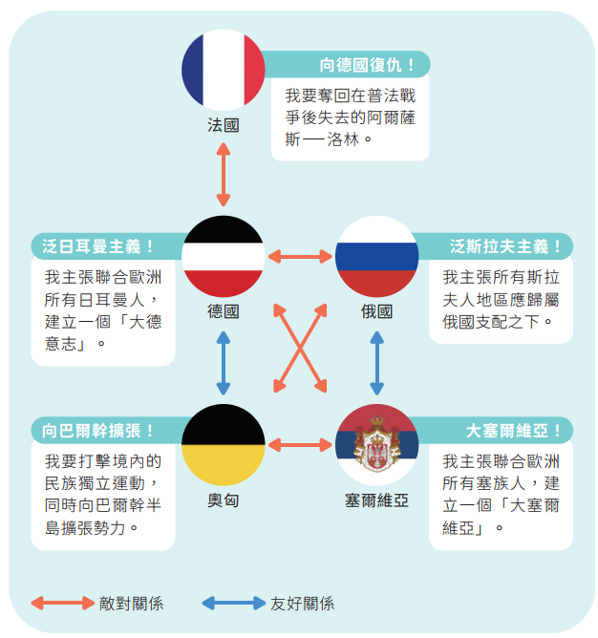
各國不願以和平方法解決矛盾，甚至作好開戰的準備。

A First World War (1914-1918)

European political situation at the end of the 19th century

- In 1871, Prussia defeated France in the Franco-Prussian War. Since then, France and Germany had become archenemies of each other.
- Germany's rapid rise threatened traditional European powers such as Britain and Russia.
- The influence of the Ottoman Empire declined. The Austro-Hungarian Empire (Austria-Hungary) and Russia seized the opportunity to expand into the Balkan Peninsula in southeastern Europe. The situation in Europe became increasingly tense.

- Causes of the First World War
- Growth of extreme nationalism

Extreme nationalism demanded absolute obedience to the state. It also advocated foreign expansion to show off national strength and racial superiority.

Main forms of extreme nationalism in Europe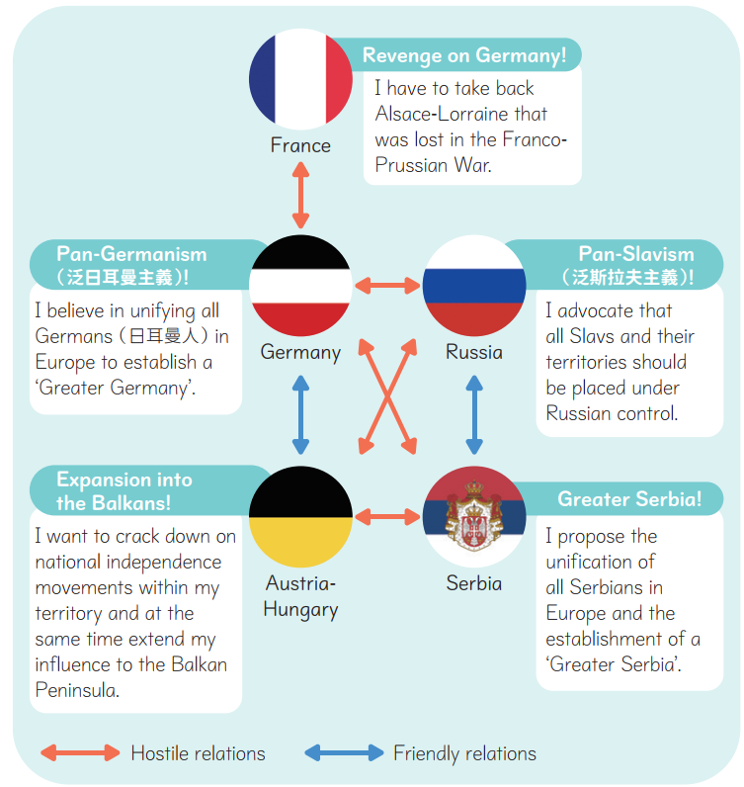
Countries were unwilling to settle conflicts peacefully and even prepared for war.

- 對立軍事同盟形成

- 1882 年，德國與奧匈及意大利組成「三國同盟」，以防範法國的報復。
- 法國為打破孤立的局面，積極拉攏俄國和英國。1907 年，英、法、俄組成「三國協約」。

20世紀初歐洲的對立軍事同盟
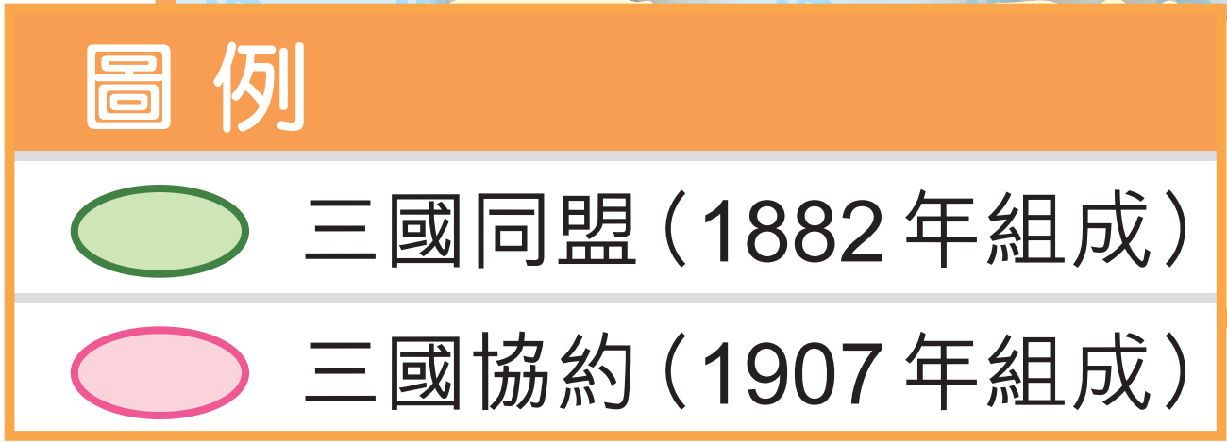
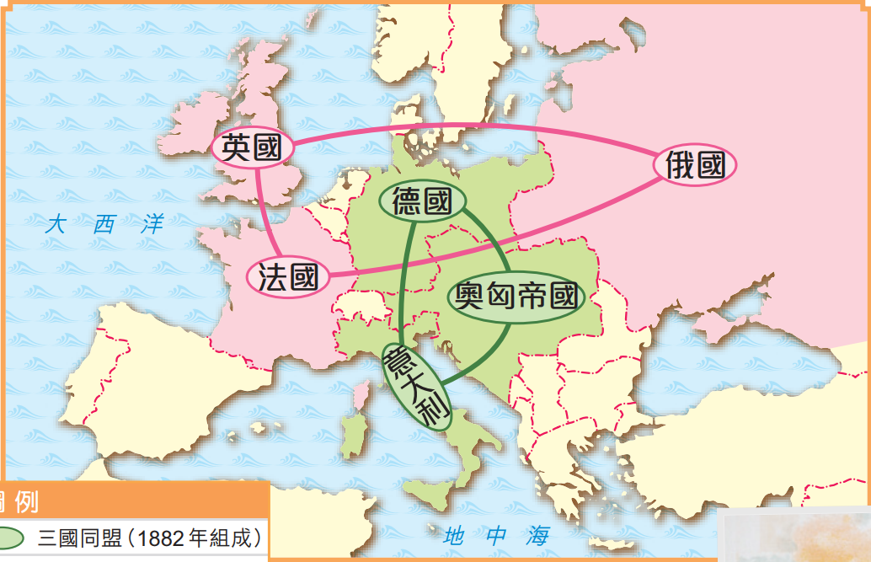
- 歐洲分裂成兩大敵對軍事同盟。
- 一旦同盟內任何一國受到攻擊，其他盟友都可能因着軍事協約的緣故而介入，把地區性戰爭擴展成大型戰爭。

2 Formation of rival military alliances

- In 1882, Germany formed the Triple Alliance with Austria-Hungary and Italy to prevent France's revenge.
- In 1907, Britain, France and Russia formed the Triple Entente.

Rival military alliances in early 20th-century Europe
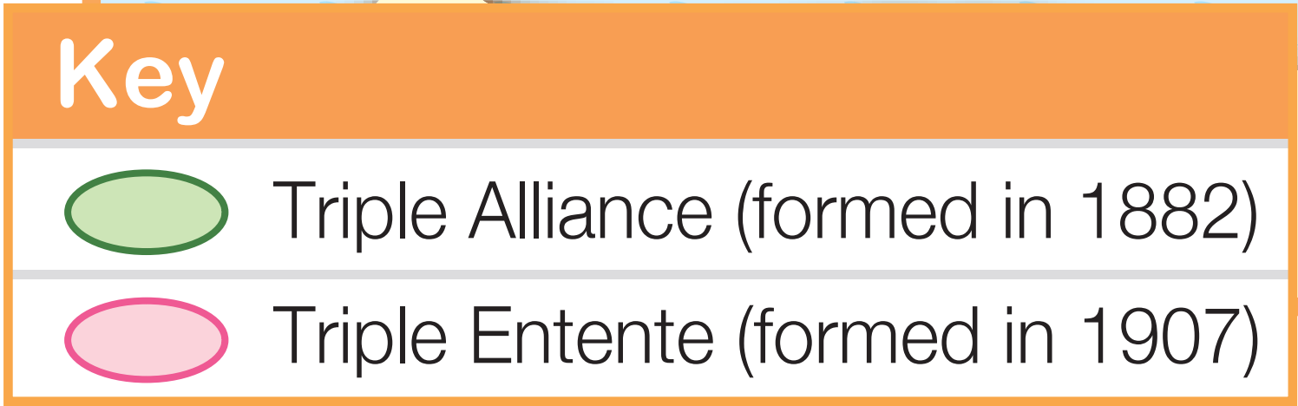
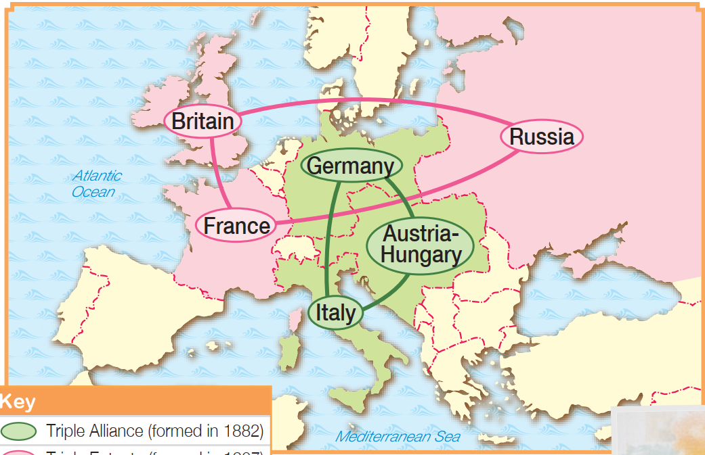
- Europe was divided into 2 rival military alliances.
- If anyone country in the alliance came under attack, the other allies would have to intervene because of the military pact. A local war might then escalate into a large-scale war.
- 列強爭奪殖民地

- 工業革命後，英、法等歐洲列強為了開發海外的商品市場和新的原料產地，紛紛在亞洲和非洲建立殖民地。
- 至 19 世紀末，新興的德國亦加入到爭奪殖民地的行列中。

20世紀初歐洲列強和美國殖民地位置圖
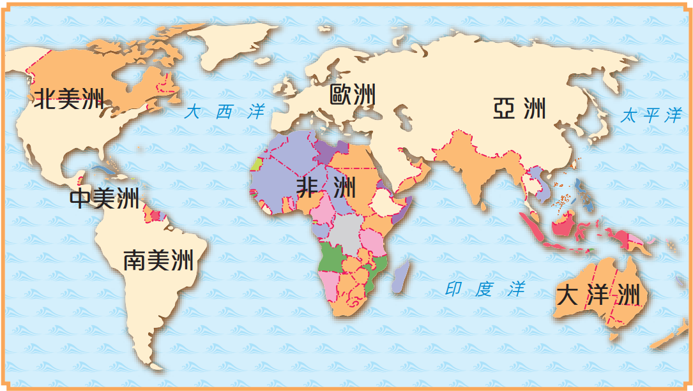
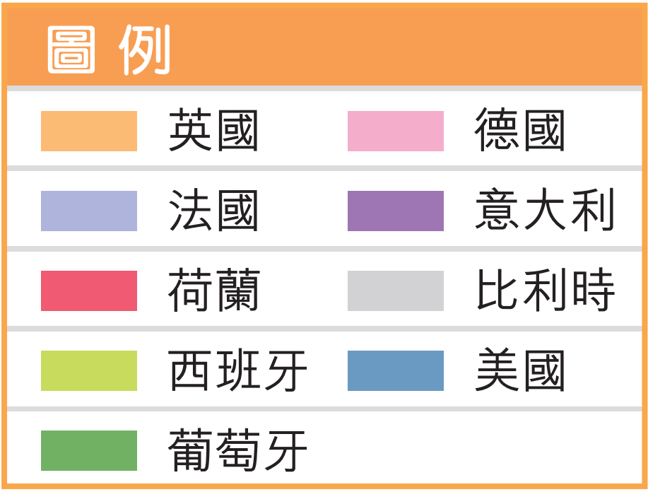
殖民地的爭奪使歐洲列強的關係更形惡劣，引發連串外交衝突。

- Scramble for colonies among the powers

- After the Industrial Revolution, European powers such as Britain and France explored overseas markets for commodities and new origins of raw materials. In order to do so, they set up colonies in Asia and Africa.
- By the end of the 19th century, the rising Germany had joined the scramble for colonies.

Distribution of colonies of European powers
and the US in the early 20th century
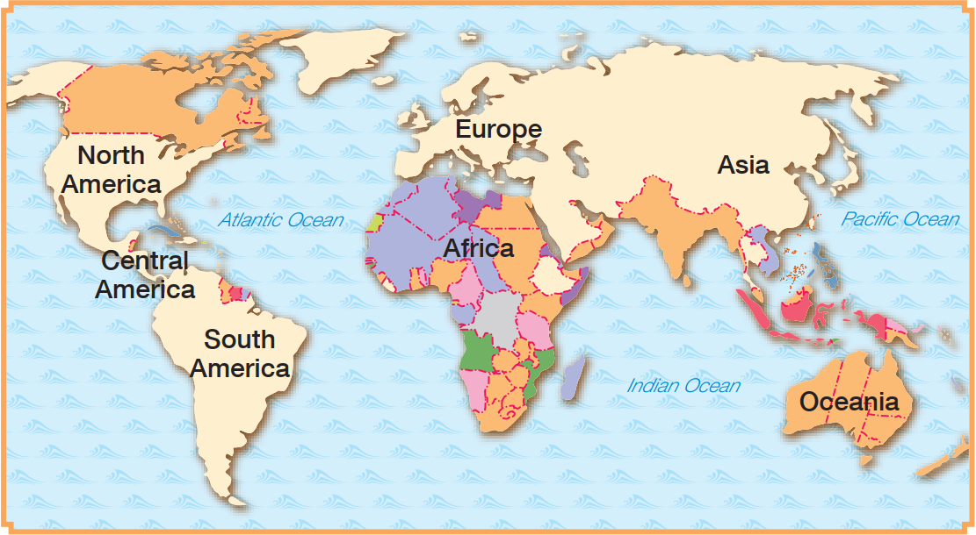
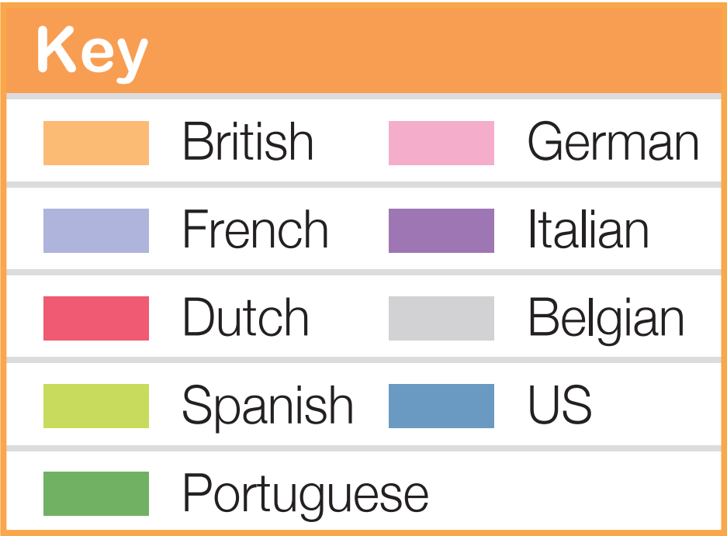
The scramble for colonies worsened the relations among European powers, leading to a series of diplomatic conflicts.

- 列強展開軍備競賽

- 為擴建殖民地及炫耀國力，歐洲列強在19世紀末起不斷增加軍備開支。
- 俄、德等國推行徵兵制，以增加軍隊人數。
- 列強爭相建造大型戰艦「 無畏艦」，當中以英、德的競爭最為劇烈。

1908-1913年間歐洲列強的國防及軍事支出
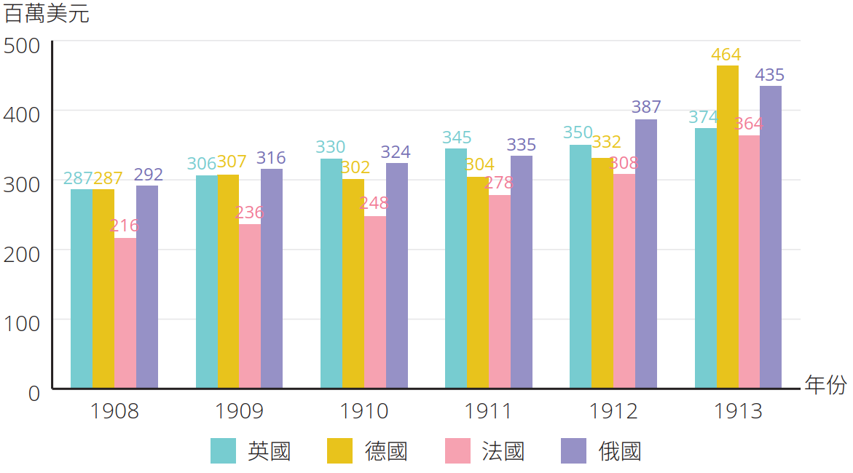
- 列強間的軍備競賽不但未能使它們感到安全，反而令各國
關係更為緊張。
- 在時刻惶恐被別國攻擊的情況下，歐洲列強對裁軍會議持反對態度，增加了戰爭爆發的可能性。
- Arms races among the powers

- To expand colonies and to show off national strength, European powers had kept increasing their military expenditures since the end of the 19th century.
- Russia and Germany adopted conscription to increase the number of troops.
- Powers competed to build large-scale battleship named dreadnought. The race between Britain and Germany was particularly fierce.

Defence and military spending of European powers in 1908-1913
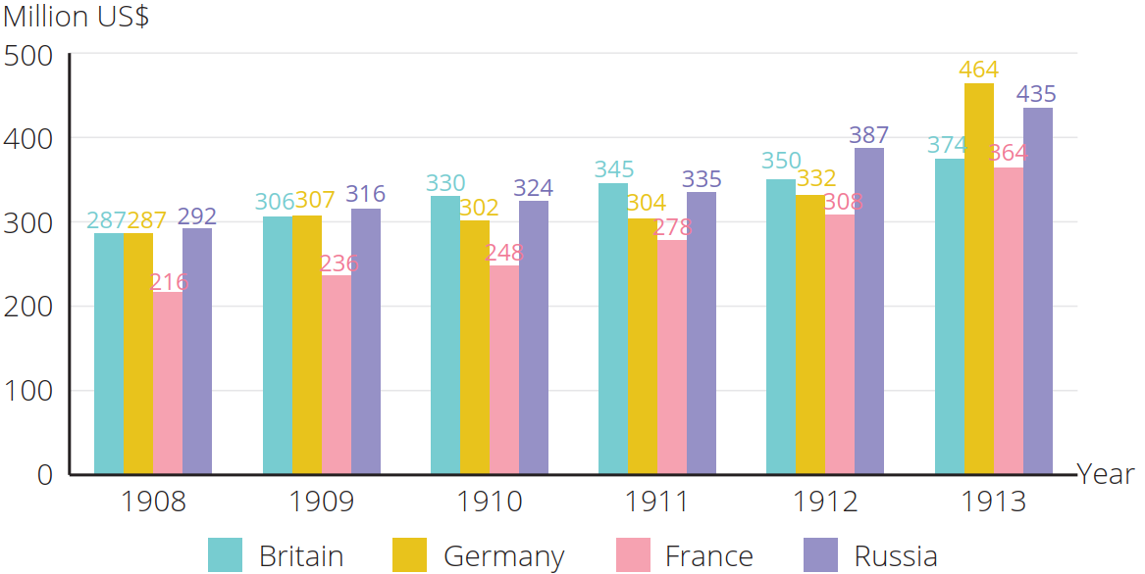
- Instead of making powers feel safe, arms races intensified mutual tensions.
- Fearing that they would be attacked anytime, European powers held a resistant attitude towards disarmament conferences. A war was on the brink of breaking out.

第一次世界大戰前夕的國際危機

北非的國際衝突

1.1 第一次摩洛哥危機（1905-1906年）

德國與法國為爭奪北非摩洛哥的控制權，於1905年發生衝突。結果德國在外交孤立下作出讓步。

1.2 第二次摩洛哥危機（1911年）

1911 年，法、德兩國在摩洛哥再起衝突，因英國支持法國，德國只好再一次讓步。

摩洛哥位置圖
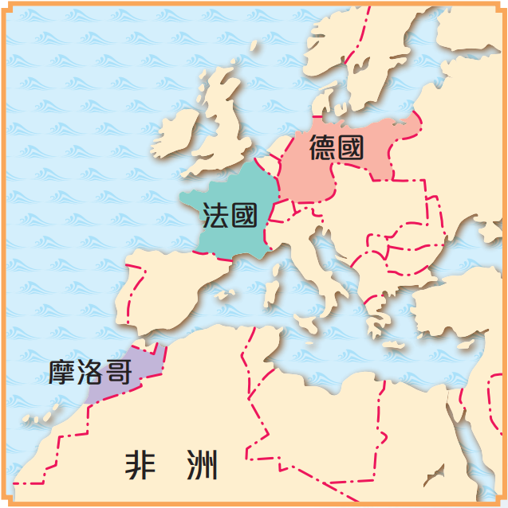
德國在兩次摩洛哥危機中遭受外交挫敗，對英、法的不滿情緒日益高漲。

International crises on the eve of the First World War

International conflicts in North Africa

1.1 First Moroccan Crisis (1905-1906)

Germany and France competed to control Morocco in North Africa. A conflict broke out in 1905. In the end, Germany gave in because it was diplomatically isolated.

1.2 Second Moroccan Crisis (1911)

In 1911, France and Germany clashed because of Morocco again. As Britain supported France, Germany gave in for a second time.

Location of Morocco
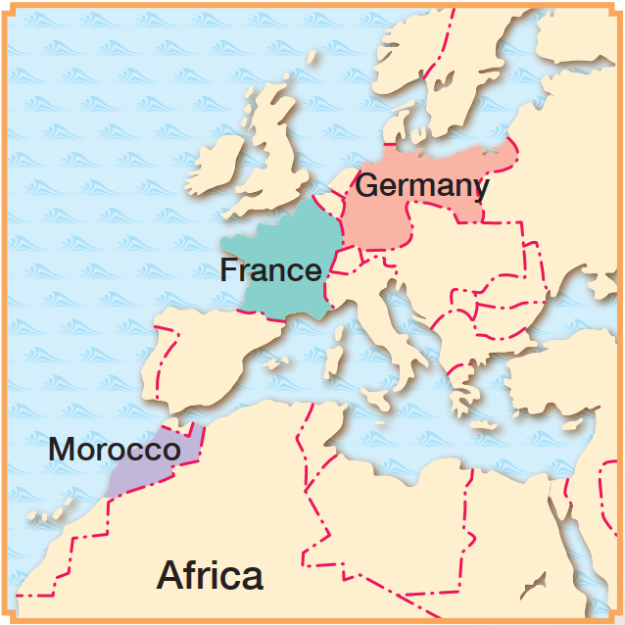
Germany suffered diplomatic setbacks in the two Moroccan Crises.
Its resentment against Britain and France continued to grow.

巴爾幹半島的國際衝突

由於巴爾幹半島由多個民族組成，加上列強的介入，令當地局勢混亂，被稱為「歐洲的火藥庫」。

2.1 波斯尼亞危機（1908年）

- 1908 年，奧匈吞併巴爾幹半島上的波斯尼亞和黑塞哥維那，引起塞爾維亞及俄國的不滿。
- 奧匈獲得德國支持，而俄國則得不到盟友的支持，與塞爾維亞只好作出讓步。
塞爾維亞與奧匈關係進一步惡化。塞族人的反奧情緒急速升温。

2.2 兩次巴爾幹戰爭（1912-1913年）

1912-1913 年，巴爾幹半島上的小國為搶掠鄂圖曼帝國在歐洲剩餘的土地，在九個月內先後爆發了兩次戰爭。
在兩次巴爾幹戰爭後，塞爾維亞領土大增，直接威脅奧匈在巴爾幹半島上的地位。因此，奧匈決心要剷除塞爾維亞。

亞洲的國際衝突

- 19世紀末、20世紀初，很多亞洲地區已淪為列強的殖民地或勢力範圍。
- 1899年，美國提出門戶開放政策，要求各國在中國享有平等的貿易機會，自此開始介入東亞事務。
- 日本自明治維新成功後開始積極在亞洲擴張。 1904年，日本發動日俄戰爭，並擊敗俄國，從此確立在中國東北的勢力。1910年，日本正式吞併朝鮮。

第一次世界大戰的爆發

導火線：塞拉耶佛事件（1914年 6月）

1914年 6月28日，奧匈皇儲斐迪南大公夫婦訪問波斯尼亞首府塞拉耶佛期間，被一名塞爾維亞激進分子所槍殺。

International conflicts on the Balkan Peninsula

The Balkans was made up of multiple ethnic groups. Along with foreign interventions from powers, the situation there had been chaotic. The Balkans became known as the ‘powder keg of Europe’.

2.1 Bosnian Crisis（1908）

- In 1908, Austria-Hungary annexed Bosnia and Herzegovina in the Balkans, upsetting Serbia and Russia. Austria-Hungary was supported by Germany.
- Since Russia could not gain support from its allies, Russia and Serbia backed down.
The relations between Serbia and Austria-Hungary became worse.
Anti-Austrian sentiments grew rapidly among Serbians.

2.2 Two Balkan Wars（1912-1913）

In 1912-1913, 2 wars broke out among small nations in the Balkans within 9 months as they scrambled for the remaining European territory of the Ottoman Empire.
After the two Balkan Wars, Serbia's territory grew significantly, threatening the position of Austria-Hungary in the Balkans. Hence, the latter decided to get rid of Serbia.

International conflicts in Asia

- By the end of the 19th century and the early 20th century, many regions in Asia had already become the powers' colonies or spheres of influence.
- In 1899, the US put forward the Open Door Policy, demanding that all countries should trade in China on an equal basis. This marked the beginning of US interference in East Asian affairs.
- Japan had actively carried out expansion in Asia since the success of the Meiji Modernisation. In 1904, Japan initiated the Russo-Japanese War and defeated Russia, consolidating its influence in Northeast China. In 1910, Japan officially annexed Korea.

Outbreak of the First World War

Spark: the Sarajevo Incident (June 1914)

On 28 June 1914, Archduke Ferdinand, heir to the Austro-Hungarian throne, visited Sarajevo (Bosnia's capital) with his wife. During the visit, he was assassinated by a Serbian radical.

塞拉耶佛事件引起的連鎖效應

在德國支持下，奧匈於7月23日向塞爾維亞發出最後通牒，提出十項條款，並限令塞爾維亞於四十八小時內答覆。其內容包括︰
- 制止一切反奧宣傳和活動；
- 懲罰反奧的官員；
- 由奧匈派人共同追捕和審判兇手。

儘管塞爾維亞接受大部分要求，奧匈仍於 7 月 28 日向塞爾維亞宣戰。接着，歐洲列強和其他國家以不同理由相繼參戰，一戰正式爆發。

主要國家參戰的經過

主要國家參戰經過時間線
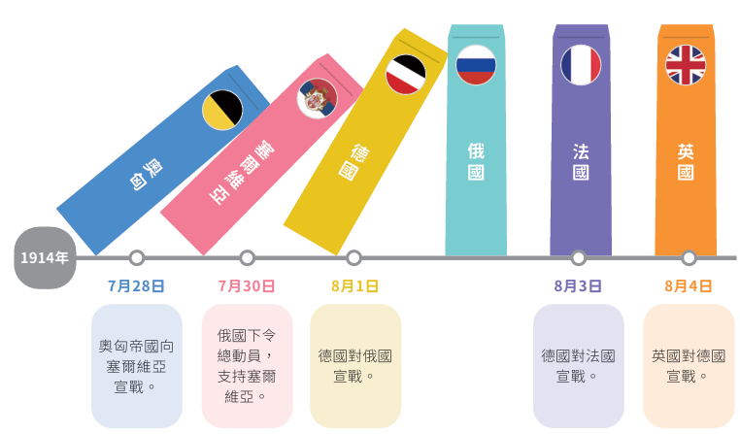

Chain of events beginning with the Sarajevo Incident

Austria-Hungary sent an ultimatum, which consisted of 10 terms, to Serbia on 23 July with the support of Germany. It demanded that Serbia reply within 48 hours. The content of Austria-Hungary's ultimatum included:
- Stopping all anti-Austrian propaganda and activities;
- Punishing anti-Austrian officials;
- Allowing Austria-Hungary to send representatives to take part in the investigation and the trial of murderers.

Even though Serbia accepted most of the terms, Austria-Hungary still declared war on Serbia on 28 July 1914. Since then, other European powers had joined the war one after another for various reasons. The First World War officially broke out.

Course of entry into the war among major countries

Timeline of entry into the war among major countries 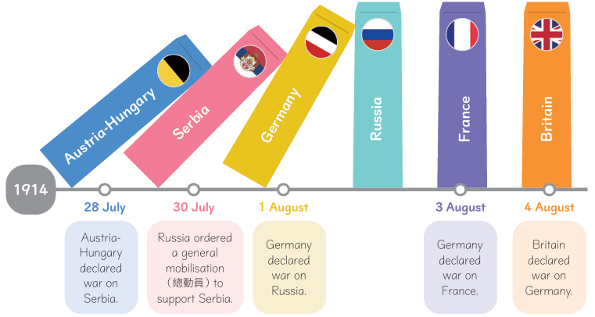

參戰陣營 （美國於1917年加入一戰，但它從未成為協約國的一員）
主要參戰國及其參戰年份
 | 同盟國 | 協約國
1914年 | 奧匈、德國、鄂圖曼帝國 | 英國、法國、俄國（1917 年爆發革命，退出戰事）、塞爾維亞、比利時、日本
1915年 | 保加利亞 | 意大利  （由原三國同盟成員轉向支持協約國）
1916年 |  | 羅馬尼亞
1917年 |  | 希臘、中國

第一次世界大戰的經過

主要戰場
一戰的主要戰線
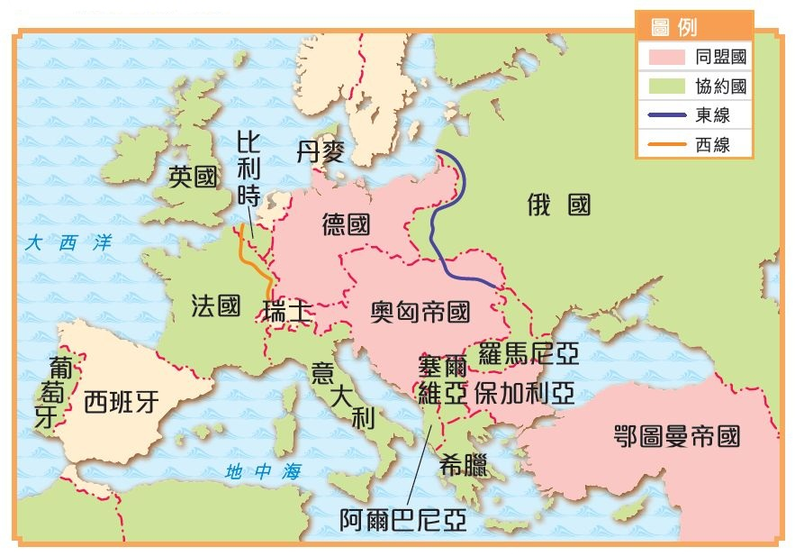
- 主要戰場在歐洲，分東、西兩邊同時進行。
- 西線由英、法對德作戰，以「塹壕戰」為主；東線則主要由德國和奧匈對俄國作戰。
- 德國為斷絕英國的外來物資供應，採取「無限制潛艇戰」，使多艘美國船隻被擊沉，最終促使美國於 1917 年向德國宣戰。

Opposing camps (The US entered WWI in 1917. However, it was never one of the Allied Powers.)
Major participating countries and their years of entry into the war
 | Central Powers | Allied Powers
1914 | Austria-Hungary, Germany, the Ottoman Empire | Britain, France, Russia (withdrew after a revolution in 1917), Serbia, Belgium, Japan
1915 | Bulgaria | Italy (originally a member of the Triple Alliance but changed sides to support the Allied Powers)
1916 |  | Romania
1917 |  | Greece, China

Course of the First World War

Main theatre
Major war fronts during WWI
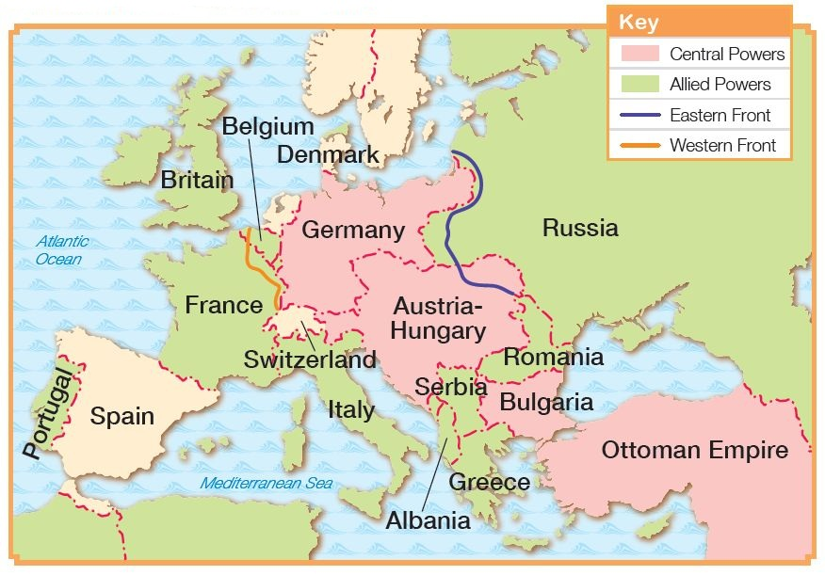
- Europe was the main theatre of war. Battles took place in the west and the east.
- Britain and France fought against Germany on the Western Front mainly through trench warfare. Germany and Austria-Hungary fought against Russia on the Eastern Front.
- Germany adopted unrestricted submarine warfare to cut off Britain's supplies from outside, sinking a large number of US ships. Later, the US declared war on Germany in 1917.

主要發展
戰爭膠着時期 （1914-1917年）
- 7月 28日，奧匈對塞爾維亞宣戰。
- 德軍立即實行「施里芬計劃」，企圖跨越比利時，快速攻陷法國，但未能成功。自此同盟國須在東線和西線兩面作戰。
1914年

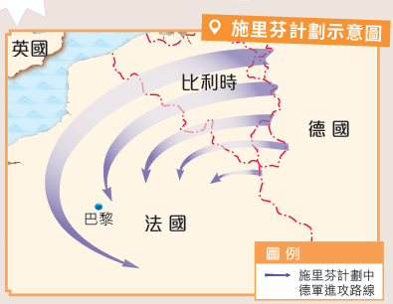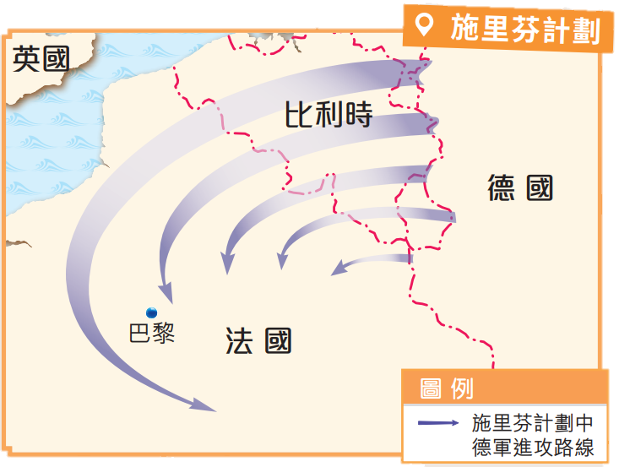

- 空戰逐漸成為重要的作戰模式。
- 坦克的出現，令塹壕戰漸失效用。
1916年

- 1月，日本向中國提出「二十一條」， 以取得德國在山東半島的權益。
- 2月，德國實施無限制潛艇戰，企圖從海上封鎖英國。英國郵輪「路西坦尼亞號」被擊沉，過百名美國人遇難，美、德關係惡劣。
- 5月，意大利加入協約國陣營。
- 7月，德、奧匈在東線擊敗俄國，但未能使它崩潰。
- 10月，保加利亞加入同盟國陣營，並與德、奧匈在11月攻陷塞爾維亞。
1915年

Major developments
Period of stalemate ( 1914-1917）
- Austria-Hungary declared war on Serbia on 28 July.
- Germany immediately executed the Schlieffen Plan in order to pass through Belgium for a quick victory over France. However, the plan failed. The Central Powers had to fight on both the Eastern and Western Fronts.
1914

- In January, Japan presented the Twenty-one Demands to China, aiming to seize the German rights in the Shandong Peninsula.
- In February, Germany launched unrestricted submarine warfare in an attempt to impose a naval blockade on Britain. The British passenger ship Lusitania was attacked and sunk, killing over 100 Americans on board. This incident made the relations between the US and Germany worse.
- In May, Italy joined the Allied Powers.
- In July, Germany and Austria-Hungary defeated Russia on the Eastern Front but failed to make it surrender.
- In October, Bulgaria joined the Central Powers. Together with Germany and Austria-Hungary, they captured Serbia in November.
1915

- Air warfare gradually became a major mode of combat.
- The appearance of the tank led to the decline of trench warfare.
1916

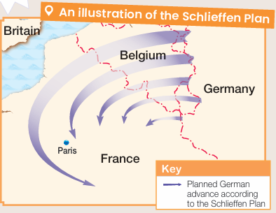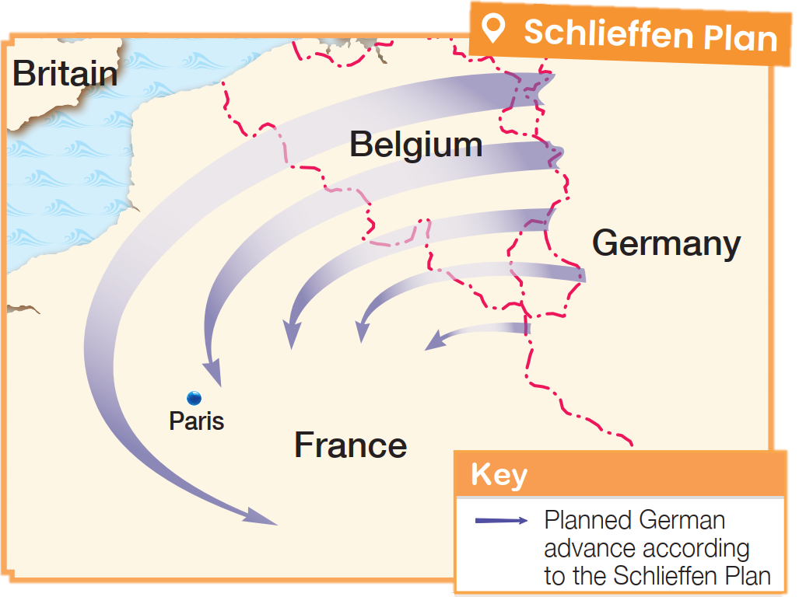
協約國取得上風（1917-1918年）
- 2月，德國再次實施無限制潛艇戰。
- 4月，美國對德國宣戰。
- 8月，中國加入協約國 陣營。
- 11月，俄國爆發十月革命（當時是俄曆10月）。俄國隨後退出戰爭。
1917年

- 年初，德軍在西線發動多次攻勢，但屢戰屢敗；其後協約國全面反攻。
- 9月至11月初，保加利亞、鄂圖曼帝國和奧匈先後投降。
- 11月9日，德皇威廉二世退位。
- 11月 11日，德國與協約國簽訂停戰協議。一次大戰結束。

1918年

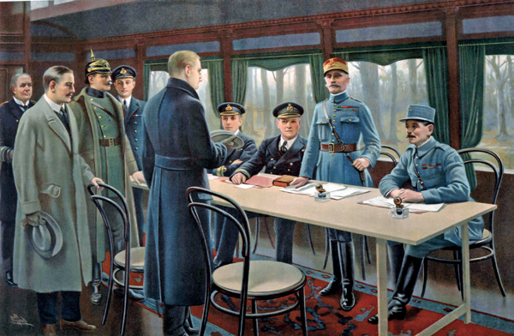
描繪一次大戰停戰協議簽署的畫作

1917
- In February, Germany resumed unrestricted submarine warfare.
- In April, the US declared war on Germany.
- In August, China joined the Allied Powers.
- In November (October on the Russian calendar), the October Revolution broke out in Russia. Russia subsequently withdrew from the war.
1917

The Allied Powers gaining the upperhand (1917-1918)

- At the beginning of the year, Germany made a series of attacks on the
- Western Front, which all failed. Since then, the Allied Powers had launched a full-scale counter-offensive.
- Between September and early November, Bulgaria, the Ottoman Empire and Austria-Hungary surrendered one after another.
- On 9 November, Kaiser William II abdicated.
- On 11 November, an armistice was signed between Germany and the Allied Powers. The WWI ended.
1918

Painting depicting the signing of the armistice that ended WWI

第一次世界大戰的結果

巴黎和會的召開（1919年）

1919 年 1 月至 6 月期間，英、法、美、意、日等戰勝國（俄國除外）的代表，齊集在巴黎，舉行和平會議，以商討戰後安排，稱為「巴黎和會」。戰敗國全部不獲准參加。
巴黎和會三巨頭
勞萊喬治 | 克里孟梭 | 威爾遜
英國首相 | 法國總理 | 美國總統
對戰敗國的態度  強硬，  但不如克里孟梭嚴苛 | 對戰敗國的態度  嚴苛 | 對戰敗國的態度  寬大
目標  - 調解美、法兩國之間的分歧，維持歐洲的勢力均衡。  - 削弱德國軍事力量，確保英國的海上霸權地位。 | 目標  要求嚴懲德國，永久削弱其力量，保障法國的安全。 | 目標  - 提出「十四項建議」，並推動以此作為和會的指導原則，從而維持長久和平。  - 防止德國經濟崩潰，以助歐洲經濟儘快重建。
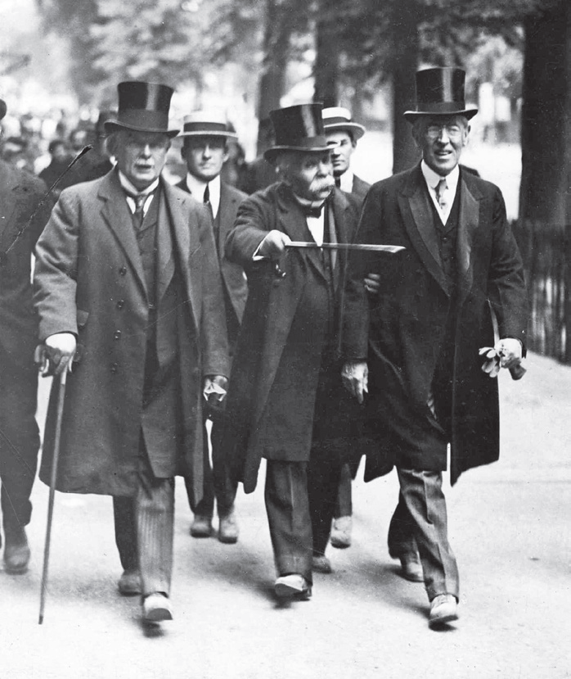

Results of the First World War

Calling of the Paris Peace Conference (1919)

From January to June 1919, representatives of the victorious countries (except Russia), including Britain, France, the US, Italy and Japan, held a peace conference in Paris to discuss the post-war arrangements. All the defeated countries were not allowed to attend.
‘Big Three’ at the Paris Peace Conference
David Lloyd Geroge | Georges Clemenceau | Woodrow Wilson
British prime minister | French prime minister | US president
Attitude towards the  defeated countries  Tough, but not as harsh as Clemenceau | Attitude towards the  defeated countries  Harsh | Attitude towards the  defeated countries  Lenient
Goal  - To reconcile the differences between the US and France, and maintain the balance of power in Europe.  - To weaken the German military strength to ensure Britain's naval supermacy | Goal  To punish Germany severely, and permanently weaken its power to ensure the safety of France | Goal  - To put forward the ‘Fourteen Points’ and promote them as  the guiding principles of the peace conference in order to achieve long-lasting peace  - To prevent the economic collapse of Germany in order that the European economy could recover as soon as possible

《凡爾賽條約》的簽訂（1919年）

1919 年6月28日，戰勝國和德國在巴黎的凡爾賽宮簽訂《凡爾賽條約》。《凡爾賽條約》的條款極為苛刻及不公平，大大激起了德國人民的不滿情緒，成為下一次世界大戰的遠因之一。
- 德國須裁減陸軍和海軍，並不得擁有空軍。
- 德國向法國歸還阿爾薩斯—洛林，並割讓部分土地予鄰近國家。
- 萊茵河區列為非軍事區。
- 德國放棄所有海外殖民地。
- 德國承擔發動一次大戰的全部責任。
- 德國向戰勝國支付六十六億英鎊賠款。
《凡爾賽條約》的主要內容

一戰後德國的領土轉變
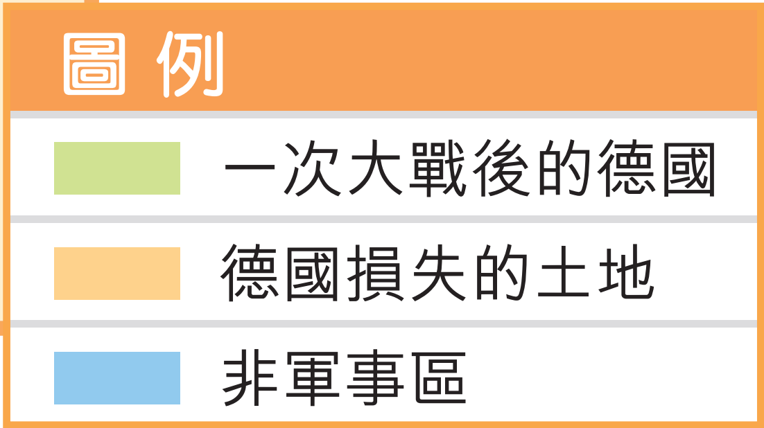
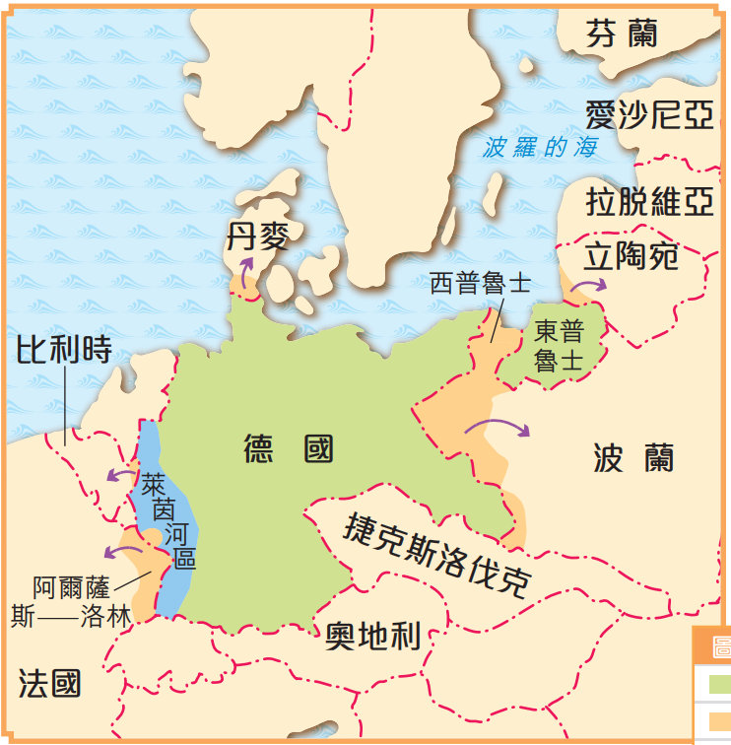

集體安全的引入

- 在巴黎和會上，威爾遜提出成立一個維護和平的國際組織。
- 國際聯盟（簡稱「國聯」）於 1920 年正式成立，總部設於瑞士的日內瓦，旨在透過「 集體安全」制度，以非武力的方法解決國際糾紛。

Signing of the Treaty of Versailles (1919)

On 28 June 1919, the victorious countries signed the Treaty of Versailles with Germany at the Palace of Versailles. The terms of the treaty were very harsh and unfair. Germans felt extremely dissatisfied. This became one of the remote causes of another World War.
- Germany had to reduce its army and navy. It was banned from having an air force.
- Germany had to return Alsace-Lorraine to France and cede part of its land to the neighbouring countries.
- The Rhineland was made a demilitarised zone.
- Germany had to give up all overseas colonies.
- Germany had to bear the sole responsibility for WWI.
- Germany had to pay 6.6 billion British pounds in reparations to the victorious countries.
Main content of the Treaty of Versailles

Territorial changes of Germany after WWI
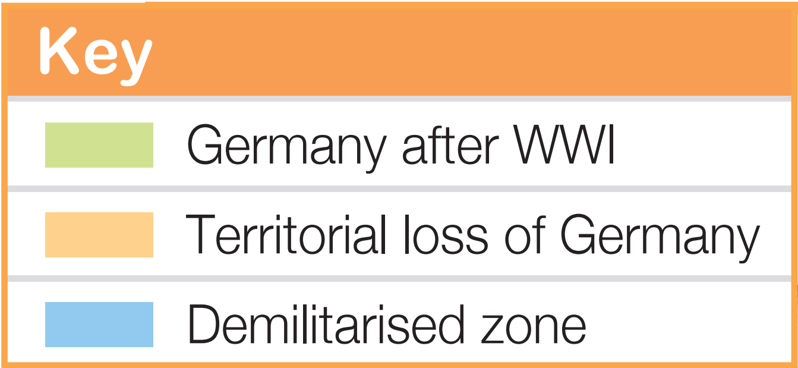
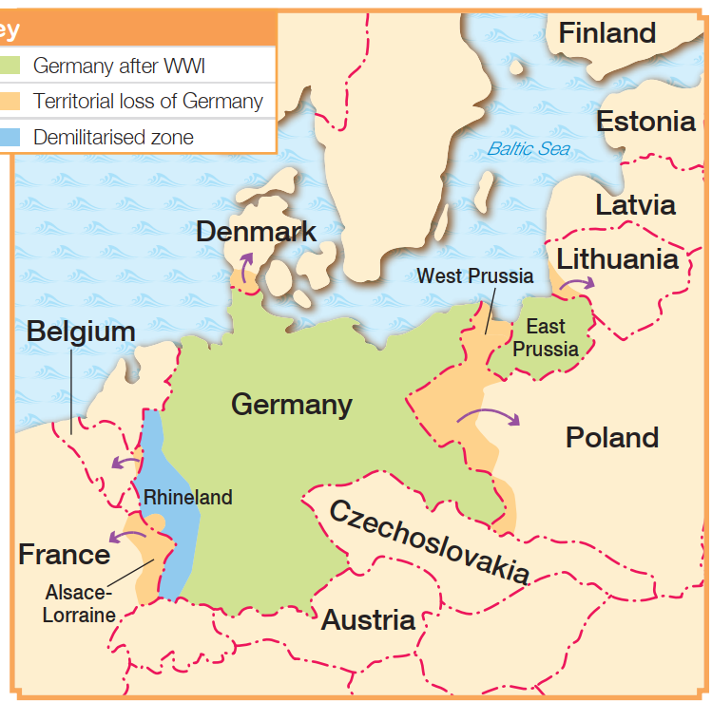

Introduction of collective security

- At the Paris Peace Conference, Wilson proposed the establishment of an international peacekeeping organisation.
- The League of Nations was officially founded in 1920 and was headquartered in Geneva,
Switzerland. It aimed to resolve international disputes by non-violent means through the system of collective security.
重點練習
1. 根據課文內容，完成下列各題文字。
- 第一次世界大戰分為兩大陣營： ___同盟國___ 和 ___協約國___ 。
(b) 工業革命後， 英、法等歐洲列強為了開發海外的商品市場和新的原料產地，紛紛在 ___亞洲___ 和 ___非洲___ 建立殖民地。至19世紀末，新興的 ___德國___ 亦加入到爭奪殖民地的行列中。
(c) 殖民地的爭奪使歐洲列強的關係更形惡劣，引發連串外交衝突。法國在北非分別與 ___意大利___ 、德國發生衝突。

2. 根據課文內容，完成下表。
歐洲各國民族主義的主張
國家 | 主張
德國 | 提出「 ___泛日耳曼主義___ 」，主張聯合歐洲所有日耳曼人，建立一個「 ___大德意志___ 」。
俄國 | 提出「 ___泛斯拉夫主義___ 」，主張支配所有___斯拉夫人___ 及其地區
法國 | 主張向 ___德國___ 復仇，奪回在普法戰爭中失去的阿爾薩斯—洛林。
塞爾維亞 | 提出「大塞爾維亞」主義，主張聯合歐洲的 ___塞族人___ ，組成「大塞爾維亞」
奧匈帝國 | 向___巴爾幹半島___ 擴張

3. 試選擇適當答案，並將其英文代號填入方格內。
- 以下哪項不是觸發第一次世界大戰的原因？
A. 國際衝突 B. 局部戰爭
C. 刺殺事件 D. 德國戰敗
D
Key Exercises
1. Fill in the blanks according to the textbook content.
(a) The First World War (WWI) were fought by two opposing camps: the ___Central Powers___ and the ___Allied Powers___ .
(b) After the Industrial Revolution, European powers such as Britain and France explored overseas markets for commodities and new origins of raw materials. In order to do so, they set up colonies in ___Asia___ and ___Africa___ . By the late 19th century, the rising ___Germany___ had joined the scramble for colonies.
(c) The scramble for colonies worsened the relations among European powers, leading
to a series of diplomatic conflicts. For example, France had conflicts with ___Italy___ and Germany in North Africa respectively.

2. Complete the graph according to the textbook content.
Different forms of nationalism of various European countries
Nation | Form of nationalism
Germany | ___Pan-Germanism___ , believing in unifying all ___Germans___ in Europe to establish a ‘___Greater Germany___’.
Russia | ___Pan-Slavism___ , advocating that all ___Slavs___ and their territories should be under Russian control.
France | Revengeful feelings against ___Germany___, eager to take back Alsace-Lorraine that was lost in the ___Franco-Prussian War___
Serbia | Greater-Serbia, proposing the unification of the ___Serbians___ in Europe and the establishment of a Greater Serbia.
Austria-Hungary | Expansion into the ___Balkans___ .

3. Choose the appropriate answer and put it in the corresponding box.
- Which of the following factors did not cause WWI?
A. International conflicts B. Regional wars
C. An assassination D. Defeat of Germany
D
- 哪些是巴爾幹半島被稱為「歐洲的火藥庫」的原因？
（1） 民族組成複雜
（2） 斯拉夫人性格衝動
（3） 列強介入
（4） 當地局勢混亂

A. （1）、（2）、（3） B. （1）、（2）、（4）
C
C. （1）、（3）、（4） D. （1）、（2）、（3）、（4）

- 一次大戰期間，哪個國家加入同盟國？
A. 保加利亞 B. 羅馬尼亞
A
C. 中國 D. 塞爾維亞

- Which of the following were the reasons for the Balkan Peninsula to be called the ‘powder keg of Europe’?
(1) Multiple ethnic groups
(2) Impulsive nature of Slavic peoples
(3) Foreign interventions from powers
(4) chaotic situation there

A. (1), (2), (3) B. (1), (2), (4)
C
C. (1), (3), (4) D. (1), (2), (3), (4)

- During WWI, which country joined the Central Powers?
A. Bulgaria B. Romania
A
C. China D. Serbia

