課題9 20 世紀的國際紛爭及危機(I)

—兩次世界大戰
I 兩次世界大戰前歐美、亞洲等國家的關係和爆發衝突的原因

關鍵詞
經濟大衰退 | Great Depression
極權主義 | totalitarianism
新民族國家 | new nation state
國際聯盟 | League of Nations
法西斯主義 | Fascism
納粹主義 | Nazism
軍國主義 | militarism
種族滅絕 | genocide
軸心國 | Axis Powers
綏靖主義 | appeasement policy
孤立主義 | isolationism

溫習要點
B 第二次世界大戰（1939-1945年）

第一次世界大戰後的世界局勢

政治方面

1.1 傳統帝國的瓦解

- 一戰期間，歐洲的政局出現劇烈的轉變。一些專制國家因革命或政變而瓦解，包括俄羅斯帝國、奧匈帝國、德意志帝國，以及鄂圖曼帝國。
- 當中以 1922 年蘇維埃社會主義共和國聯盟（簡稱「蘇聯」）在俄國的成立影響最為深遠，它是世界上首個社會主義國家。

Topic 9 International conflicts and crises in the 20th century (I)—the two

World Wars
I Relations among countries in Europe, America and Asia and reasons for their conflicts before the two World Wars

Key Terms
經濟大衰退 | Great Depression
極權主義 | totalitarianism
新民族國家 | new nation state
國際聯盟 | League of Nations
法西斯主義 | Fascism
納粹主義 | Nazism
軍國主義 | militarism
種族滅絕 | genocide
軸心國 | Axis Powers
綏靖主義 | appeasement policy
孤立主義 | isolationism

Revision Points

B Second World War (1939-1945)

World situation after the First World War

Political aspect

1.1 Fall of traditional empires

- During WWI, there were huge changes in European political situation. Some absolute states collapsed because of revolution or coup, including the Russian Empire, the Austro-Hungarian Empire, the German Empire and the Ottoman Empire.
- Among them, the establishment of the Union of Soviet Socialist Republics (USSR) in
Russia in 1922 had the most far-reaching impact. It was the first socialist country in the world.

一戰前的歐洲版圖 一戰後的歐洲版圖
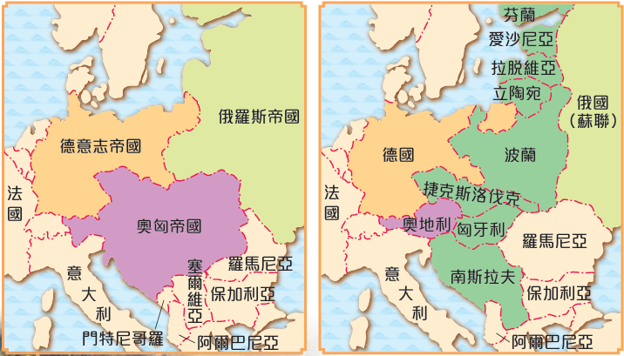
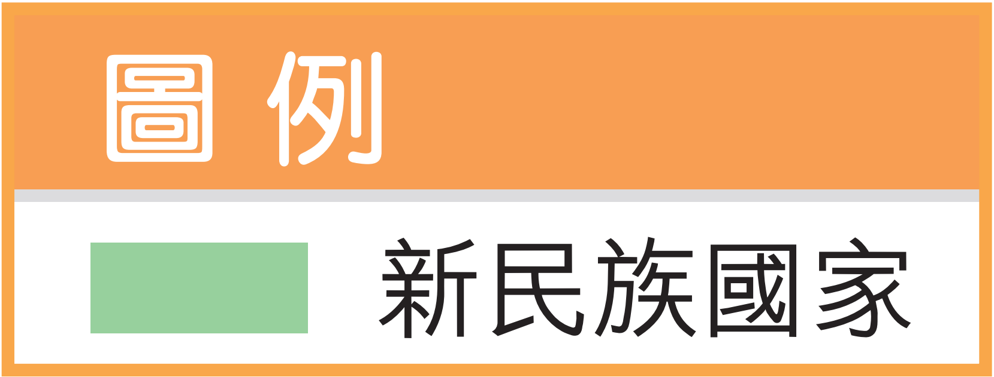

1.2 新民族國家的建立

傳統帝國瓦解後，原來的土地上出現眾多新民族國家，主要集中在歐洲東部，包括匈牙利、 波蘭、 捷克斯洛伐克、 南斯拉夫、 芬蘭、 立陶宛、 拉脫維亞及愛沙尼亞。

1.3 歐洲轉弱

德、奧在戰敗後面對鉅額賠款帶來的經濟困難，英、法亦受大戰破壞的影響，國力大大削弱。歐洲國家逐漸失去世界強國的地位。

1.4 美、日崛起

- 在歐洲轉弱的同時，美國則不斷擴大其國外市場及軍事實力。它在一次大戰後期能調動大量軍事力量，並向英、法等國提供貸款。
- 日本也不遑多讓，它在中國大量投資，海軍實力與英、美等國並駕齊驅。

Europe before WWI Europe after WWI
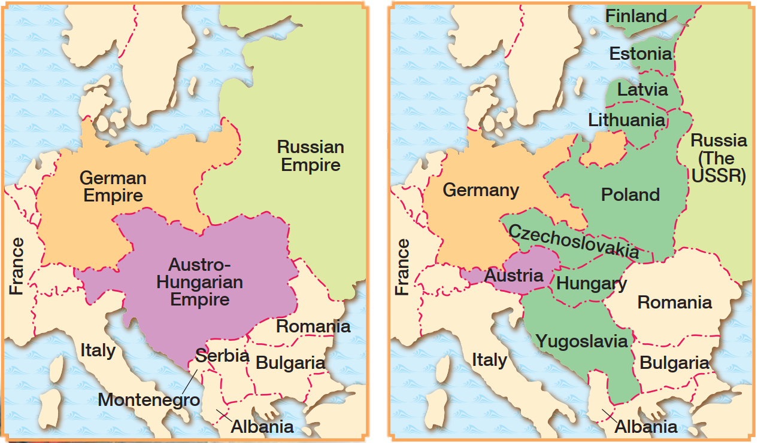


1.2 Formation of new nation-states

After traditional empires collapsed, there appeared a number of new nation-states mainly in the east of Europe, including Hungary, Poland, Czechoslovakia, Yugoslavia, Finland, Lithuania, Latvia and Estonia.

1.3 Europe in decline

Germany and Austria suffered economic difficulties caused by huge reparations. Britain and France were greatly weakened by war damage. European countries eventually lost their statuses as world powers.

1.4 Rise of the US and Japan

- When Europe was weakening, the US expanded its foreign markets and military strength. It could deploy a great number of military personnel in late WWI and lend to Britain and France.
- Similarly, Japan invested a lot in China. Its navy was as powerful as that of Britain and
the US.

一戰前後的國際局勢轉變
 | 一戰前 | 一戰後 | 實力
  英國 | 憑海外貿易和強大海軍成為歐洲最強帝國 | 經濟受戰爭破壞 | 下降
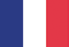  法國 | 歐洲列強，擁有不少海外殖民地 | 經濟受戰爭破壞 | 下降
  德國 | 新興工業及軍事強國 | 戰敗後承擔鉅額賠款，國力大受打擊 | 下降
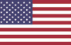  美國 | 新興經濟及工業強國 | 成為全球最大生產國和債權國 | 上升
  日本 | 明治維新後實力逐漸增加 | 軍事及經濟力量進一步增強 | 上升

經濟方面

各交戰國的直接或間接損失，共達三千三百多億美元。而交戰雙方直接動員的兵力共六千五百萬人，其中至少一千五百萬人陣亡，大約二千萬人受傷。歐洲普遍出現物資短缺、通貨膨脹的現象。歐洲各國經濟普遍萎靡不振。
一戰在歐洲造成的經濟破壞
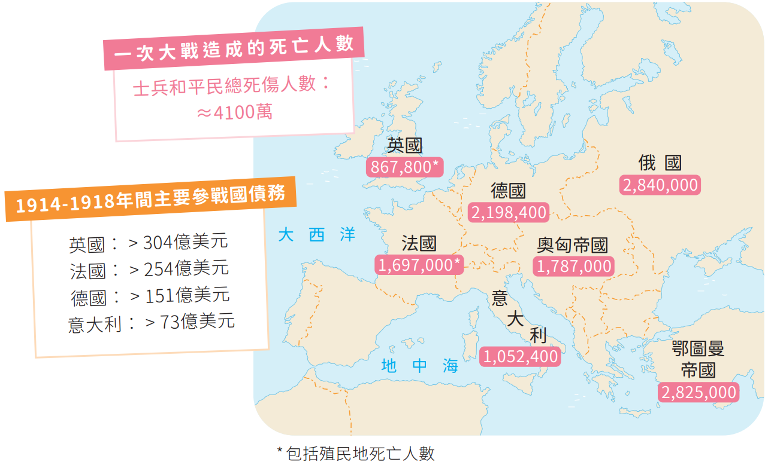

Changes in the international situation before and after WWI
 | Before WWI | After WWI | Strength
Britain | Becoming the greatest European empire with its overseas trade and powerful navy | Economy suffering from war damage | Declining
France | As a European power that owned many overseas colonies | Economy suffering from war damage | Declining
Germany | As a rising industrial and military power | Having to pay huge reparations after defeat, national strength suffering a blow | Declining
The US | As a rising economic and industrial power | Becoming the world's largest manufacturing country and creditor country | Growing
Japan | Gradual growth in national strength after the Meiji Modernisation | Further growth in military and economic powers | Growing

Economic aspect

The direct and indirect losses amounted to over US$330 billion. Out of 65 million soldiers mobilised by both camps in WWI, at least 15 million were killed and around 20 million were injured. Europe faced widespread resource shortages and inflation. Most European countries therefore suffered economic recessions.
Economic devastation caused by WWI in Europe
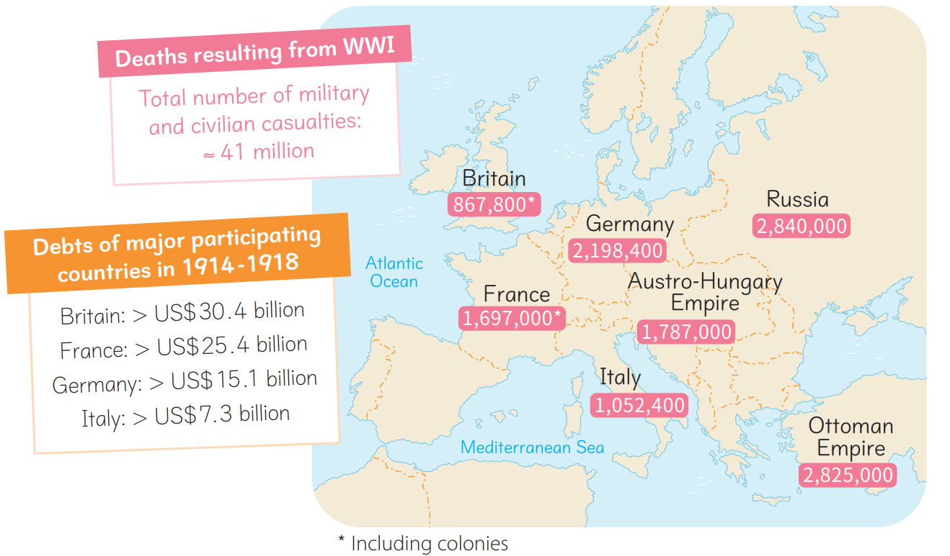

巴黎和會的後遺症

德國的憤恨

- 美國總統威爾遜提出民族自決原則，使歐洲出現不少新民族國家。可是，這一原則卻不適用於德國，令德國人深感不滿。
- 《凡爾賽條約》對德國的條款極度苛刻。除了割讓領土外，德國還要承擔所有戰爭責任，軍備的種類和數量亦受到限制。這些條款激起德國人的復仇情緒。加上，
- 英、法要求德國支付鉅額賠款，導致德國在戰後出現嚴重的經濟困難。

意大利的不滿

- 意大利未能從《凡爾賽條約》取得所期望的報酬，令意大利人非常不滿。
- 一次大戰嚴重破壞了意大利的農業及工業，但《凡爾賽條約》卻未有提出解決戰後經濟問題的措施。
- 意大利面對嚴重的物資匱乏、通貨膨脹和失業等問題，使社會到處籠罩着不滿情緒。
1918-1923年間美元與意大利里拉的兑換率

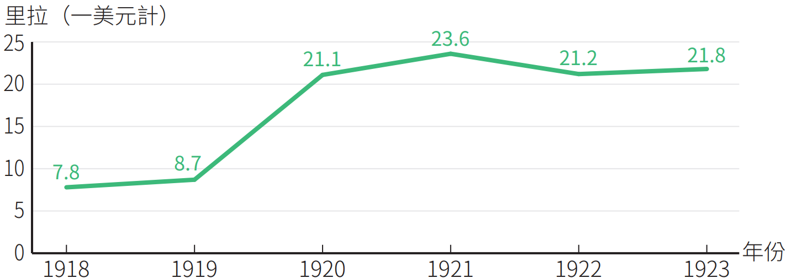

新民族國家實力不足

一次大戰後，根據民族自決的原則，中歐、東歐成立了一眾新民族國家。但是這些新興國家的力量十分薄弱，缺乏保衞自己的能力，因此容易成為侵略目標。

Effects of the Treaty of Versailles

Resentment in Germany

- US president Wilson put forward the principle of national self-determination. This led to the emergence of many new nation-states in Europe. However, this principle was not applicable to Germany, arousing discontent among the people of Germany.
- The terms of the Treaty of Versailles were extremely harsh. In addition to territorial concessions, Germany had to bear the sole responsibility for the war and limit the type and quantity of its armaments. All these triggered vengeful feelings among Germans. Britain and France demanded huge reparations, causing severe economic difficulties in Germany.

Discontent in Italy

- The Treaty of Versailles did not reward Italy as it expected. This upset the people of Italy.
- WWI seriously damaged Italy's agriculture and industry, yet the Treaty of Versailles provided no solutions to post-war economic problems.
- Facing severe resource shortages, inflation and unemployment, Italy was full of
social discontent.

Exchange rate between US$ and Italian lira in 1918-1923

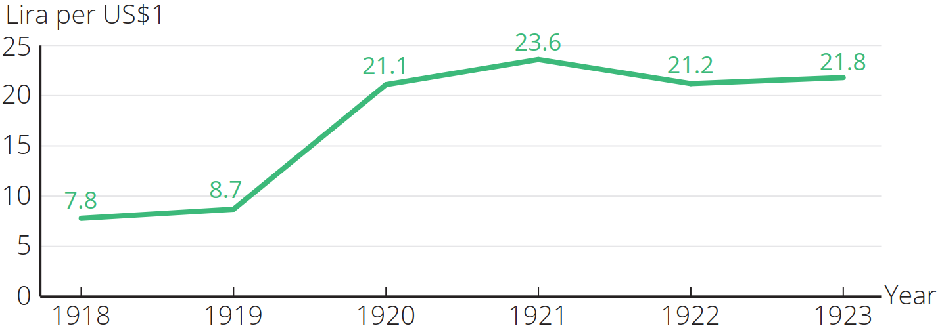

Weak new nation-states

After WWI, based on the principle of national self-determination, a number of new nation-states were founded in Central and Eastern Europe. However, these newly emerged countries were very weak and lacked the ability to defend themselves. They easily became invasion
targets.

經濟大衰退（1929-1933 年）

源起和經過

- 1920 年代，美國成為戰後全球最大的生產國和債權國。
- 美國國內的生產量不斷上升，借貸活動因而越趨頻繁，投機氣氛熾熱。
- 直至1929年10月，經濟不景的消息傳出。結果，紐約華爾街股票市場崩潰。 美國經濟步入蕭條，國內消費力大跌，銀行接二連三倒閉，工人普遍失業。

對世界的影響

- 經濟大衰退期間，美國撤回對歐洲各國的援助及投資，並提高關稅。一向依賴對美國貿易的歐洲國家和日本，紛紛陷入經濟困境，當中以德國受到的打擊最為嚴重。
- 德國和日本等政府因無力解決國內的經濟困境，引起人民的強烈不滿，促使納粹主義和軍國主義在兩國的興起。
- 英、法也因忙於解決國內的經濟問題，而無暇處理國際事務，助長納粹德國和日本軍國政府的野心。

美國經濟大衰退對世界政局的影響
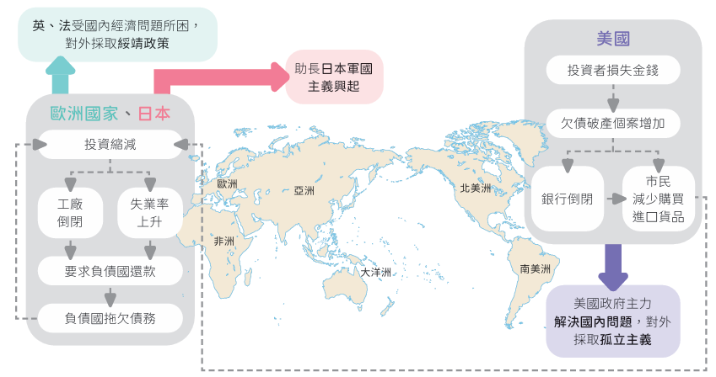

Great Depression (1929-1933)

Origins and course

- During the 1920s, the US became the largest manufacturing country and creditor country in the post-war world. The US domestic production kept rising.
- Borrowing and lending activities became frequent. People made a lot of risky investments.
- In October 1929, there were rumours that the US economy would soon face a major
downturn. As a result, the Wall Street Crash took place in New York. The US economy went into a recession. Domestic spending power fell sharply. Banks closed one after another. Widespread unemployment among workers resulted.

Impact on the world

- During the Great Depression, the US withdrew its aid and investments in European countries and raised tariffs. European countries and Japan, which had always relied on trade with the US, fell into economic hardship, while Germany was hit the hardest.
- Since the governments of Germany and Japan were unable to solve domestic economic hardship, their peoples became discontented. Thus, Nazism and militarism rose in Germany and Japan respectively.
- Britain and France had their hands full dealing with domestic economic problems. They had no time for international affairs. This fuelled the ambitions of Nazi Germany, Fascist Italy and militarist Japan.

Impact of the Great Depression on the world's political situation
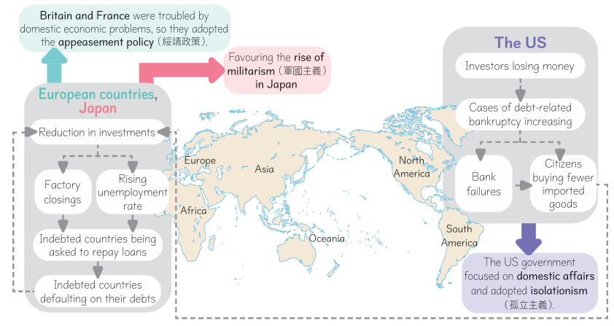

極權主義的興起

極權主義的特徵
國家的政治權力被某一政黨或其元首控制的制度。
國內實行獨裁專政，人民必須服從國家及執政黨領袖，提倡國家利益至上的思想，並以秘密警察嚴格監控人民生活。

對外推行侵略擴張的政策，以彰顯民族的優越性。

日本的軍國主義

- 一戰後，日本經濟陷入不景氣，加上受 1929 年經濟大衰退的影響，日本國內軍國主義迅速崛起。
- 日本軍國主義者把目光集中在中國及太平洋地區，明確定下先入侵中國東北、進而攻佔全中國、最後佔領東南亞的侵略方案。

意大利的法西斯黨獨裁

- 1921 年，墨索里尼創立法西斯黨。1922 年，墨索里尼獲意大利國王委任為首相。
- 法西斯黨控制國會，逮捕並驅逐共產黨員。墨索里尼又通過設立秘密警察、嚴格限制新聞自由等手段，鎮壓一切反對法西斯黨的勢力。

德國的納粹黨專政

- 希特拉提倡種族優越，認為若要拯救德國，必須透過軍事擴張，把所有講德語的優秀日耳曼人統一，使德國成為一個主宰全世界的國家。
- 希特拉在 1933 年出任總理，次年兼掌總統權力，成為國家「 元首」。
- 希特拉實行獨裁恐怖統治。他成立秘密警察，逮捕異己分子；宣揚個人崇拜及嚴密監管文化活動。他對猶太人實施種族滅絕。
- 對外方面，他鼓吹漠視國聯和廢棄《凡爾賽條約》，並不斷對外擴張。

Rise of totalitarianism

Characteristics of totalitarianism
A system under which the state's political power
rests with a single party or the head of state.
Domestically, absolute dictatorship is adopted. The people must be obedient to the state and the leader of the ruling party. The state's interests are of utmost importance. Secret police strictly monitor the people's daily lives.
Externally, the state follows expansionist policies to
show the superiority of its own ethnic group.

Militarism in Japan

- After WWI, Japan experienced an economic downturn and negatively affected by the Great Depression of 1929, militarism rose in Japan rapidly.
- Targeting China and the Pacific region, Japanese militarists formulated a strategy of aggression to invade Northeast China first, then conquer the entire China, and finally occupy Southeast Asia.

Fascism in Italy

- In 1921, Benito Mussolini founded the Fascist Party. In 1922, Mussolini was appointed prime minister by the Italian king.
- The Fascist Party controlled the parliament. Communists were arrested and exiled. Mussolini also suppressed all forces in opposition to the Fascist Party by means such as setting up secret police and strictly limiting freedom of the press.

Nazism in Germany

- Hitler promoted racial superiority. He believed that, to save Germany, he had to unify all German-speaking excellent Germans through military expansion, so that Germany could rule the whole world.
- Hitler became chancellor in 1933. In the following year, he took over the powers of president, ruling Germany as Führer.
- Hitler adopted an oppressive dictatorship. He set up secret police to arrest the dissidents. He also promoted his cult of personality and strictly monitored cultural activities. Furthermore, he committed genocide on Jews.
- Regarding external affairs, Hitler advocated ignoring the League of Nations and abolishing the Treaty of Versailles, while continuing to launch foreign expansion.

第二次世界大戰的成因

極權主義國家的擴張

1.1 日本的對外侵略

1930年代日本的擴張
1931年9月18日 | 日本在瀋陽發動「九一八事變」，佔領東北三省。
1932年3月 | 日本扶植清朝末代皇帝溥儀，在中國東北建立「偽滿洲國」。
1937年7月7日 | 日本發動「盧溝橋事變」，大舉進攻北平，正式全面侵略中國。
1937年11月 | 日本攻陷上海。
1937年12月 | 日軍佔領南京，其後進行大屠殺。

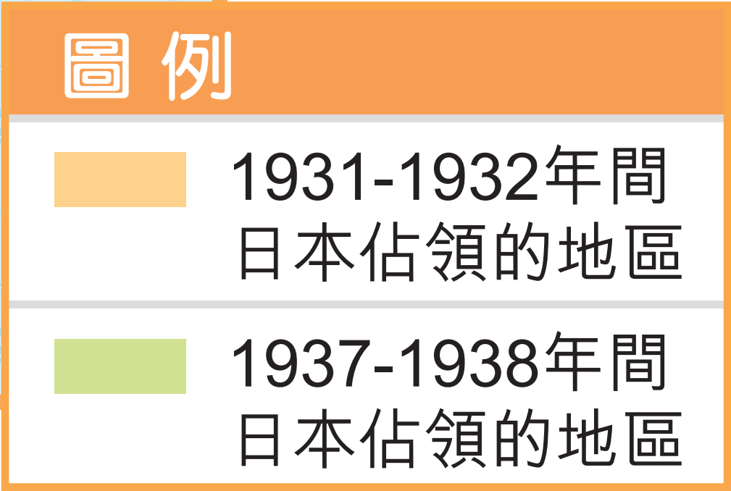
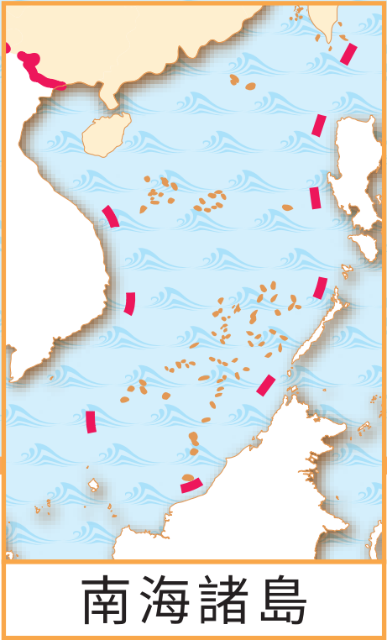
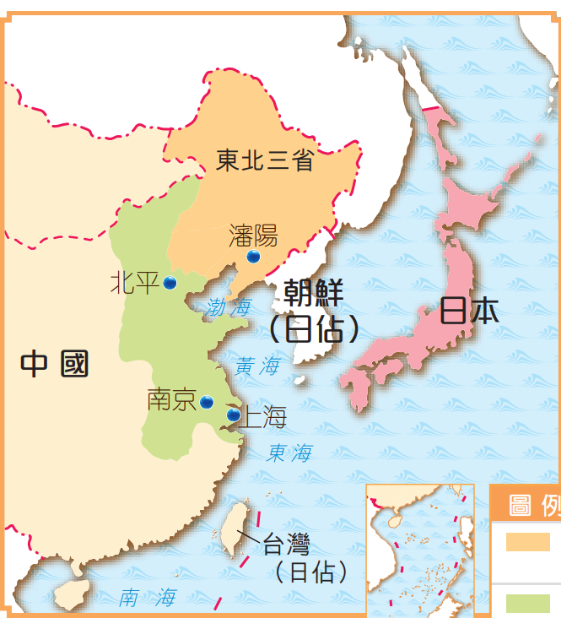

Causes of the Second World War

Expansion of totalitarian states

1.1 Japanese foreign expansion

Japanese expansion in the 1930s
1931  18 September | Japan staged the Mukden Incident in Shenyang and occupied the Three Northeastern Provinces.
1932  March | Japan restored Puyi, the last emperor of the Qing dynasty, and established the puppet Manzhouguo regime in Northeast China.
1937  7 July | Japan staged the Lugouqiao Incident and fiercely attacked Beiping, officially launching the full-scale invasion of China.
1937  November | Japan captured Shanghai.
1937  December | The Japanese forces occupied Nanjing and subsequently committed a massacre there.

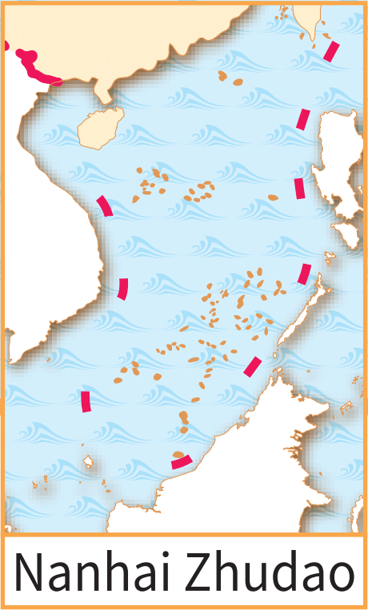
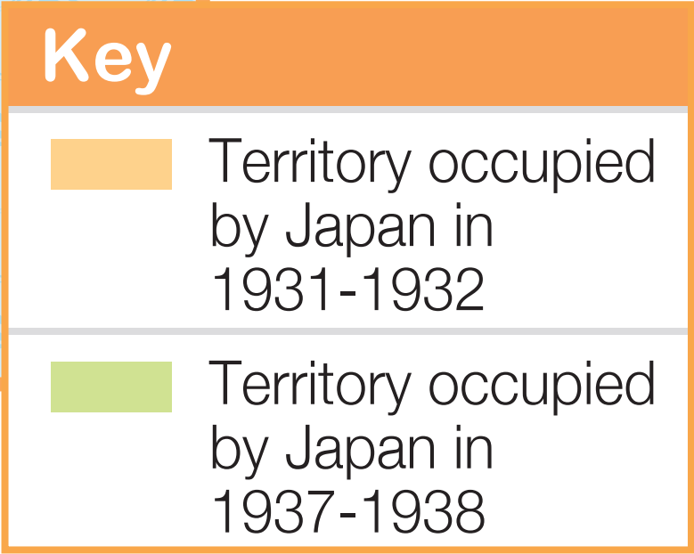
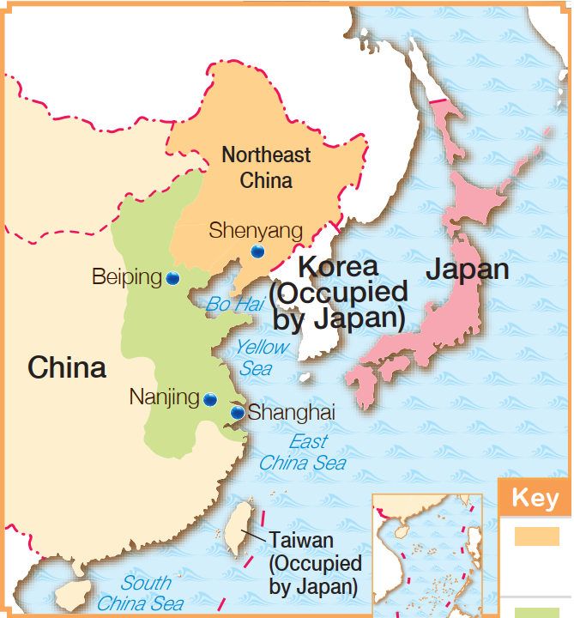

1.2 意大利的對外侵略

1930 年代，意大利乘歐洲各國忙於處理經濟問題，進一步展開侵略，如在 1935 - 1936 年征服非洲東北部的阿比西尼亞（今埃塞俄比亞）、1939 年吞併阿爾巴尼亞。

1930年代意大利的擴張
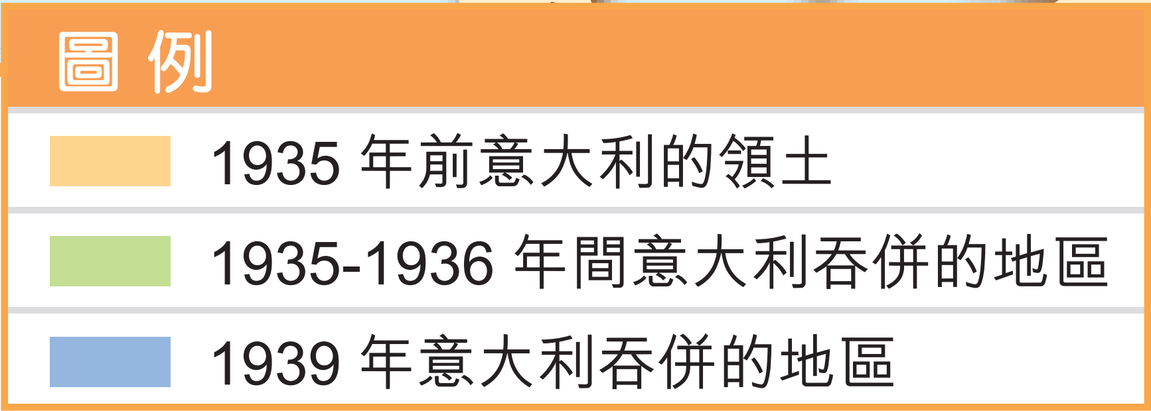
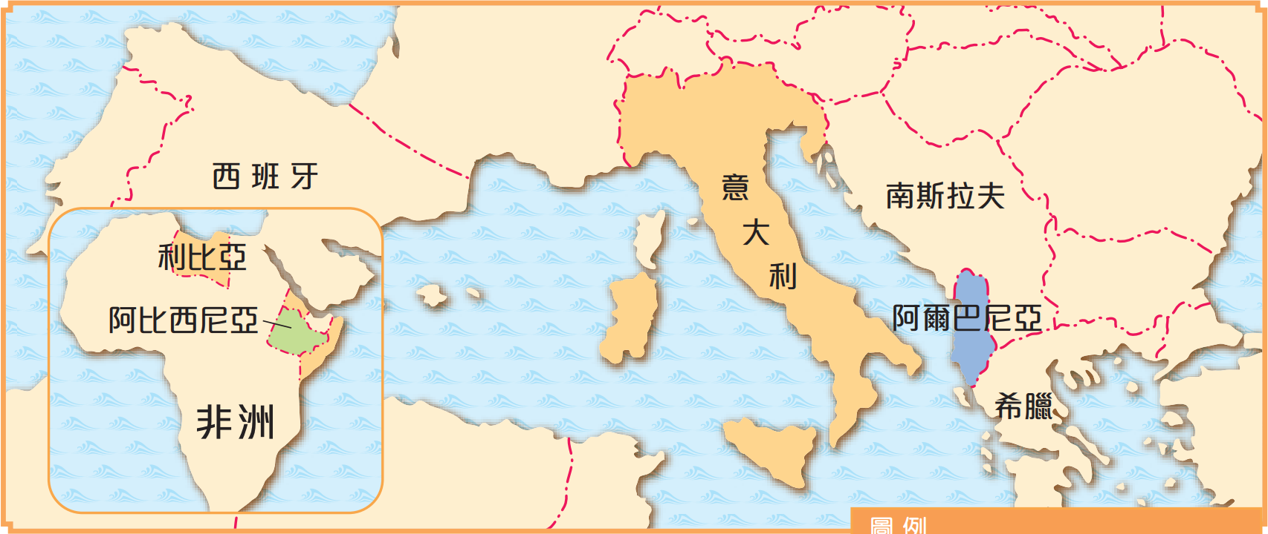

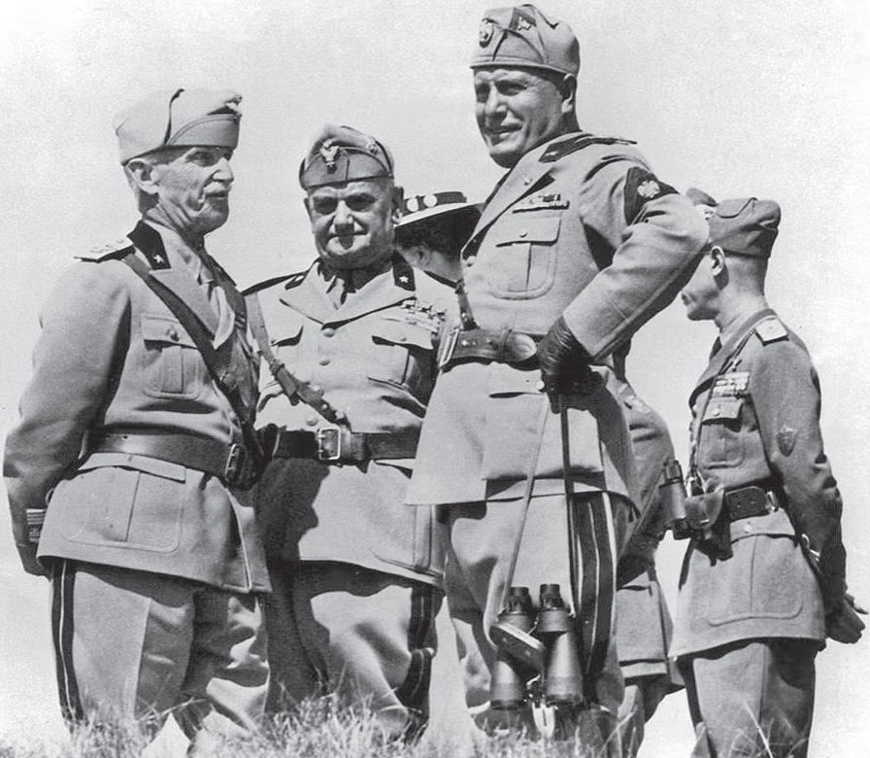
在阿比西尼亞的墨索里尼（右二）

1.2 Italian foreign expansion

In the 1930s, when other European countries were busy dealing with their own economic problems, Italy expanded further. It conquered Abyssinia (today's Ethiopia) in the northeast of Africa in 1935-1936, and annexed Albania in 1939.

Italian expansion in the 1930s
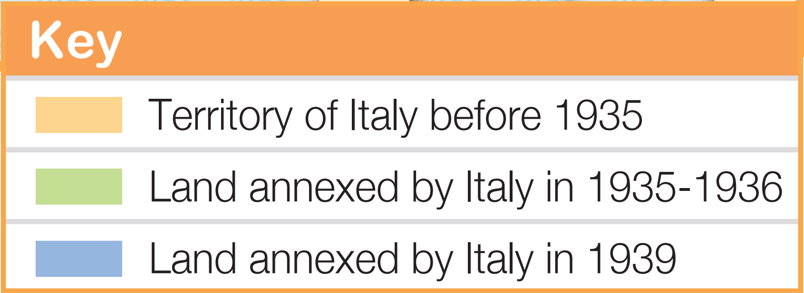
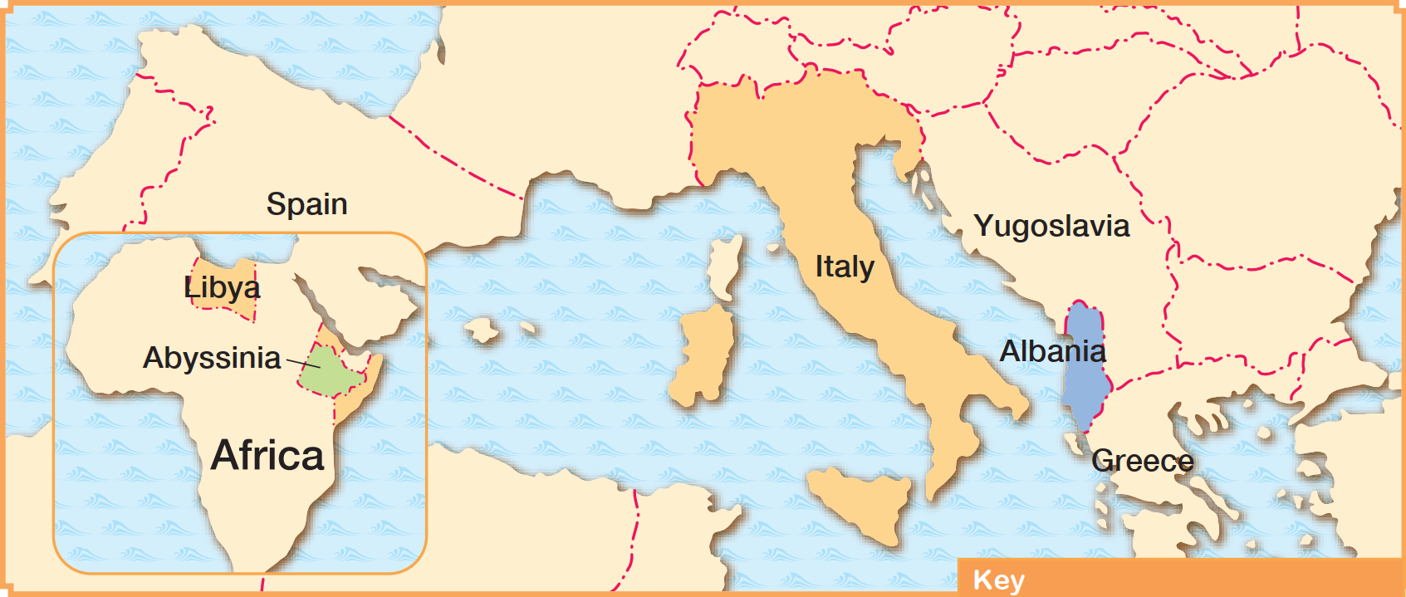

Mussolini in Abyssinia (second right)

1.3 德國的對外侵略

- 1935 年，希特拉撕毀《凡爾賽條約》，宣布重新武裝德國，並逐步實施擴張政策。
- 1939 年 9 月 1日， 德軍入侵波蘭， 導致二戰全面爆發。

二戰全面爆發前德國的擴張
1935年 | 德國重新武裝。
1936年 3月 | 德國向非軍事化的萊茵河區進軍。
1938年 3月 | 德國宣布與奧地利合併。
1938年9月 | 德國與英、法簽訂《慕尼黑協定》後，吞併捷克斯洛伐克的蘇台德區。
1939年 3月 | 德國完全佔領捷克斯洛伐克。
1939年9月 | 《德蘇互不侵犯條約》於8月簽訂後，德軍入侵波蘭。  二次大戰爆發。

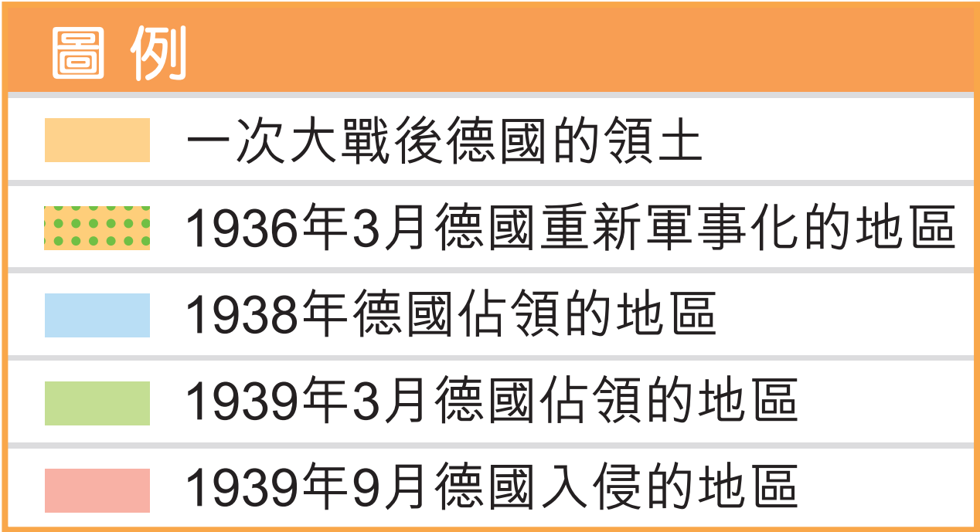
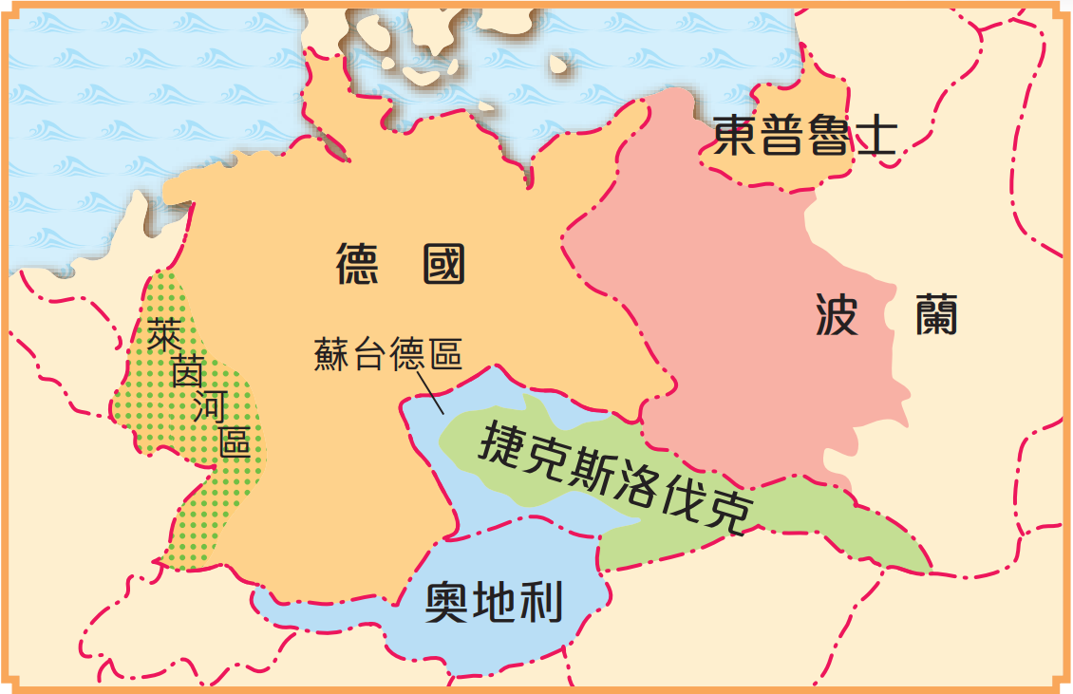

1.3 German expansion

- In 1935, Hitler announced that he would rearm Germany in violation of the Treaty of Versailles. After that, he gradually carried out the policy of expansion.
- On 1 September 1939, Germany invaded Poland, leading to the official outbreak of the Second World War.
German expansion before the outbreak of WWII in full-scale
1935 | Germany rearmed.
1936 March | The German forces entered the demilitarised Rhineland.
1938 March | Germany annexed Austria.
1938 September | Germany signed the Munich Agreement with Britain and France, and annexed the Sudetenland of Czechoslovakia.
1939 March | Germany occupied the whole of Czechoslovakia.
1939 September | After the signing of the German-Soviet Non-Aggression Pact in August, the German forces invaded Poland.

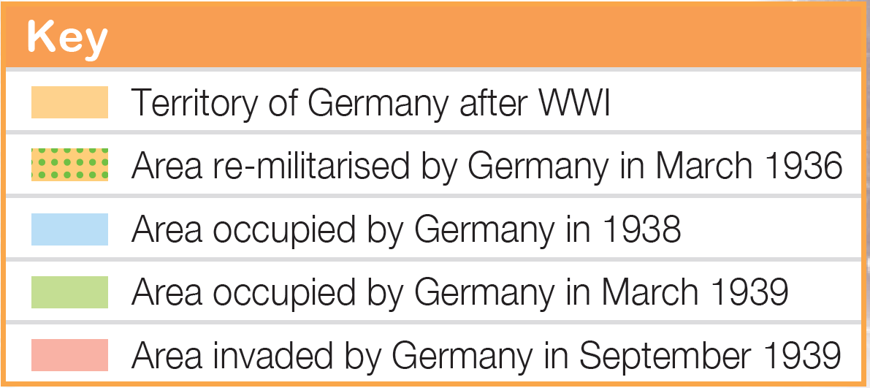
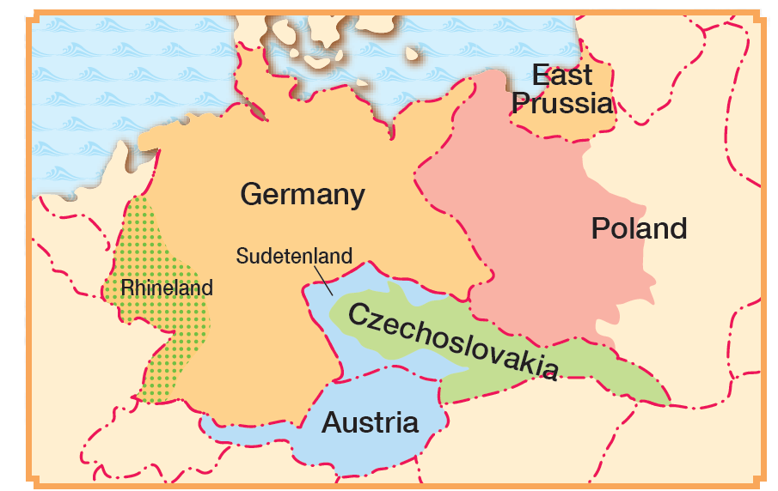

1.4 軸心國的形成

- 1936年，德國與日本簽訂《反共公約》，意大利於翌年加入， 三國逐步建立同盟關係。
- 1940 年9月， 德、意、日簽署《三國公約》，正式組成軍事聯盟，稱為「軸心國」。

集體安全的失敗

2.1 國際聯盟的局限
國聯的運作主要由英、法兩國支撐，而美國從未加入國聯。日本、德國、意大利在1930 年代更先後退出，大大影響了國聯的成效。
成員國代表性不足

國聯規定所有議案須全體成員國一致通過，導致難以採取行動。
運作機制缺乏效率
國聯沒有常備軍，面對侵略行為時，只能予以譴責或實施經濟制裁，未能有效阻止侵略國的擴張。

缺乏自設軍事力量

國聯的主要成員（1920-1946年）
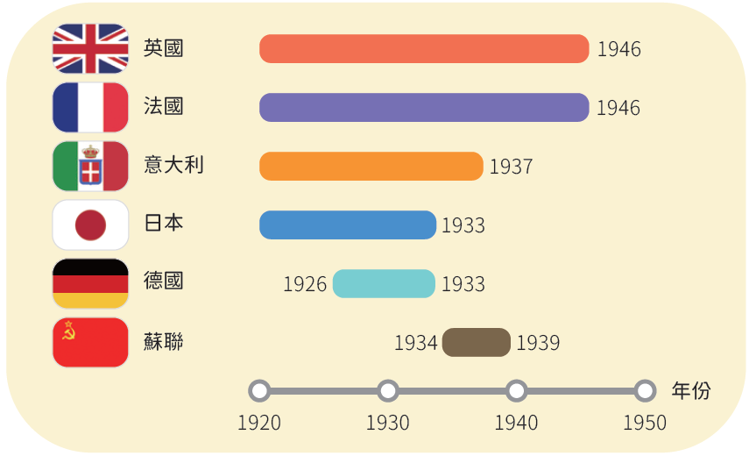

1.4 Formation of the Axis Powers

- In 1936, Germany and Japan signed the Anti-Comintern Pact, which Italy joined in the following year. The trio gradually became allies.
- In September 1940, Germany, Italy and Japan officially formed a military alliance called the Axis Powers by signing the Tripartite Pact.

Failure of collective security

2.1 Limitations of the League of Nations
The League was mainly run by Britain and France. The US never joined. Following the successive withdrawals of Japan, Germany and Italy in the 1930s, the League's effectiveness was greatly affected.

Lack of representation

The League required a unanimous vote of all member states to pass a resolution. This made actions difficult.
Inefficient mechanism

The League had no standing armed forces. Facing aggression, the League could only condemn or impose economic sanctions. It was unable to effectively stop the aggressor's expansion.
Lack of military power of its own

Major members of the League of Nations (1920-1946)
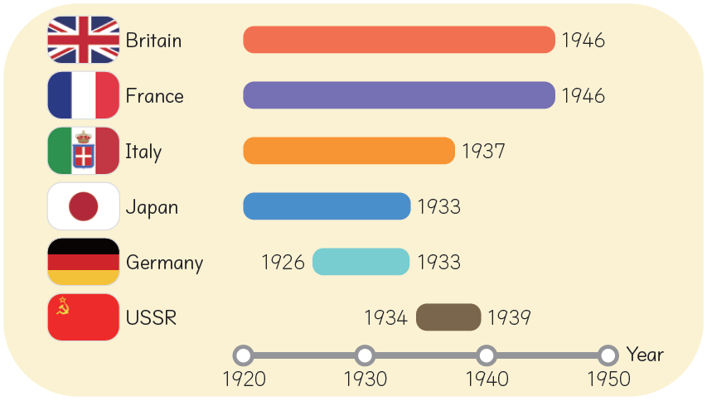

2.2 和平協約缺乏約束力

1920 年代，英、美、法等國曾試圖通過簽訂和平協約，來緩和國際間的關係，如1925年的《羅加諾公約》， 以及1928 年的《凱洛格—白里安公約》。可是，這些協約都沒有明確約束侵略行動的條款，使集體安全的努力徒勞無功。

《羅加諾公約》的簽訂儀式

2.3 裁軍會議的失敗

一次大戰後，各國曾先後多次召開裁軍會議，以遏止國際間的軍備擴張。其中以1932-1934年間舉行的日內瓦會議規模最大，共有六十一個國家參加。不過，日內瓦會議因各國未能達成共識而以失敗告終。

1933年日內瓦會議各國代表合影。德國在會議期間宣布退出會議及國聯。

2.2 Lack of binding effect for peace agreements

In the 1920s, Britain, the US, France, etc. had attempted to ease international tensions by signing peace agreements, such as the Locarno Treaties in 1925 and the Kellogg-Briand Pact in 1928.However, these agreements did not include concrete binding terms against acts of aggression, making the efforts towards collective security in vain.

Signing ceremony of the Locarno Treaties

2.3 Unsuccessful disarmament conferences

After WWI, several disarmament conferences were convened in an attempt to stop the expansion of armaments among countries. The largest one in scale was the Geneva Conference held in 1932-1934, which was participated by 61 countries. However, it ended up in failure without reaching a consensus.

Photograph showing the representatives of countries at the Geneva Conference in 1933.
During the session, Germany announced its withdrawal from both the conference and the League.

2.4 英、法、美、蘇外交政策的失誤
《德蘇互不侵犯條約》的簽訂儀式
- 英、法不願捲入新一輪的戰爭，以集中精力處理內政。因此選擇滿足極權國家的領土要求，以換取和平。
- 當德國在1938 年進攻捷克斯洛伐克時，英、法與希特拉簽訂《慕尼黑協定》，強迫捷克斯洛伐克割讓蘇台德區，助長了希特拉的野心。
- 翌年，德國直接吞併捷克斯洛伐克全境，加速了集體安全的崩潰。
英、法的綏靖政策

- 美國一直沒有加入國聯。
- 自經濟大衰退後，美國在`外交上奉行孤立主義，盡量避免介入歐洲的事務，對極權國家的擴張視而不見，助長了它們的野心。

美國的孤立主義

- 一戰後，蘇聯長期受到西方國家的孤立。英、法與德國簽署《慕尼黑協定》，更令蘇聯深感威脅。
- 蘇聯在1939 年8 月與德國簽訂《德蘇互不侵犯條約》，雙方協議十年內互不開戰，並共同瓜分波蘭。
- 自此，德國再沒後顧之憂，可以全力推行侵略全歐洲的計劃。
蘇聯力求自保

2.4 Mistakes in the foreign policies of Britain, France, the US and the USSR
- Britain and France were unwilling to get involved in a new round of warfare so that they could focus on dealing with domestic affairs. Therefore, Britain and France decided to meet the territorial demands of totalitarian states in exchange for peace.
- When Germany attacked Czechoslovakia in 1938, Britain and France signed with Hitler the Munich Agreement that forced Czechoslovakia to cede the Sudetenland, in the hope of avoiding war, fueling Hitler's ambitions.
- In the following year, Germany directly annexed the whole of Czechoslovakia, speeding up the collapse of collective security.
Appeasement policy of Britain and France

- The US never joined the League.
- Since the Great Depression, the US followed isolationism in diplomacy and avoided getting involved in European affairs. The US had turned a blind eye to the expansion of totalitarian states, fuelling their ambitions.
Isolationism of the US

- After WWI, the USSR had long been isolated by Western countries. Britain and France signed the Munich Agreement with Germany, making the USSR feel deeply threatened.
- The USSR signed the German-Soviet Non-Aggression Pact with Germany in August 1939. Both sides agreed not to go to war with each other within 10 years and to jointly carve up Poland.
- Since then, Germany no longer had any worries and could fully implement its plan to invade the whole of Europe.
The USSR trying to protect itself
Signing ceremony of the German-Soviet Non-Aggression Pact

第二次世界大戰全面爆發

戰事率先在亞洲地區爆發（1931年9月）

- 1931年9月，日本在中國東北發動「九一八事變」，拉開了二戰的序幕。
- 1937年7月，「盧溝橋事變」爆發，日本正式全面 侵略中國，標誌着二戰在亞洲的爆發。
- 二戰期間，中國成為亞洲 地區的主要戰場，牽制着日本陸軍的主力，對同盟國取得最後勝 利作出了莫大的貢獻。

全面爆發的導火線：德國突襲波蘭（1939年9月）

- 希特拉矢志收復被《凡爾賽條約》割讓予波蘭的德國土地。
- 1939 年9 月1 日，德國突然入侵波蘭。法國和英國隨即於9月3日對德宣戰，第二次世界大戰正式爆發。

參戰陣營

二次大戰的參戰陣營
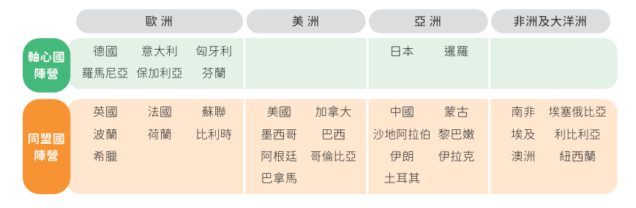

Outbreak of the Second World War

Initial outbreak of war in the Asian region (September 1931)

- In September 1931, Japan staged the Mukden Incident in Northeast China, setting the stage for WWII.
- In July 1937, Japan staged the Lugouqiao Incident and launched a full-scale invasion of China, symbolising the outbreak of WWII in Asia.
- As the main battlefield in the Asian region during WWII, China tied down the ground troops of the Japanese army, significantly contributing to the final victory of the Allied Powers.

Spark leading to the outbreak in full-scale: the German sudden attack on Poland (September 1939)

- Hitler was determined to recover the German territories ceded to Poland by the Treaty of Versailles.
- On 1 September 1939, Germany invaded Poland all of a sudden. France and Britain then immediately declared war on Germany on 3 September. The Second World War officially broke out.

Opposing camps

Participating camps in WWII
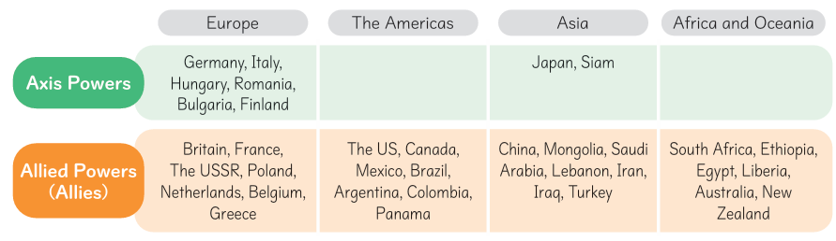

第二次世界大戰的經過

軸心國初期得利（1939- 1942年）
7月7日
日本正式全面侵略中國。
1937年
4-5月
德軍迅速攻陷丹麥、挪威、荷蘭、比利時和盧森堡，並開始進攻法國。英、法聯軍於5月底開始撤離歐洲大陸。
6月
巴黎淪陷，法國投降。
7-12月
德軍日夜轟炸英國，但未能使它投降。
1940年
1-5月
日軍先後攻佔馬來亞、新加坡、印度尼西亞、菲律賓和緬甸。
1942年
6月
德軍突襲蘇聯，蘇聯加入同盟國作戰。
12月7 日
日軍偷襲美國珍珠港，美國隨即向日本宣戰。太平洋戰爭開始。
12月25日
日軍攻陷香港。
1941年
9月
德軍入侵波蘭，二次大戰正式展開。
1939年

Course of the Second World War

Early Axis triumphs (1939-1942)
7 July
Japan launched a full scale invasion of China.
1937
April to May
German troops quickly captured Denmark, Norway, the Netherlands, Belgium and Luxembourg. They then began to invade France. At the end of May, the joint force of Britain and France began to retreat from the European continent.
June
Paris was captured. France surrendered.
July to December
The German forces bombed Britain day and night, but failed to make it surrender.
1940
January-May
Japanese troops successively occupied Malaya, Singapore, Indonesia, the Philippines and Myanmar.
1942
June
German troops suddenly attacked the USSR. The USSR joined the Allies.
7 December
The Japanese forces launched a surprise strike on Pearl Harbor of the US. The US then immediately declared war on Japan. The Pacific War started.
25 December
Japanese troops captured Hong Kong.
1941
September
Germany invaded Poland. WWII broke out.
1939

1939-1942年間軸心國進攻歐洲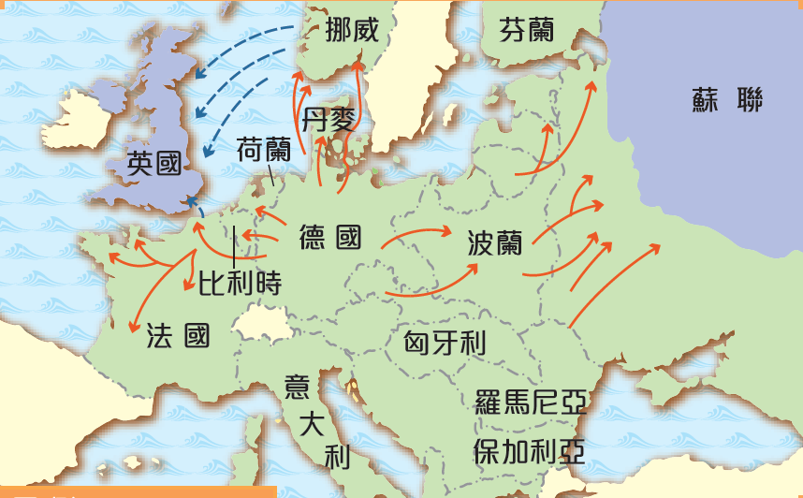
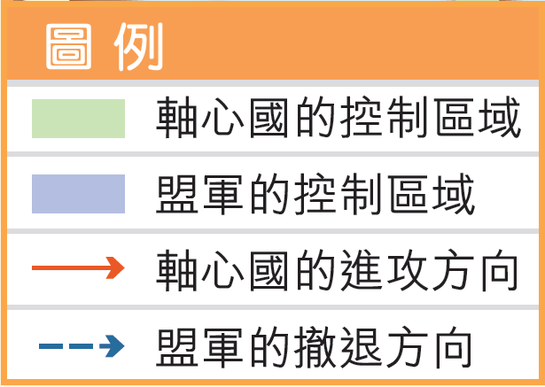

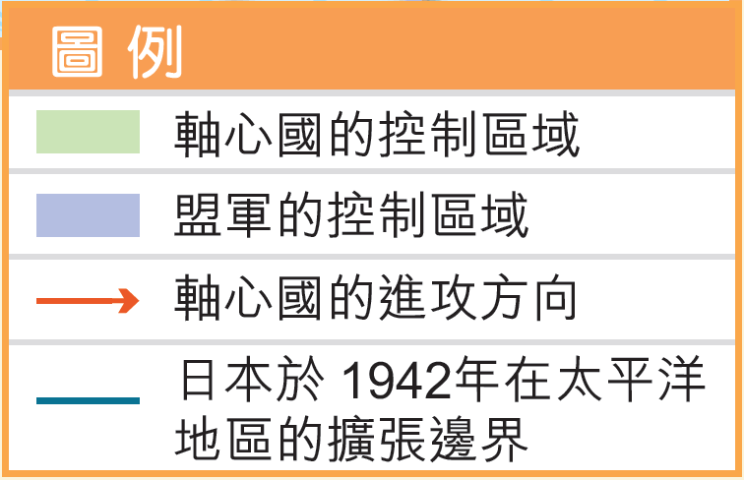
1937-1942 年間軸心國進攻亞洲及太平洋地區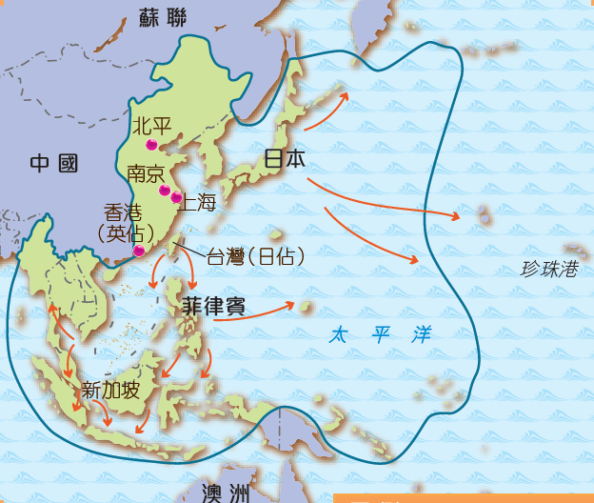

Axis advances in Europe, 1939-1942 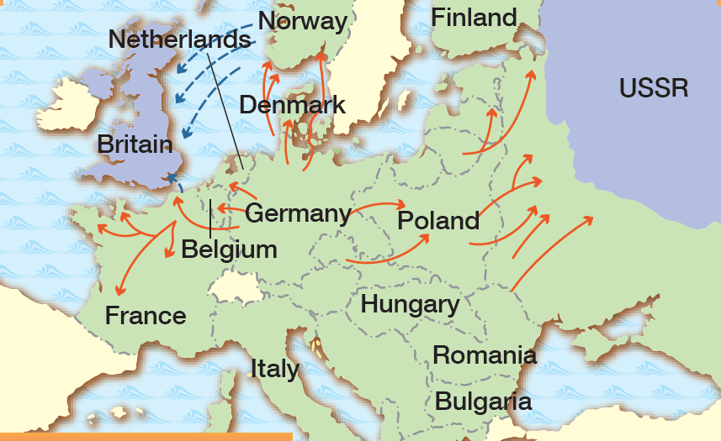
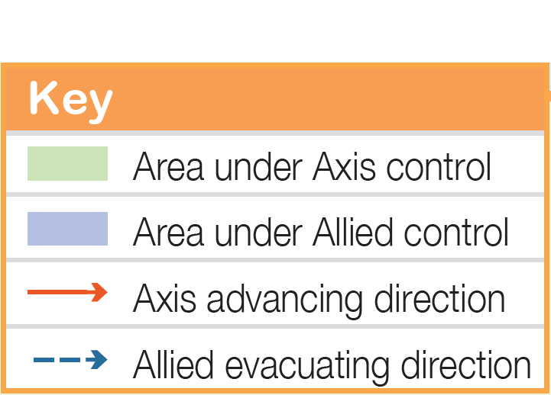

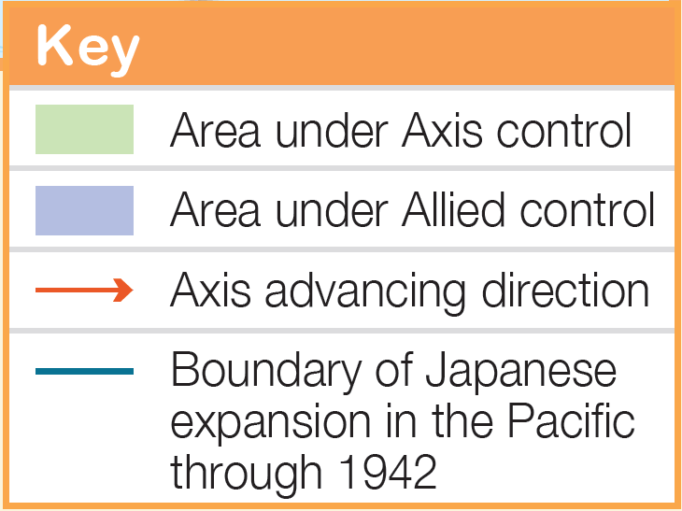
Axis advances in the Asia-Pacific region, 1937-1942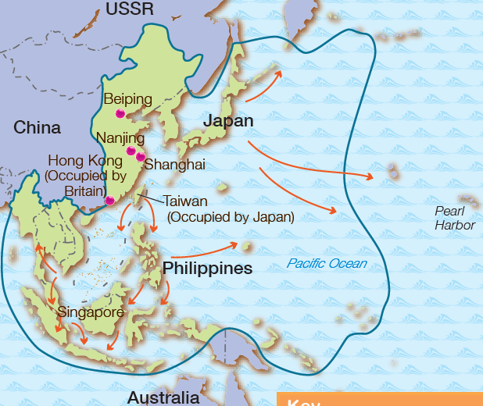

同盟國反敗為勝（1942- 1945年）

6月
美國在中途島戰役中大敗日軍，成為太平洋戰爭的轉捩點。
冬天
蘇軍在史太林格勒一役中獲勝，開始反攻。
1942年
9月
盟軍登陸意大利本土，意大利投降。
1943年
2月
美軍於硫磺島再敗日軍。
5月
盟軍東西夾攻柏林，德國投降。
8月
美國先後於6日及9日向日本的廣島及長崎投擲原子彈。15日，日本宣布無條件投降。二次大戰結束。
1945年
6月6 日
盟軍登陸法國的諾曼第， 史稱盟軍「反攻日」。
8月
盟軍解放巴黎。
1944年

Allies turning the tables（1942-1945）
June
The US defeated the Japanese forces at the Battle of Midway. This became the turning point of the Pacific War.
Winter
The USSR won the Battle of Stalingrad and began to fight back.
1942
6 June
The Allied forces landed at Normandy in France. This is referred to as D-Day.
August
The Allied forces liberated Paris.
1944
February
US troops defeated Japanese troops again on Iwo Jima.
May
The Allied forces attacked Berlin from the west and the east. Germany surrendered.
August
On 6 and 9 August, the US dropped atomic bombs on Hiroshima and Nagasaki in Japan respectively. On 15 August, Japan announced its unconditional surrender. WWII ended.
1945
September
The Allied forces landed on mainland Italy. Italy surrendered.
1943

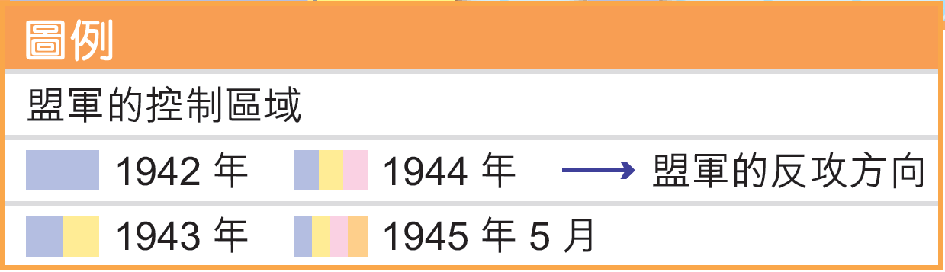
1942-1945年間盟軍於歐洲的反攻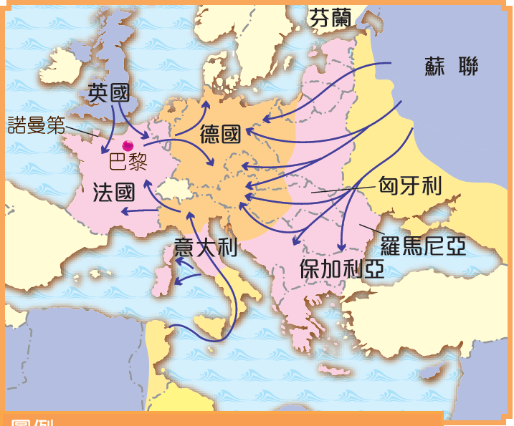

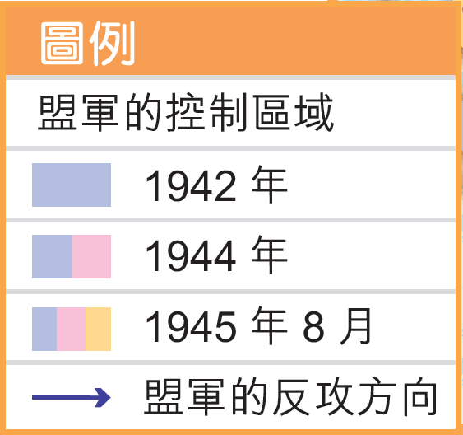
1942-1945年間盟軍於亞洲及太平洋地區的反攻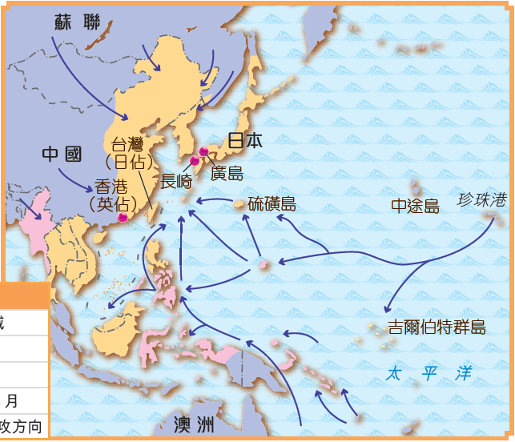

Allied counter-offensives in Europe, 1942-1945
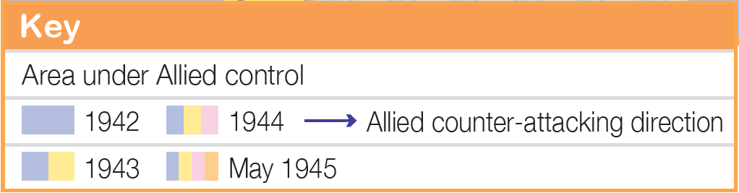
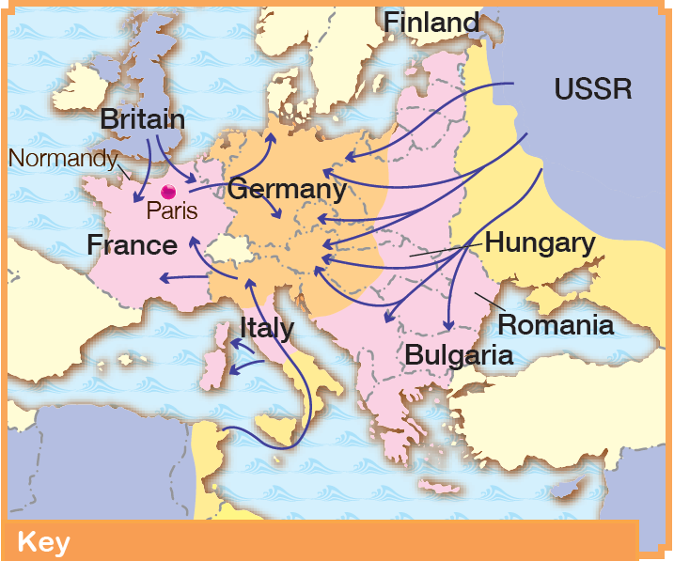

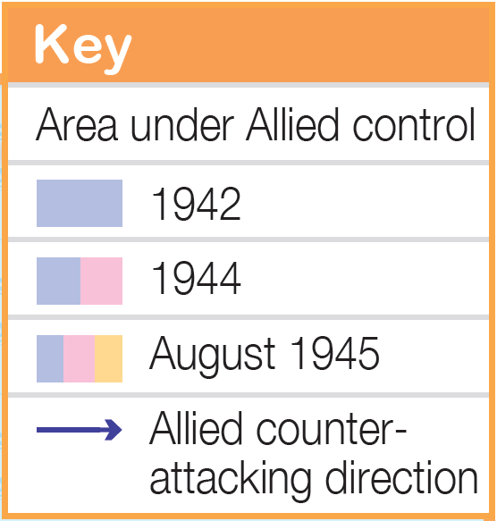
Allied counter-offensives in the Asia-Pacific region, 1942-1945
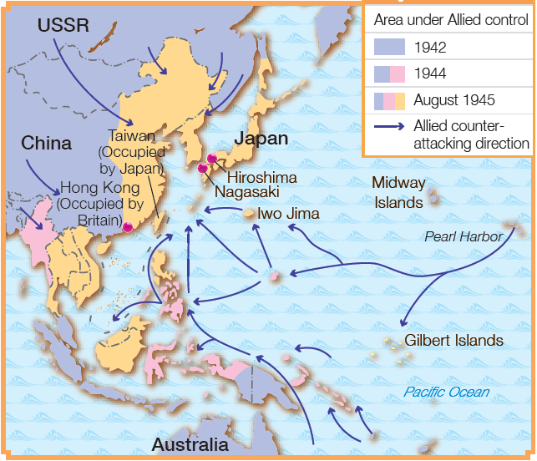

第二次世界大戰的結果

對戰敗國的處置

- 意大利須解散所有法西斯組織；德國須實行非納粹化。
- 德國及其首都柏林分為四個佔領區，分別由美、英、法、蘇管理。
- 日本由駐日盟軍總司令佔領，直至1952年重獲自主。

二戰期間的重要會議
開羅會議（1943年11月）
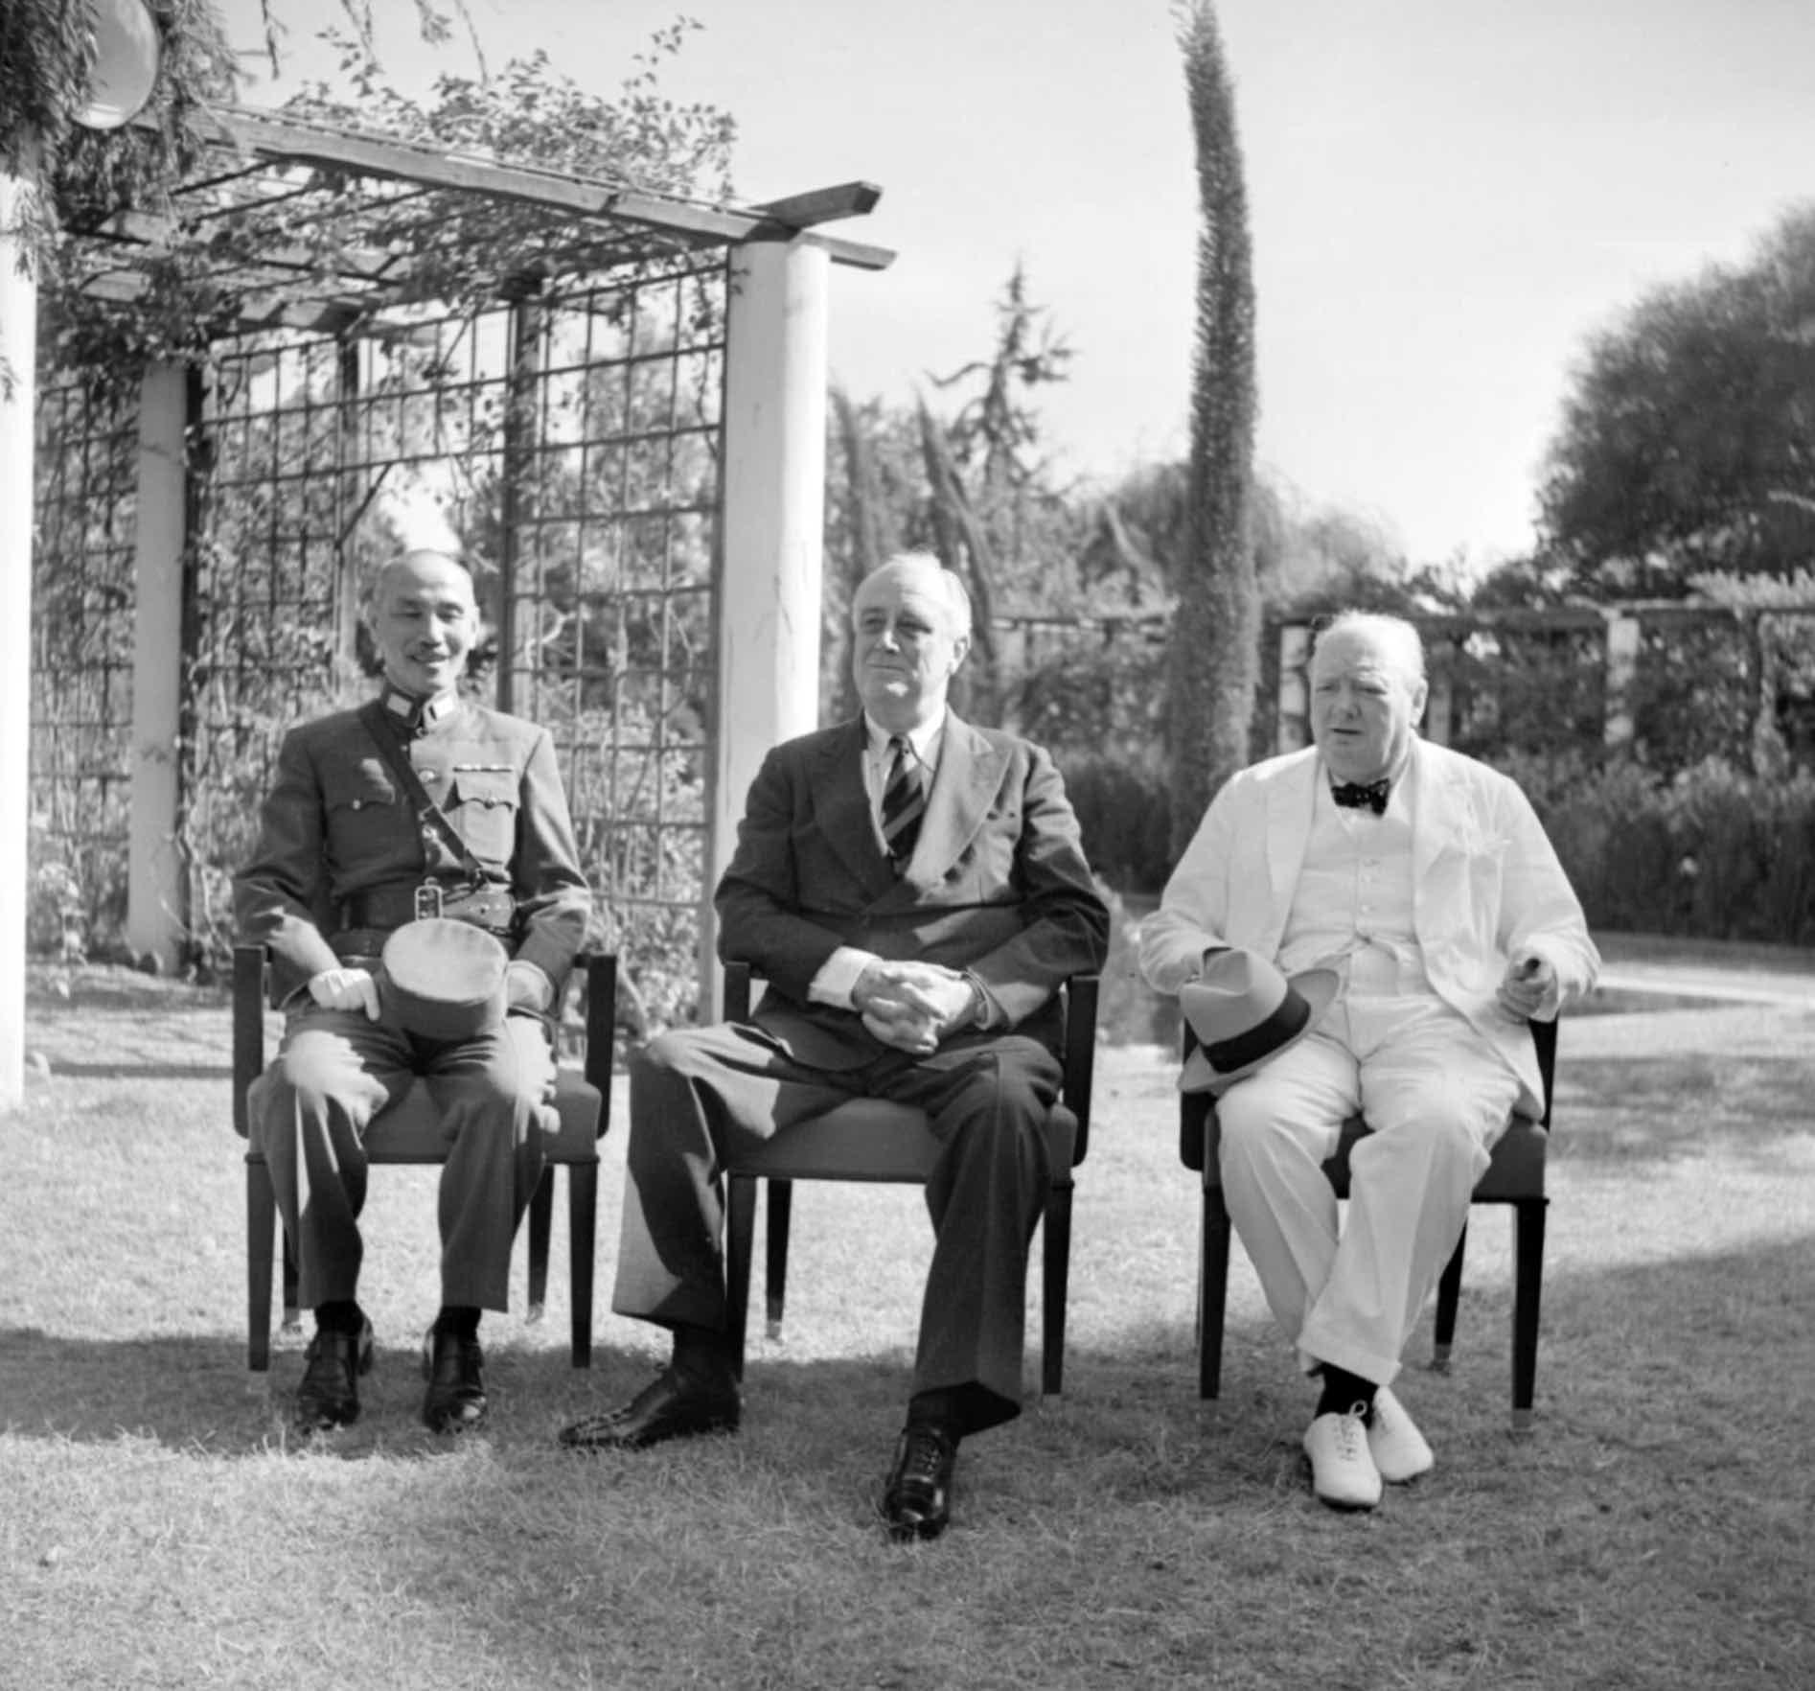 | 部分決定  - 初步制定戰後亞洲和太平洋地區的領土安排。  - 確認日本必須歸還自1894年以來從中國取得的領土。
德黑蘭會議 （1943年11-12月）
部分決定
- 初步制定戰後歐洲領土的安排。
- 建立一個維護世界和平的新國際組織。
雅爾塔會議 （1945年2月）
部分決定
- 確認戰後對德國的安排，包括列強在德國及柏林建立佔領區、戰後賠償等。
- 定下蘇聯戰後在歐洲及亞洲獲得的領土。
波茨坦會議 （1945年7-8月）
部分決定
- 重申戰後對德國的安排，各國認同協助德國復甦經濟的原則。
- 建立一個維護世界和平的新國際組織。

Results of the Second World War

Handling of the defeated countries

- Italy had to dismiss all Fascist organisations; Germany had to carry out denazification.
- Germany and its capital Berlin were divided into 4 occupation zones, each administered by the US, Britain, France and the USSR.
- Japan was occupied by SCAP until it regained its independence in 1952.
Major conferences during WWII
Cairo Conference（November 1943）
Part of the decisions
- Tentatively formulating post-war territorial arrangements in Asia and the Pacific region
- Confirming that Japan had to return the Chinese territories it had seized since 1894
Tehran Conference (November to December 1943 )
Part of decisions
- Tentatively formulating post-war territorial arrangements in Europe
- Founding a new international organisation to maintain world peace
Tehran Conference (February 1945)
Part of decisions
- Confirming the post-war arrangements regarding Germany, including the establishment of occupation zones by powers in Germany and Berlin, post-war compensation, etc.
- Determining the territories in Europe and Asia to be given to the USSR after the War
Potsdam Conference (July to August 1945)
Part of decisions
- Reaffirming the post-war arrangements regarding Germany; countries agreeing on the principle of assisting Germany's economic recovery
- Confirming that Japan was to be occupied by the Allies after the War

聯合國的建立

- 由於國際聯盟未能阻止二次大戰的爆發，英、美兩國在戰時已構思新的國際組織，從而更有效維繫世界和平。
- 1945年10月， 聯合國正式成立，以取代國聯。
- 時至今日，聯合國在維持世界和平、促進文化交流和經貿合作等方面，仍發揮着重要的作用。

聯合國成立的宣傳海報

國際秩序的轉變

- 二戰大大削弱歐洲各國的經濟和軍事力量，導致歐洲霸權時代終結。
- 美國和蘇聯成為當時世界唯二的超級大國，主導國際事務。
- 以蘇聯為首的社會主義陣營，正式與以美國為首的資本主義陣營展開長期的激烈對抗。

Founding of the United Nations

- Due to the failure of the League to prevent the outbreak of WWII, Britain and the US had conceived of a new international organisation to maintain world peace more effectively during the War.
- In October 1945, the United Nations (UN) was officially founded to replace the League.
- Nowadays, the United Nations still plays important roles in various aspects, such as maintaining world peace, promoting cultural exchanges as well as economic and trade co-operation, etc.
Promotional poster for the founding of the United Nations

Changes in the international order

- Devastated by WWII, European countries' economic and military powers were greatly weakened. This means the end of Europe's dominance.
- The US and the USSR became the only two superpowers in the world at the time, dominating international affairs.
- The long-term and fierce confrontation between the Soviet-led socialist bloc and the US-led capitalist bloc thus officially began.

重點練習
1. 根據課文內容，完成下列各題文字。
- 1920年，列強在 ___巴黎和會___ 上簽署 ___《凡爾賽條約》___ ，並成立了 ___國際聯盟___ 以促使各國用非武力的方法解決國際糾紛。
(b) 一次大戰後，包括鄂圖曼帝國在内的專制國家因革命或政變而倒台。這導致 ___新民族國家___ 的出現，而 ___俄羅斯帝國___ 的衰落促使蘇聯的成立，它是世界首個 ___共產主義___ 國家。
(c) 1920年代，美國成為全球最大的生產國和 ___債權國___。可是，到了1929年紐約 ___華爾街股票市場崩潰___ 導致美國經濟步入衰竭，這段時期被稱為美國___經濟大衰退___ 。
(d) 極權主義下，國内實行 ___獨裁專政___ 。對外方面，國家推行 ___侵略擴張___的政策，以彰顯民族的優越性。
(e) 國際聯盟沒有常備軍，因此面對侵略行為時，只能予以 ___譴責___或實施 ___經濟制裁___ 。
(f) 1940年9月，德國、意大利及日本簽訂了《 ___三國公約___ 》並組成「 ___軸心國___ 」軍事聯盟。

Key Exercises
1. Fill in the blanks according to the textbook content.
(a) In 1920, the great powers established the League of Nations to resolve conflicts peacefully when they signed the Treaty of Versailles at the Paris Peace Conference.
(b) After WWI, absolute countries such as the Ottoman Empire collapsed due to coups and revolutions. This resulted in the appearance of new nation states. In particular, the fall of the Russian Empire led to the rise of the USSR, the first communist country in the world.
(c) During the 1920s, the US was the world’s largest produce and creditor. However, in 1929 the Wall Street Crash happened in New York which led to a period of economic recession known as the Great Depression.
(d) Under totalitarianism, absolute dictatorship is adopted. The state follows an expansionist foreign policy in order to demonstrate its racial supremacy.
(e) The League of Nations lacked a standing army. Thus, it could only condemn or impose economic sanctions.
(f) In September 1940, Germany, Italy and Japan formed a military alliance known as the Axis Powers by signing the Tripartite Pact.

2. 根據課文內容，完成下表。
德國和意大利在《凡爾賽條約》下的政治及經濟困局
 | 德國 | 意大利
領土劃分 | - ___民族自決___ 原則不適用於德國。 ___日耳曼人___ 被置於不同國家的統治下 | - 意大利雖然是一次大戰的 ___戰勝國___ ，但由於它在戰時的表現不佳，因此未能從取得所期望的報酬
條款苛刻 | - 除了割讓領土外，德國還要承擔所有 ___戰爭責任___  - 軍備的種類和數量亦受到限制。
經濟困難 | - 英、法要求德國支付鉅額賠款，導致德國在戰後出現嚴重的經濟困難。 | - 一次大戰嚴重破壞了意大利的 ___農業___ 及工業  - 意大利面對嚴重的物資匱乏、通貨膨脹和失業等問題

3. 試選擇適當答案，並將其英文代號填入方格內。
- 以下哪項不是造成一次大戰後意大利不滿的原因？
A. 《凡爾賽條約》沒有提出解決意大利戰後經濟問題的措施
B. 意大利在戰爭中落敗，並被戰勝國嚴厲處罰
C. 意大利在戰爭中死傷慘重，但沒有獲得應有的報酬
B
D. 意大利面對嚴重的物資匱乏、通貨膨脹和失業問題

- 希特拉在哪年出任德國總理？
A. 1929年 B. 1930年
D
C. 1932年 D. 1933年

2. Complete the graph according to the textbook content.
The political and economic struggles of Germany and Italy under the Treaty of Versailles
 | Germany | Italy
Territorial division | - The principle of ___national self-determination___ was not applicable to Germany  - Many ___Germans___ were put under foreign rule | - Even though Italy was a victorious country in WWI, its wartime performance was unsatisfactory. Hence, Italy was not rewarded as it expected.
Harsh terms | - In addition to territorial concessions, Germany had to bear the sole responsibility for the war  - The type and quantity of its armaments is under restriction
Economic hardship | - Britain and France demanded huge reparations, causing severe economic difficulties in Germany. | - WWI seriously damaged Italy's ___agriculture___ and industry  - Italy faced severe resource shortages, inflation and unemployment

3. Choose the appropriate answer and put it in the corresponding box.
- Which of the following was not a reason for the discontent of Italy after WWI?
A. The Treaty of Versailles did not provide any solution to the post-war economic problems of Italy
B. Italy was defeated in the War and was punished harshly by the victors
C. Despite losing many soldiers, Italy was not rewarded accordingly
B
D. Italy had serious resource shortages, inflation and unemployment

- When did Hitler become the Chancellor of Germany?
A. 1929 B. 1930
D
C. 1932 D. 1933
- 1937年7月7日，日軍在北平發動了甚麽事變？
A. 「九一八事變」 B. 「蘆溝橋事變」
B
C. 「滿州國事變」 D. 「明治事變」

- 英、法兩國跟希特拉簽訂了甚麽協議，以實行他們對德國的綏靖政策？
A. 《羅加諾公約》 B. 《凱洛格—白里安公約》
C
C. 《慕尼黑協定》 D. 《日內瓦公約》

- On 7 July 1937, what incident did Japan start in Beijing?
A. The Mukden Incident B. The Lugouqiao Incident
B
C. The Manzhouguo Incident D. The Meiji Incident

- What treaty did Britain and France sign with Hitler as part of their appeasement policy?
A. The Locarno Pact B. The Kellogg-Briand Pact
C
C. The Munich Agreement D. The Geneva Pact

