課題9 20 世紀的國際紛爭及危機(I)

—兩次世界大戰
II 兩次世界大戰後的非殖民地化與「第三世界」的冒起
關鍵詞
給予殖民地國家和人民獨立的宣言 | Declaration on the Granting of Independence to Colonial Countries and Peoples
非殖民地化 | decolonisation
大東亞共榮圈 | Greater East Asia Co-Prosperity Sphere
非洲獨立年 | Year of Africa
第三世界 | Third World
和平共處五項原則 | Five Principles of Peaceful Co-existence
萬隆會議 | Bandung Conference
不結盟運動 | Non-Aligned Movement
七十七國集團 | Group of 77

溫習要點

A 亞洲及非洲的非殖民地化

背景

民族自決原則的發展

- 美國總統威爾遜提出民族自決原則，讓各民族有權決定自治或獨立。
- 大部分西方國家在亞洲、非洲的殖民地仍未能獲得獨立。

非殖民地化概念的源起

- 二戰後亞洲和非洲殖民地由受宗主國管治，轉為在政治、經濟、社會及文化方面享有獨立的過程。
- 聯合國在1960 年通過《給予殖民地國家和人民獨立的宣言》，聲明所有民族均享有自決權利。

Topic 9 International conflicts and crises in the 20th century (I)—the two

World Wars
II Decolonisation and the rise of the Third World after the two World Wars
Key Terms
給予殖民地國家和人民獨立的宣言 | Declaration on the Granting of Independence to Colonial Countries and Peoples
非殖民地化 | decolonisation
大東亞共榮圈 | Greater East Asia Co-Prosperity Sphere
非洲獨立年 | Year of Africa
第三世界 | Third World
和平共處五項原則 | Five Principles of Peaceful Co-existence
萬隆會議 | Bandung Conference
不結盟運動 | Non-Aligned Movement
七十七國集團 | Group of 77

Revision Points

A Decolonisation of Asia and Africa

Background

Development of the principle of national self-determination

- US president Wilson proposed the principle of national self-determination, allowing various ethnic groups to decide between autonomy and independence.
- Most colonies of Western countries in Asia and Africa were not granted independence.

Origin of the concept of decolonisation

- The process in which colonies in Asia and Africa, which used to be under the rule of their colonising countries, became independent in political, economic, social and cultural aspects after WWII.
- In 1960, the United Nations passed the Declaration on the Granting of Independence to Colonial Countries and Peoples, stating that all ethnic groups have the right of self-determination.

歐洲宗主國勢力下降

歐洲國家無力維持海外的殖民統治。於是，亞洲和非洲殖民地爭取獨立建國。

亞洲的非殖民地化

- 一戰後，民族自決原則成為亞洲殖民地人民爭取獨立的理據。
- 二戰期間，日本提出建立大東亞共榮圈，聲稱要從西方列強手上解放亞洲各民族。雖然這只是日軍發動侵略的藉口，但亦同時促使東南亞人民更渴望擺脫西方殖民統治。
- 二戰後，菲律賓率先於1946年獨立。至1984 年，文萊獨立，亞洲的非殖民地化終於完結。

非洲的非殖民地化

- 當地少數菁英分子不甘再受外來剝削，開始要求爭取獨立。
- 1960 年代是非洲非殖民化的高峰期。單在1960 年，便有十七個殖民地宣布獨立，包括法國的喀麥隆、英國的尼日利亞、比利時的剛果民主共和國等。該年因而被稱為「非洲獨立年」。1990年，納米比亞獨立，標誌着非洲殖民地化完成。

第二次世界大戰後宣布獨立的非洲及亞洲殖民地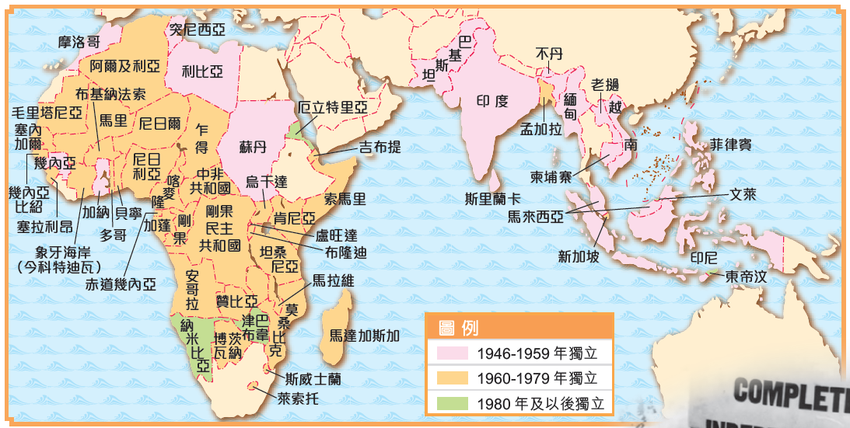

Declining strength of European colonising countries

European countries were unable to maintain overseas colonial rule. Therefore, colonies in Asia and Africa took this opportunity to demand independence from their colonising countries.

Decolonisation in Asia

- After WWI, the principle of national self-determination became grounds for pursuing independence among colonial Asians.
- During WWII, Japan proposed establishing the Greater East Asia Co-Prosperity Sphere, claiming that all Asian peoples would be freed from Western powers. Although this idea was an excuse for Japanese aggression, it also made Southeast Asians more eager to get rid of Western colonial rule.
- After WWII, the Philippines first declared independence in 1946. The independence of Brunei in 1984 marked the end of decolonisation in Asia.

Decolonisation in Africa

- Some local elites became unwilling to tolerate foreign exploitation any longer. They started to struggle for independence.
- The 1960s was the peak of decolonisation in Africa. Only in 1960, 17 colonies in Africa had declared independence, including France's Cameroon, Britain's Nigeria, Belgium's Democratic Republic of the Congo, etc. This year is referred to as the ‘Year of Africa’. In 1990, the independence of Namibia symbolised the completion of decolonisation in Africa.

Colonies in Africa and Asia that declared independence after WWII
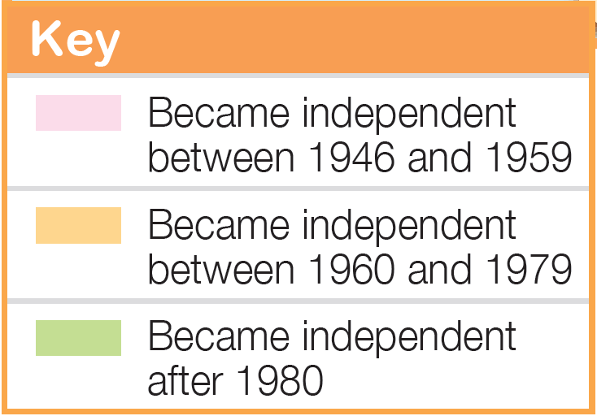
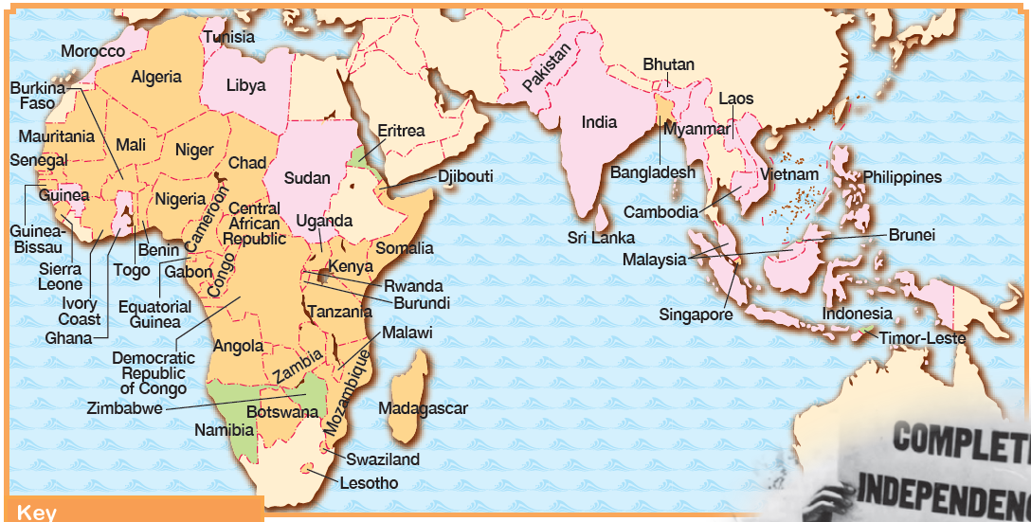

B 「第三世界」的冒起

何謂「第三世界」？

- 「第一世界」是以美國為首的資本主義陣營，「第二世界」是以蘇聯為首的社會主義陣營，而「第三世界」則指二次大戰後新興民族國家。
- 「第三世界」國家多位於亞洲、非洲和拉丁美洲，特點是曾為西方的殖民地，獨立後主張政治中立。

「和平共處五項原則」的提出

1954 年，中國、印度與緬甸共同發表「和平共處五項原則」，成為日後「第三世界」國家發展外交的指導原則。
互相尊重主權和領土完整
互不侵犯
互不干涉內政
平等互利
和平共處

萬隆會議

- 1955 年，二十九個亞、非國家在印尼召開萬隆會議。中國總理周恩來在會議上重申「和平共處五項原則」。
- 參與國共同聲明拒絕加入美、蘇兩大對立陣營，並支持民族自決、反對殖民主義。

不結盟運動

- 1961 年，二十五個「第三世界」國家在南斯拉夫召開不結盟運動的第一次峰會，討論反殖民主義和反帝國主義等議題。
- 成員國奉行獨立自主的外交政策，不與美、蘇兩國任何一方結盟，亦不介入地區性衝突。

B Rise of the Third World

What is the Third World?

- The First World was the capitalist bloc led by the US. The Second World was the socialist bloc led by the USSR. The Third World refers to the new nation-states founded.
- Most Third World countries were former Western colonies in Asia, Africa and Latin America. When they gained independence, they advocated political neutrality.

Declaration of the Five Principles of Peaceful Co-existence

In 1954, China, India and Myanmar jointly declared the Five Principles of Peaceful Co-existence, becoming the guiding principles in the diplomatic development of Third World countries.
Mutual respect for sovereignty and territorial integrity
Mutual non-aggression
Mutual non-interference in each other's internal affairs
Equality and mutual benefit
Peaceful co-existence

Bandung Conference

- In 1955, 29 Asian and African countries convened the Bandung Conference in Indonesia. Premier Zhou Enlai of China reaffirmed the Five Principles of Peaceful Co-existence at the conference.
- Participating countries declared their refusal in joining in the two blocs led by the US and the USSR respectively. They also stated their support for national self-determination and anti-colonialism.

Non-Aligned Movement

- In 1961, 25 Third World countries held the first summit of the Non-Aligned Movement in Yugoslavia to discuss issues such as anti-colonialism and anti-imperialism. Member states of the Non-Aligned
- Movement pursued an independent foreign policy, did not ally themselves with either the US or the USSR, and did not intervene in regional conflicts.

七十七國集團
七十七國集團的標誌

- 1964 年，七十七個「第三世界」國家聯合提出有關國際經濟發展的主張，形成七十七國集團。
- 聯合國體制內的經濟組織，主要由亞、非、拉國家組成。
- 在聯合國內推動成員國在經濟方面的國際合作。該組織也積極在國際事務上發表意見，如支持全球裁軍。

七十七國集團成員國的分佈
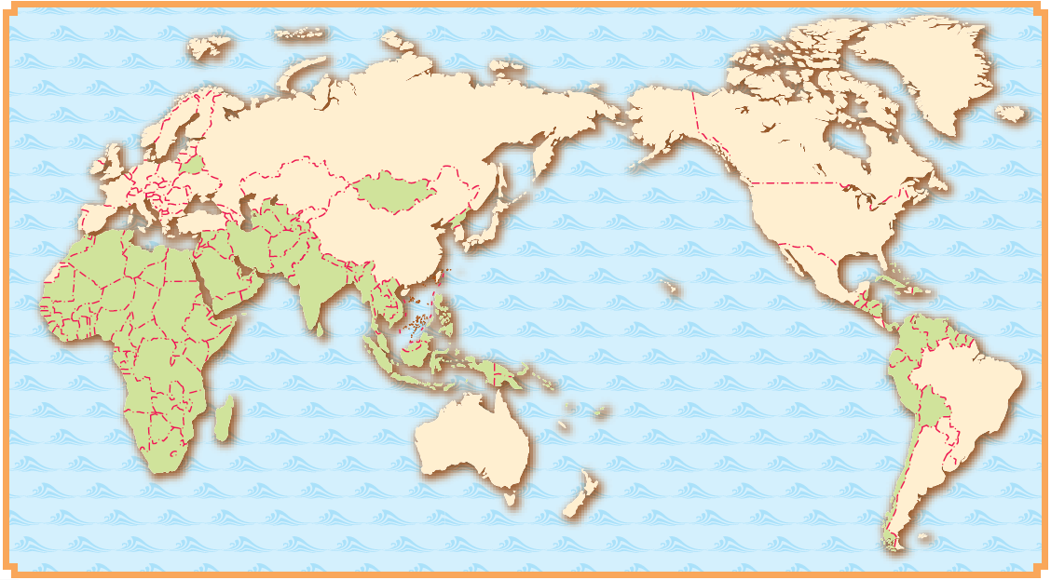
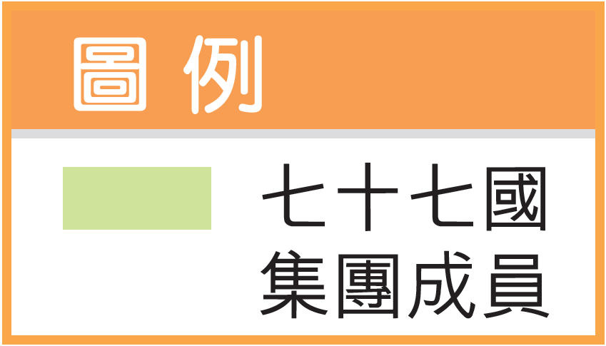

Group of 77
- In 1964, 77 Third World countries formed the Group of 77 by jointly raising proposals regarding the international economic developments.
- An economic organisation within the United Nations system. It mainly consists of countries in Asia, Africa and Latin America.
- It aimed at promoting international economic co-operation among its member states within the United Nations. Meanwhile, it also actively voiced its opinions on international affairs, such as supporting global disarmament.
Emblem of the Group of 77

Distribution of member states of the Group of 77
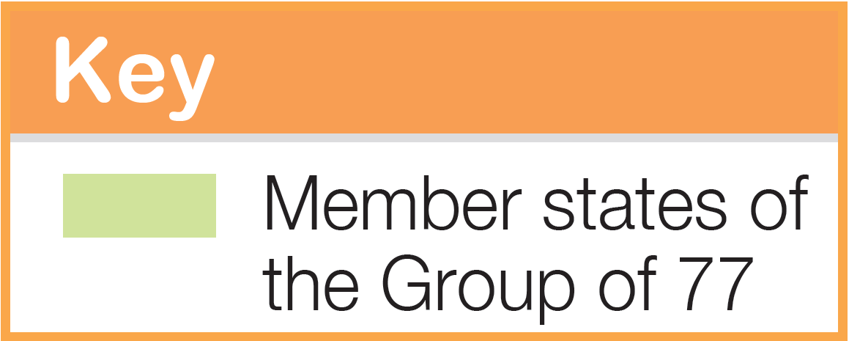

重點練習
1. 根據課文內容，完成下列各題文字。
(a) ___非殖民地化___ 指一個地方由受外國殖民管治，轉為在政治、經濟和軍事方面獨立自治的過程。這概念主要用於形容亞洲和非洲國家在二次大戰後爭取獨立的過程。
(b) 1960年，有 ___十七___ 個非洲殖民地宣佈獨立，包括法國的喀麥隆、英國的尼日利亞、比利時的 ___剛果___ 等。該年因而被稱為「 ___非洲獨立年___ 」。
(c) 「 ___第三世界___」一詞，最先出現於1950年代。它指二次大戰後新興的獨立國家。這些國家多位於亞洲、非洲和 ___拉丁美洲___，特點是曾為西方的殖民地，獨立後來主張政治中立，不與其他國家結盟。
(d) 1955年，二十九個亞洲和非洲國家在印尼召開了「 ___萬隆___ 會議」。各國聲明拒絕加入 ___美___ 、___蘇___ 兩大對立陣營，並支持 ___民族自決___、反對 ___殖民主義___ 。

2. 試選擇適當答案，並將其英文代號填入方格內。
- 1971年，哪個國家的獨立標誌整個亞洲地區的非殖民地化過程完結？
A. 越南 B. 孟加拉
B
C. 馬來亞 D. 印度尼西亞

Key Exercises
1. Fill in the blanks according to the textbook content.
(a) ___Decolonisation___ refers to the process in which former colonies became independent and autonomous in political, economic and military aspects. This concept mainly refers to the processes of independence for the ___Asian___ and ___African___ countries after WWII.
(b) In 1960, ___17___ African colonies declared independence, including French Cameroon, British Nigeria and Belgian Congo. This year was known as the ___Year of Africa___ .
(c) The term ‘ ___Third World___ ’ was put in use since the 1950s. It refers to the new independent states after WWII. Most of them were former colonies of the West in Asia, Africa and ___Latin America___ . After independence, they preferred political ___neutrality___ and not to ally with other countries.
(d) In 1955, 29 Asian and African countries met at the ___Bandung___ Conference. The countries declared their refusal in joining the two blocs led by the ___US___ and the ___USSR___ respectively and stated their support for___ national self-determination___ and ___anti-colonialism___ .

2. Choose the appropriate answer and put it in the corresponding box.
- In 1971, the independence of which country marked the end of decolonisation in Asia?
A. Vietnam B. Bangladesh
B
C. Malaya D. Indonesia

- 「和平共處五項原則」包括了以下哪項原則？
(1) 互不侵犯
(2) 和平共處
(3) 平等互利
(4) 互不干涉内政

A. (1)、(2)、(3) B. (1)、(2)、(4)
D
C. (2)、(3)、(4) D. (1)、(2)、(3)、(4)

- 哪個經濟組織由聯合國貿易和發展會議成立？
A. 七十六國集團
B. 七十七國集團
C. 七十八國集團
B
D. 七十九國集團

- Which of the following principles were included in the Five Principles of Peaceful Co-existence?
(1) Mutual non-aggression
(2) Peaceful co-existence
(3) Equality and co-operation for mutual benefit
(4) Mutual non-interference in each other’s internal affairs

A. (1), (2), (3) B. (1), (2), (4)
D
C. (2), (3), (4) D. (1), (2), (3), (4)

(c) What organisation was formed by the United Nations Conference on Trade and Development?
A. The Group of 76
B. The Group of 77
C. The Group of 78
B
D. The Group of 79

