課題9 20 世紀的國際紛爭及危機(I)

—兩次世界大戰
III 個案研習（一）：戰爭與發明（二選一，延伸部分多選一項）
關鍵詞
總體戰 | total war
經濟封鎖 | economic sanction
禁運 | embargo
彈道導彈 | ballistic missile
盤尼西林 | penicillin
衛星 | satellite
雷達 | radar
能源危機 | energy crisis
風衣 | trench coat

溫習要點

A 戰爭模式的改變：總體戰

第一次世界大戰前的戰爭模式

- 戰爭大都採用線式戰術來進行，即雙方在戰場訂下清晰的交戰線作戰。
- 戰事的目標在於攻佔個別的戰略要地或堡壘，平民大致上不受戰事波及。戰場也只局限於陸戰和海戰。

總體戰的出現

- 一戰期間，隨着戰況陷入膠着狀態，以及更多國家的參戰，參戰國只得動員更多資源，以爭取最後勝利。
- 總體戰指參戰國動員所有資源投入戰爭，包括前線的軍隊和後方的平民，其目的是消滅敵國的所有武裝力量。

Topic 9 International conflicts and crises in the 20th century (I)—the two

World Wars
III Case study (1): Wars and inventions (Choose 1 out of 2, study 1 more case for the extended part)
Key Terms
總體戰 | total war
經濟封鎖 | economic sanction
禁運 | embargo
彈道導彈 | ballistic missile
盤尼西林 | penicillin
衛星 | satellite
雷達 | radar
能源危機 | energy crisis
風衣 | trench coat

Revision Points

A Changes in warfare: total war

Warfare before WWI

- Linear tactics were commonly used in warfare. Soldiers from both sides would form clear lines to attack.
- The goal of warfare was to capture individual strategic locations or fortresses. Civilians were generally not affected. In addition, battles were mostly fought on land and at sea.

Emergence of total war

- When WWI reached a stalemate and more countries joined the war, participating countries had to mobilise more resources to seize the final victory.
- Total war means that countries invest all their resources into the war, including soldiers at the war front and civilians in the rear. They aim is to destroy all of the armed forces of the enemy.
總體戰的概念
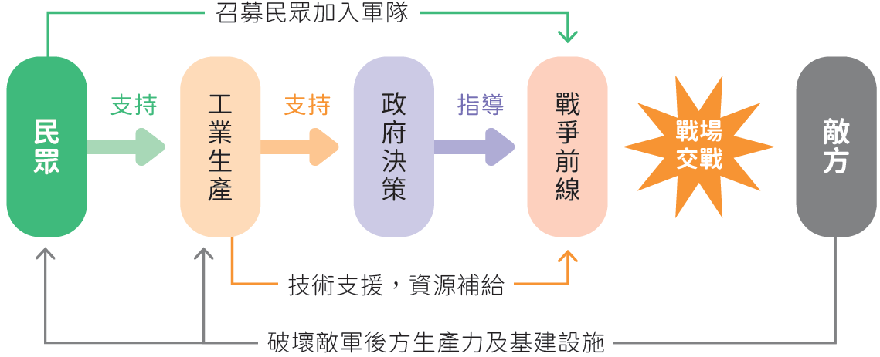

總體戰如何改變人類戰爭模式？
 | 19世紀初的戰爭模式 | 20世紀的總體戰
空間 | 局限於一個或數個戰場或地區 | 涉及全球不同地域，二次大戰較一次大戰的範圍更廣
士兵來源 | 募兵制 | 徵兵制
軍備 | 滑膛炮、步槍、刺刀、長矛、軍刀等 | 以各種殺傷力更強的新型武器作戰，如坦克、戰機和原子彈
交通及通訊設備 | - 使用馬匹及戰船等作軍事運輸，速度緩慢  - 通訊設備落後，不利戰時傳遞訊息 | - 鐵路、運輸機等交通網絡完善，能迅速運送兵員及物資到戰場  - 使用電話、電報等無線電通訊系統，改善作戰時的溝通

Concept of total war
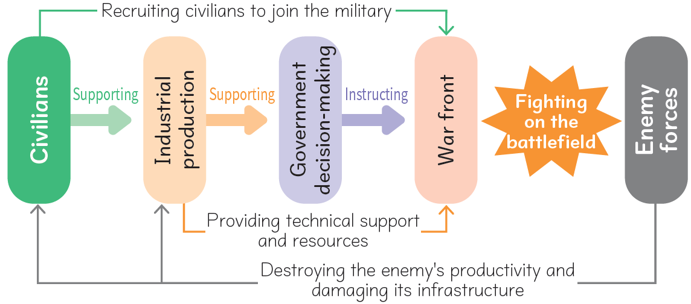

How did total war change human warfare?
 | Warfare in the early 19th century | Total war in the 20th century
Space | Being confined to a single or several battlefields or regions | Involving different regions around the world; WWII having a greater scope than WWI
Source  of soldiers | Recruitment system | Conscription
Armaments | Smooth-bore cannons , rifles, bayonets, spears, sabres, etc. | A variety of new and more deadly weapons, such as tanks, fighter aircraft and atomic bombs, were in use.
Transport  and communication | - Horses and warships were used for military transport at slow speeds.  - Communication equipment was backward, making it difficult to deliver messages in combat conditions. | - Transport networks such as railways and airlifters were well developed, allowing a faster transport of soldiers and supplies to battlefields.  - The use of radio communication systems such as the telegraph and the telephone enhanced exchanges of information in combat conditions.

總體戰的特徵

軍事方面

- 戰事範圍的擴大，發展成海、陸、空三方的立體戰爭。
- 參戰國所使用的武器也越趨多樣化和更具殺傷力。
- 採取各種戰略，例如包圍軍事據點、戰略轟炸敵方城市、封鎖敵軍海域等。
- 戰場不再局限於交戰的前線，後方的工廠、交通幹道等基礎建設亦成為被攻擊的目標。

經濟方面

- 對外方面，參戰國會對敵方進行經濟封鎖，實施禁運。
- 國內方面，參戰國的政府會實施糧食和物資配給，並發行戰爭債券以籌募資金。

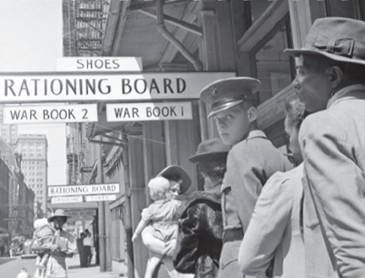
二次大戰期間，美國政府實施配給制，民眾須排隊購買各種生活物資。

社會方面

- 參戰國在本國實行徵兵制，強制男性參軍；同時動員婦女參加生產工作。
- 參戰國亦將殖民地的資源投入戰爭。

文化方面

- 參戰國會發動宣傳戰，利用媒體及海報抹黑敵軍，團結國民。
- 音樂、戲劇等藝術在戰時亦為戰爭服務，以提升軍隊士氣及激發大眾的愛國情緒。

Characteristics of total war

Military aspect

- The scope of warfare on land, at sea and in the air was enlarged.
- The armaments used became more diverse and deadly.
- Different strategies would be adopted in total warfare, including surrounding the enemy's strongholds, conducting strategic bombings, blockading the enemy's waters, etc.
- Battlefields were no longer confined at the war front. Infrastructure such as factories and roads in the rear would become military targets too.

Economic aspect

- Externally, participating countries would impose economic sanctions and embargoes on the enemy.
- Domestically, governments would introduce food and resources rationing as well as issuing war bonds to raise funds.

During WWII, the US government implemented a rationing system.
Americans had to queue up to buy daily necessities.

Social aspect

- Participating countries adopted conscription, making military service compulsory for men. At the same time, women were required to participate in production work.
- Participating countries also invested colonial resources in the war.

Cultural aspect

- Participating countries would compete in propaganda. They made use of media and posters to discredit the enemy and unite civilians.
- The arts such as music and dramas had to serve war purposes, boosting the morale of soldiers and enhancing patriotic emotions among civilians.

總體戰的影響

平民傷亡慘重

- 根據統計，二次大戰的總死亡人數約七千五百萬，當中平民比例高達六成五。
- 二次大戰成為人類歷史上首次平民死亡人數超越軍事死亡人數的戰爭。

經濟活動癱瘓

主要城市經常遭到轟炸，就連遠離戰場的區域也受到波及。後方的交通網絡、工廠、農田、民居受到嚴重破壞，大量人口流離失所，產業接近完全停擺。

女性地位提升

- 各國政府為了保持國內工業的生產力，積極提倡婦女出外工作。除了後勤工作，部分婦女還參與前線戰鬥。婦女的工作表現及貢獻獲得一致認同，地位得以提升。
- 歐洲國家的婦女陸續享有投票權。她們還在政治、經濟等方面爭取男女平等，如爭取相同薪酬及待遇。

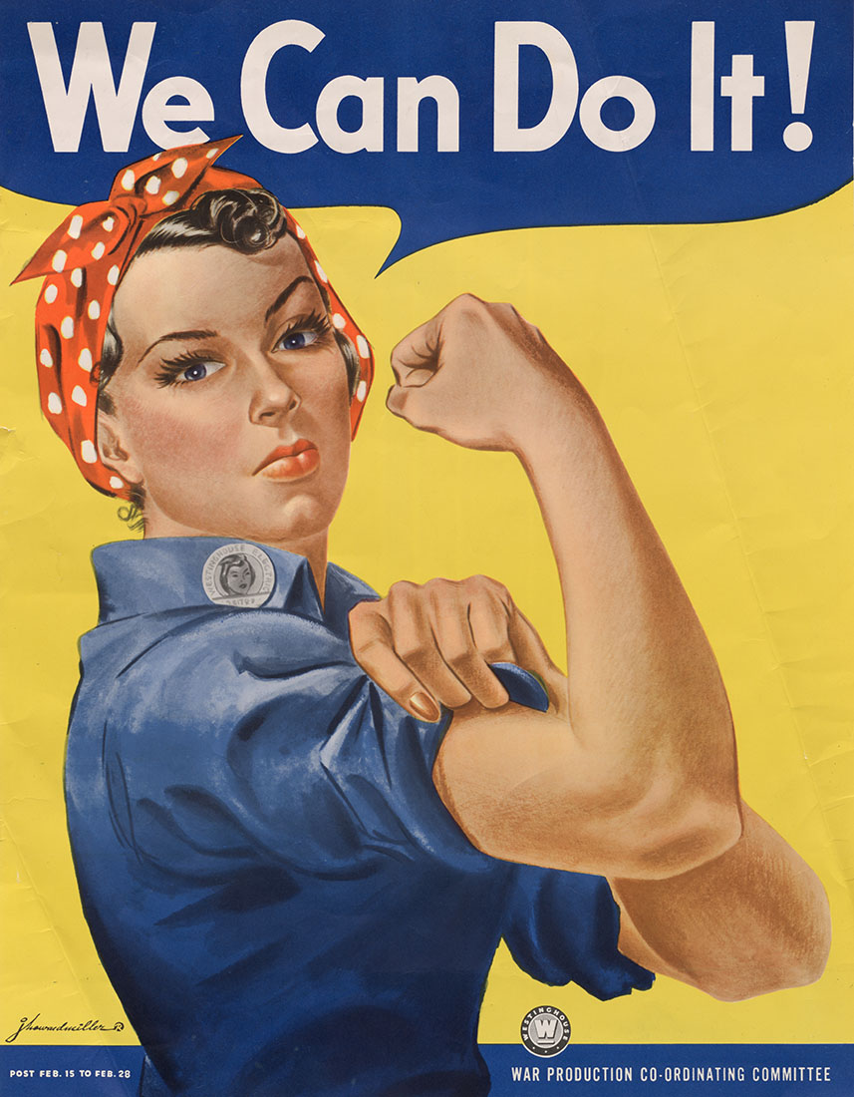
鉚釘工蘿西

Impact of total war

Heavy civilian casualties

- According to statistics, the total deaths of WWII are estimated at 75 million, of which 65% are civilians.
- WWII became the first war in human history in which civilian deaths exceeded military deaths.

Paralysed economic activities

Major cities were often bombed, and even regions far away from the battlefield were affected. Transport networks, factories, farmland, and civilian residences in the rear were severely damaged. A large number of people were displaced, and the industry was close to a complete shutdown.

Rising status of women

- Governments actively encouraged women to go out to work, for the purpose of maintaining domestic industrial production. In addition to working on the home front, some women also fought at the war front. The contributions of women came to recognition.
- Their status rose. European women were gradually given the right to vote. They also strived for political and economic equality, such as equal pay and treatment.

Rosie the Riveter

B 新型軍備的出現

第一次世界大戰期間使用的新型軍備

陸軍

- 德、法兩國在塹壕戰中首次應用催淚氣體和毒氣，士兵開始戴上防毒面罩作戰。
- 1916年，英國首次將坦克應用於塹壕戰。此後，坦克成為了陸軍的重要武器。

一戰時期英軍的坦克

海軍

- 無畏艦的發明大幅提升了海軍的機動力和火力，海戰的規模因而大幅擴大。
- 德國的潛艇亦在一戰期間投入作戰，以魚雷擊沉前往英國的船隻。

空軍

一戰期間，飛船被用作偵察敵軍及投擲炸彈。到了戰爭後期，戰鬥機成為空戰的主要力量。

第二次世界大戰期間使用的新型軍備

- 航空母艦的發展，以及長程轟炸機的廣泛使用，令海戰和空戰的規模更大，亦造成更嚴重的死傷。
- 二戰末期，德國研發了火箭。
- 美國在1945年成功研製原子彈，成為當時最具毀滅性的武器。

B Emergence of new armaments

New armaments during the First World War

Army

- Germany and France started to use tear gas and other poison gases in trench warfare. Soldiers had to wear gas masks in combat.
- In 1916, Britain first use tanks in trench warfare. Since then, the tank had become a significant land weapon.

British tank during WWI

Navy

- The invention of the dreadnought greatly enhanced the mobility and the fire power of the navy. Sea battles became greater in scale.
- Germany used submarines to sink ships heading to Britain with torpedoes during WWI.

Air force

During WWI, airships were used to spy on and bomb enemy forces. At the later stage of the war, fighter aircraft replaced airships to become the main fighting strength in air warfare.

New armaments during the Second World War

- The development of aircraft carriers, along with the wide use of long-range bombers, enlarged the scale of sea and air battles, causing more severe casualties.
- At the end of WWII, Germany invented rockets.
- The US successfully made the atomic bomb, which was the most destructive weapon at the time.

新型軍備的影響

造成鉅大的破壞

一戰期間，估計有一千五百萬人死於戰場；到了二戰，總死傷人數更高達七千五百萬人。

兩次世界大戰部分參戰國的死亡人數（包括軍人及平民）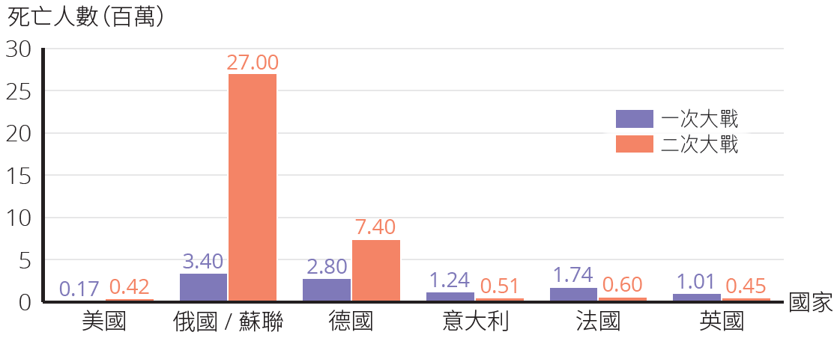

重型武器的出現

- 兩次大戰期間，火砲等重型武器的發展十分迅速。
- 二戰後，美國和蘇聯取得德國研發火箭的成果，並在此基礎上繼續發展彈道導彈。

核子時代來臨

原子彈的發明和應用，標誌着未來的戰爭可以隨時滅絕人類。於是，一個國家是否或擁有多少核武器，成為衡量其實力的指標，以及它在國際事務上談判的籌碼。核武器的出現，自此持續威脅世界的和平。

Impact of new armaments

Mass devastation

It is estimated that 15 million people were killed in the field during WWI. For WWII, the total number of casualties reached 75 million.

Number of deaths (including soldiers and civilians) in
participating countries of the two World Wars 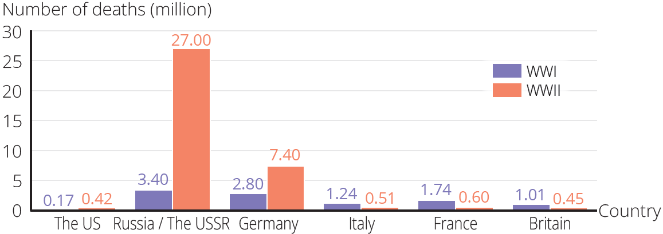

Emergence of heavy weapons

- During the two World Wars, heavy weapons such as artillery were developed rapidly.
- After WWII, the US and the USSR seized the results of Germany's rocket research. They continued to develop ballistic missiles upon these results.

Beginning of the atomic age

The invention and use of the atomic bomb signified that future wars could wipe out mankind at any time. From then on, the strength of a country was determined by whether or not it had nuclear weapons and, if so, how many it had. Nuclear weapons became a bargaining tool in international affairs, posing a serious threat to world peace.

C 軍需發明對今日世界的影響

兩次世界大戰期間，各國投放了大量資源到科學研究的領域，促使醫療技術和科技創新的迅速發展。戰後，很多軍需發明漸漸被應用於日常生活，改善了今日人類的生活。

醫學發明

外科治療

一次大戰期間，應用了英國外科醫生托馬斯發明的「托馬斯夾板」，用作治療骨折。

整容手術

- 戰爭期間，很多士兵因被炮彈擊中，導致面容和手腳嚴重扭曲。
- 1916 年，新西蘭醫生吉爾斯開始發展整容手術，為受傷的士兵修復面容，讓他們重拾自信。

新藥物

- 1928 年，英國科學家法萊明發現抗生素「盤尼西林」。二次大戰期間，美國開始大量生產盤尼西林，成功救活不少傷兵。
- 抗生素至今仍是治療疾病的重要藥物。

急救工具

- 1917 年，瑪麗•居禮（居禮夫人）發明了便於移動的小型X射線機，用來協助前線醫護人員檢查傷兵身體內的子彈位置。
- 一次大戰期間，人們改良救護車，以加快運送傷者的速度。

C Impact of military inventions on the world today

During the two World Wars, countries had spent a lot of resources on scientific research, promoting the developments in medical technology and technological innovation. After wartime, many military inventions were gradually adopted in our daily lives, improving today's human livelihood.

Medical inventions

Surgical treatment

During WWI, Hugh Owen Thomas, a British surgeon, invented the ‘Thomas splint’ to treat bone fractures.

Plastic surgery

- In wartime, a large number of soldiers were injured by bombs and had their faces and limbs disfigured.
- In 1916, Harold Gillies, a doctor from New Zealand, developed plastic surgery to heal the faces of wounded soldiers, so that they could regain confidence.

New drugs

- In 1928, Alexander Fleming, a British scientist, discovered an antibiotic called penicillin. During WWII, the US produced penicillin on a massive scale, helping to save a lot of wounded soldiers.
- Antibiotics are still an important type of drugs for treating diseases.

First aid tools

- In 1917, Marie Curie (Madame Curie) invented a small mobile X-ray machine, which helped front-line medical personnel to detect bullets inside wounded soldiers' bodies.
- During WWI, ambulances were modified in order to save time spent on transporting the wounded.

科技發明

人造衞星

- 二戰期間，德國研發了火箭，奠定後來人類探索太空的基礎。
- 1957 年，蘇聯成功發射第一顆人造衞星到太空。

人類史上第一顆人造衞星，
蘇聯的「斯普特尼克一號」

核能源

- 二戰期間，核原理雖然被用作製成原子彈，但後來被發展成新能源。
- 1970 年代，世界出現能源危機，令核能發電開始成為主要能源之一。
1954年，位於莫斯科附近的奧布寧斯克核電廠開始運作，是世界首座商用的核電廠。

Technological inventions

Artificial satellite

- During WWII, Germany invented rockets, laying the foundation for later human space exploration.
- In 1957, the USSR successfully launched the first artificial satellite into space.

The first artificial satellite in human history, Sputnik 1 of the USSR

Nuclear energy

- During WWII, nuclear theory was used for making atomic bombs. It was later developed into a new energy source.
- Following the 1970s global energy crisis, nuclear energy had become one of the major energy sources.
In 1954, the Obninsk Nuclear Power Plant near Moscow began operation. It was the world's first commercial nuclear power plant.

雷達和微波爐

一戰時期，人們開始發展用來偵測船隻和飛機的雷達系統。 二戰以後，雷達的運用進一步拓展，不但有助預測天氣，同時衍 生了微波爐的發明。

電腦

- 二戰期間，英國數學家圖靈發明用於破解德國軍用密碼的機器。相關理論和技術後來被加以發展，促成第一台通用電腦於1945 年在美國面世。
- 電腦的應用，有助消除地域的隔閡，加強世界各地人們的聯繫。

日常用品

風衣

- 一次大戰期間， 英國的設計師設計出一種防水、防風、輕便和透氣的大衣， 供軍官在戰壕中穿着， 成為現今風衣的雛形。
- 風衣的英文trench coat， 意思就是「戰壕大衣」。

拉錬

- 早於19世紀中，已有人發明了拉鍊的雛形。直至一次大戰期間，拉鍊開始被應用於軍服和軍靴上。
- 1930年代起，時裝開始普遍應用拉鍊，成為現今服飾上不可或缺的物品。

不鏽鋼

- 一次大戰期間，英國科學家布雷爾利發明不鏽鋼，用於飛機的引擎。
- 一次大戰後，不鏽鋼被廣泛應用於日常生活的器具，例如飲食用的刀叉湯匙。

Radar and microwave oven

During WWI, people started to develop radar systems that were used for detecting ships and aircraft. After WWII, the use of radar was extended to weather forecast, and the research into radar technology led to the invention of microwave oven.

Computer

- During WWII, Alan Turing, a British mathematician, invented a machine to crack the German military code. Related theories and technologies were further developed, leading to the invention of the first general-purpose computer in the US in 1945.
- The use of computer helped to eliminate geographical barriers and strengthened communications between people around the world.

Daily necessities

Trench coat

- During WWI, British designers developed a type of light and breathable coat that offered water and wind protection. These coats were specifically made for military officers wearing in trenches.
- They became an early form of today’s trench coat,

Zipper

- As early as in the mid-19th century, an early form of the zipper was invented. During WWI, zippers began being used in military uniforms and boots.
- Since the 1930s, zippers had been widely used in modern fashion, and became a necessary item in today's clothing.

Stainless steel

- During WWI, Harry Brearley, a British scientist, invented stainless steel and used it to make aircraft engines.
- After WWI, stainless steel had been widely used in daily utensils, such as forks, knives and spoons

重點練習
1. 根據課文內容，完成下列各題文字。
- ___總體戰___ 指參戰國動員所有資源投入戰爭，包括前線的軍隊和後方的 ___平民___ 。在前線的戰事範圍，亦隨着科技的進步，擴大至海、陸、 ___空___ 三個層面。
(b) 二次大戰期間，參戰國在本國實行 ___徵兵制___ ，招募男性參軍；同時動員婦女參加生產工作，亦將 ___殖民地___ 的資源投入戰爭。
(c) ___原子___ 彈的發明和應用，標誌着未來的戰爭可以隨時滅絕人類。於是，一個國家是否或擁有多少 ___核___ 武器，成為衡量其實力的指標。
(d) 1941年，美國研發了一部大型計算機協助訓練空軍的 ___駕駛員___ 。後來，英國數學家圖靈發明破解德國軍用 ___密碼___ 的電動機。這些軍用產品後來被加以發展，而第一台電腦於___1946___ 年在美國面世。

2. 試選擇適當答案，並將其英文代號填入方格內。
- 以下哪些是有關一次大戰前的戰爭模式的正確描述？
(1) 士兵主要以滑膛槍、步槍、長矛及軍刀為武器
(2) 戰爭目的是消滅敵國的所有武裝力量
(3) 雙方在戰場訂下清晰的交戰線作戰
(4) 戰爭模式為海、陸、空三方的立體戰爭

A. (1)、(2) B. (1)、(3)
B
C. (2)、(3) D. (2)、(4)

Key Exercises
1. Fill in the blanks according to the textbook content.
(a) ___Total war___ means that countries mobilised and invested all their resources into the wars, including soldiers on the war front and ___civilians___ on the home front. As science and technology advanced, the scope of the war expanded to land, sea and ___air___ .
(b) During WWII, the warring countries adopted ___conscription___ , recruiting male adults as soldiers. Meanwhile, women were mobilised to produce with ___colonial___ resources for investing in wars.
(c) The invention and use of the ___atomic___ bomb meant that future wars could wipe out mankind at any time. From then on, the power of a country depended on whether or not it had ___nuclear___ weapons and, if so, how many it had.
(d) In 1941, a big machine was invented to help the air force to train ___pilots___ . Later, the British mathematician Alan Turing created an electric machine to ___decode___ the German telegrams. These military products were further developed after the war. The first computer was invented in the US in ___1946___ .

2. Choose the appropriate answer and put it in the corresponding box.
- Which of the following descriptions are correct descriptions of the pattern of war before WWI?
(1) Smoothbores, rifles, lances and sabres were used as weapons
(2) The aim was to eliminate all armed forces of the enemies
(3) Wars were fought between clear lines of soldiers
(4) Countries fought on land, at sea and in air

A. (1), (2) B. (1), (3)
B
C. (2), (3) D. (2), (4)

- 誰在1928年發明了盤尼西林？
A. 居禮夫人 B. 吉爾斯
C
C. 法萊明 D. 托馬斯

- 一次大戰時期的風衣由哪個國家的人發明？
A. 英國 B. 法國
A
C. 美國 D. 德國

- 二次大戰期間，估計的死亡人數高達多少人？
A. 一千五百萬人 B. 二千五百萬人
C
C. 七千五百萬人 D. 八千五百萬人

- Who invented penicillin in 1928?
A. Madame Curie B. Harold Gillies
C
C. Alexander Fleming D. Hugh Owen Thomas

- Which country invented the trench coats used in WWI?
A. Britain B. France
A
C. The US D. Germany

- What was the estimated death toll for WWII?
A. 15 million people B. 25 million people
C
C. 75 million people D. 85 million people

